NEONATAL DEVELOPMENTAL CARE GUIDELINES

INTRODUCTION

- A premature infant’s time on the neonatal unit coincides with a period of rapid brain development during which the infant is vulnerable to neurological damage.
- The advanced technology used to sustain life results in bright lights, loud and unpredictable noises, disturbed sleep and a number of intrusive, often painful procedures.
- Developmental Care is an umbrella term for a group of interventions that alter the environment and infant interactions to minimise stress and create supportive conditions for the premature infant’s neurodevelopment. This method of individualised care responds to the infant’s cues and adjusts care accordingly.
- Family involvement in developmentally supportive neonatal care is essential, as the family will have the greatest long-term influence on the infant’s health and wellbeing.
- Developmentally supportive care has been shown to:
- Improve short-term growth outcomes
- Decrease the need for respiratory support
- Decrease the incidence of moderate / severe chronic lung disease
- Reduce the length and cost of the hospital stay
- Improve neurodevelopmental outcomes to 24months corrected age
- Improve bonding and attachment between the infant and their parents

POSITIVE TOUCH AND CUE-BASED CARE

Background
- On a daily basis, premature infants undergo multiple procedures and much handling that they are developmentally unprepared for.
- Positive touch and cue-based care are techniques that can support premature infants through these experiences.
- This approach to care-giving allows care to become relationship-based rather than task-based, and to proceed according to the infant’s needs and tolerance.

Guidance
- Preparation
- Time your intervention with the infant’s sleep-wake cycle if possible, or after a minimum of 1 hour uninterrupted sleep.
- Cluster interventions as appropriate: while uninterrupted sleep is important, many premature infants will not be able to tolerate many procedures at once.
- Prepare the environment (minimal lighting, alarms silenced) and equipment needed.
- Speak to the infant and wait for them to adjust to your presence (use approach / avoidance cues below to evaluate when the infant is ready for you to begin).
- A two-person procedure is ideal (if appropriate, one or both being a parent) and one person can continuously provide positive and calming touch to the infant. Explain positive touch to parents. You may wish to refer them to the Bliss ‘Look at me’ leaflet, the TMBU welcome booklet and the TMBU app for further information.
- Consider procedure: if non-sterile, it may be possible to perform while the infant is having Kangaroo Care.
- Warm your hands and let hand gel dry.

- Connect and Pace Procedure
- Connect physically with the infant, beginning with positive touch. Positive touch is commonly a still hold with one hand on the infant’s head and the other on the hips and feet to provide a feeling of comfort and containment. Positive touch can also include finger holding and sucking.
- If a two-person procedure is not possible, swaddle the infant as appropriate and provide containment support with positioning aids. Allow the infant to practice self-soothing behaviour throughout with sucking or EBM.
- Evaluate the infant’s responses during the procedure with reference to the approach / avoidance cues below.
- Pause and return to a still hold / positive touch when needed.

- Complete
- Finish the interaction with a still hold until the infant settles.
- Break the connection with the infant slowly.
- Encourage parents to explore positive touch with their infant, become accustomed to their infant’s preferences and communicate these with the healthcare team.

Signs of stability (continue the interaction or procedure)
- Steady breathing; regular heart-rate
- Softly flexed posture; relaxed, open face
- Hands to mouth; feet together; smooth movements
- Sucking; grasping
- Good colour

Signs of distress (pause in the interaction or procedure and provide comfort)
- Irregular breathing; pauses in breathing; increased heart-rate
- Agitation; arching; squirming; twitching; grimacing; glazed expression; gaze avoidance
- Extended arms / legs; splayed fingers / toes; jerky movements
- Coughing; sneezing; hiccups; yawning; gagging / possits; crying; straining
- Colour changes; decreased tone

POSITIONING

Background
- Outside the womb premature babies, who have weak muscle tone, have to work against gravity. It is difficult for them to hold themselves in position or carry out smooth movements. This may affect the infant’s ability to bring hands to midline and subsequently delay fine motor control and hand function.
- Supportive positioning promotes good joint alignment, encourages self-soothing and behavioural organisation, increases the infant’s awareness of their body in space, facilitates head control, prevents head flattening and minimises energy expenditure.
- Nesting gives babies boundaries to rest and push against as in-utero.

Guidance
- This guidance applies to premature infants and only those on continuous monitoring. Otherwise, follow the safer sleep guidance for positioning found on The Lullaby Trust. For infants over 35 weeks who may benefit from nesting, please consult with the unit physiotherapist.
- Mattress should be elevated slightly at head to maintain greater stability during feeds. In prone and left lateral position particularly this reduces the severity of gastro-oesophageal reflux.
- Do not cover a nest fully with a sheet or muslin, as this reduces the boundary effect of the nest.
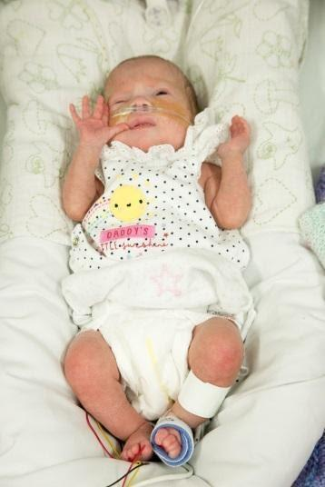
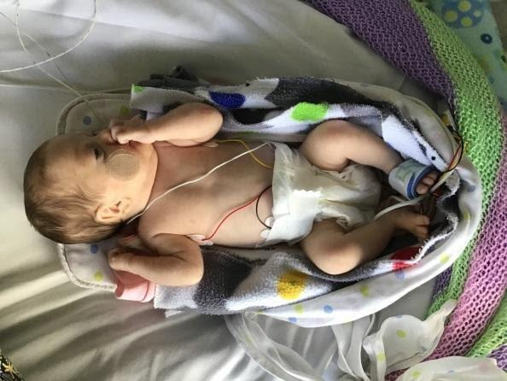
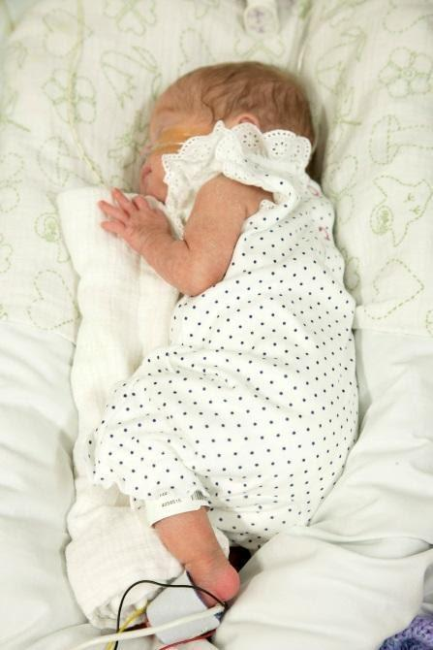
- Change infants’ position 4 hourly, unless clinical need prevents this.
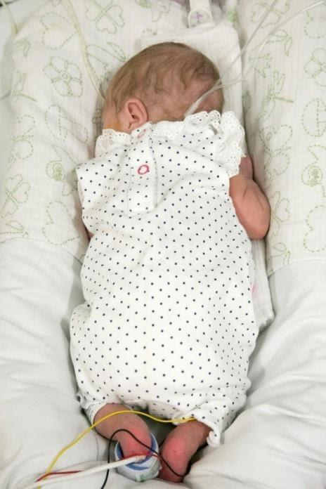

Supine position
- This position can be highly stressful to premature infants, use sparingly.
- Support head in midline if possible using an appropriate head supportive pillow and/or nest.
- Keep the infant’s shoulders forward off the bed surface, with their elbows flexed and their hands by their face/chest/each other.
- Hips and knees should be flexed and in neutral position
- Keep feet inside boundary/nest so contact with plantar surface can be made.
Lateral / side lying position
- This is the easiest position for infants to self-regulate.
- Support the infant’s back and head softly flexed in midline. Caution should be taken in this position in irritable or hypertonic babies that the spine and hips are well flexed as they may hyperextend in lateral.
- Use a roll or soft toy tucked in close to the abdomen to help with flexion.
- Larger babies may require support under their heads to maintain midline.
- Infants with chronic lung disease may push their head back slightly in this position to aid breathing, this should be allowed.
- Keep arms forward and flexed so the infant’s hands are in midline near their face.
- Hips, knees and ankles should be softly flexed with feet inside boundary.
Prone position
- This position promotes sleep and facilitates digestion.
- Infants’ arms should be flexed with their hands by their face as this facilitates hand to mouth activity and flexion.
- Hips and knees should be flexed (hips no more than 90 degrees) and neutrally aligned under the body.
- A muslin ‘surfboard’ should be used to help the infant maintain their position and to stabilise the chest wall, improving respiration rates, oxygenation and ventilation. The lower edge of the muslin should be in line with the infant’s umbilicus and the surfboard should only be one muslin thick.

Moving Premature Infants
- Always transition in quarter turns, rolling rather than lifting. Rolling an infant gives them sensory input and supports a normal movement pattern.
- If the infant is smaller or less tolerant of handling, changes of position may need to be extremely slow and paced.
- When lifting an infant: head off surface first, bottom last. Bottom down to surface first, head last.
- Keep transitions out of the incubator to a minimum. If the infant needs weighing (and does not have internal scales) or an incubator change, this should be combined with a positive experience such as kangaroo care.
- Ideally, weigh an infant swaddled and with parental involvement in an incubator if possible, otherwise in the transition to Kangaroo Care.
- AVOID sudden changes of position (e.g. prone to supine): these can cause stress and fluctuations in blood pressure.
- AVOID ‘lifting and flipping’ infants, holding infants under the arms or uncontained in space, they will not feel supported and this can cause stress.
KANGAROO CARE
Background
- Kangaroo Care (KC) is a reassuring way of communicating love and affection to infants through skin-to-skin contact between infant and parent. The infant is dressed in only a nappy and hat, placed onto the skin of the parent’s chest and covered by the parent’s clothing to help with temperature control.
- KC is a powerful, easy-to-use method which provides benefits for infants, including improved physiological stability, growth rates and decreased hospital stay.
- Parental benefits with KC include increased parent-infant attachment and bonding, increased milk production and reduced postnatal depression.

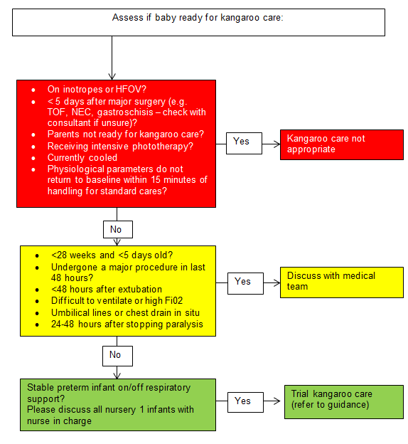

Parental preparation
- Encourage KC as often as the infant and parents can tolerate.
- Offer parents information on KC, using TMBU parent KC information sheet and chart. Advise parents that at least 1 hour of KC is recommended to allow for infant recovery time and one full sleep cycle.
- Plan a suitable time for KC as the infant's condition allows. Advise the parent to wear a front-opening shirt, bring a drink, go to the toilet and/or express first.
- Before starting KC, provide a quiet, calm environment, ensuring a reclining chair is available, offer a privacy screen and a handheld mirror.
- Discuss and explain mode of transfer. If a parent is not confident to transfer the infant themselves, ensure they are comfortable in a reclining chair before nurse-led transfer begins, with clothing open and ready to receive the infant.
- Discuss infant behavioural cues and responses to handling, including infant’s possible brief instability during transfer to/from the incubator/cot as well as possible reasons for ending it early. Reasons to end KC early include:
  - increased apnoeas/bradycardias/desaturations or prolonged increase in oxygen requirements of >15% noted.
  - the infant shows signs of distress or remains unsettled/distressed.
  - parents request that session ends.

Infant preparation
- Assess whether the infant is stable enough to receive KC. This can be done at any point prior to KC. Observe the infant’s physiological adaptation following handling. Adaptation is defined as all physiological parameters returning to baseline and staying there for three minutes. If adaptation has not occurred in 15 minutes, the infant is probably not stable enough to receive KC on that day. Additionally, see KC flow chart for contra-indications.
- Check bag-valve mask or Neopuff and suction is ready for use and will reach the infant. Ensure there is sufficient space in the area.
- Check the infant's temperature and vital signs are stable.
- Auscultate to determine if suction is necessary and allow time to recover before transfer commences.
- Position infant laterally to support access of hand to face, offer sucking opportunities, provide containment and boundaries. Transfer of the infant from bed to parent can be stressful for the infant. Good positioning pre-transfer and careful transitions are essential for beneficial KC.
- Remove any clothing and place a blanket so that the parent / nurse’s hands are not directly touching the infant’s skin when transferring.

Parent-Led Transfer
- (link to parent-led transfer video inserted here once this is completed and approved)
- Parent-led transfers should be encouraged, if the parent feels comfortable to do so.
- For parent-led transfers, at least one staff member experienced in KC must be present to support any tubing or lines, with a second staff member present for ventilated babies and some babies on CPAP.
- Use the safety prompt card for ventilated babies.
- Respiratory support should remain connected throughout.
- The incubator should be raised to an appropriate height so that the infant is at the level of the parent’s chest.
- The infant should be in a lateral position facing the parent, with a blanket behind them.
- The parent will stand at the incubator/cot side and place their forearm gently behind the infant and blanket, supporting the infant’s head and body.
- The parent will slide the infant in the nest towards them, until the infant is held against the parent’s bare chest.
- Once the parent has the infant held to their chest and supported, they gently lift the infant from the incubator (a nurse may need to facilitate removal of the nest) and sit down. The infant’s head will be facing down, this is important for the final placement of the respiratory tubing. One nurse will need to support respiratory tubing and lines, and a second may be necessary to support the ETT (if ventilated) and the parent.
- Once seated, the parent slowly moves the infant to a more upright position.
- If the infant is smaller or less tolerant of handling, changes of position may need to be extremely slow and paced.
- The nurse checks that the infant’s head is turned to the side to protect the airway, their legs are in flexion, a hat is in place, and a blanket around them.
- To return the infant to the incubator, the same process will be followed in reverse.

N.B. If developmentally appropriate for a term infant, parent-led transfer can be from supine to upright, while ensuring the infant remains held close to the parent’s chest.

Nurse-Led Transfer
- (link to nurse-led transfer video inserted here once this is completed and approved)
- Parent-led transfer is usually more straightforward, however, this may need to be nurse-led if the parent or nurse is not confident with a parent-led transfer. A second nurse is likely to be necessary and is essential for a ventilated infant.
- Use the safety prompt card for ventilated babies.
- Respiratory support should remain connected throughout.
- The incubator should be raised to an appropriate height so that the infant is at the level of the nurse’s abdomen.
- The infant should be in a lateral position facing away from the nurse, with a blanket wrapped around them.
- The nurse will stand at the incubator/cot side and place their forearm gently around the infant and blanket, supporting the infant’s head (and ETT if ventilated) with their hand.
- The nurse will slide the infant in the nest towards them, until the infant is held against the nurse’s abdomen.
- Once the nurse has the infant held and supported, they gently lift the infant from the incubator (the second nurse may need to facilitate removal of the nest). The second nurse will need to support respiratory tubing and lines during transfer.
- Parent moves legs to the left to facilitate transfer of the infant and unwraps the blanket. The nurse bends so that the infant is close to the parent’s bare chest. The parent slides their arm between the infant and the nurse’s abdomen, and brings the infant towards their bare chest, with the infant’s head facing up. This is important for the final placement of the respiratory tubing.
- Once the infant is securely between the parent’s chest and their arm, the nurse removes their arm from the infant, while ensuring the security of the ETT if ventilated.
- Once comfortable, the parent slowly moves the infant to a more upright position.
- If the infant is smaller or less tolerant of handling, changes of position may need to be extremely slow and paced.
- The nurse checks that the infant’s head is turned to the side to protect the airway, their legs are in flexion, a hat is in place and a blanket around them.
- To return the infant to the incubator, the same process will be followed in reverse.

NON-NUTRITIVE SUCKING

Background
- Non-Nutritive Sucking (NNS) is the sucking an infant does by reflex, for example on a finger or a soother. It is called Non-Nutritive as the infant is not getting any milk.
- NNS may be present from as early as 15-18 weeks gestation and becomes stronger and more coordinated over time.
- NNS practice will help infants develop their oral feeding skills and may be practiced as soon as the infant is well enough.
- NNS can lead to increased weight gain, improved digestion of milk, gastric motility and growth of intestinal mucosa and reduced distress during interventions and improved physiological stability.
- NNS is an opportunity for parent-infant interaction and bonding.

Guidance
- Always gain consent before introducing NNS for the first time, particularly if this involves a soother.
- Position the infant so they are able to move their hands to their face to suck their fingers.
- Wait for the infant to show an interest before putting a finger or soother in their mouth, and when providing mouthcare.
- Encourage infants to suck for 5 –10 minutes at each tube feed when awake.
- If appropriate, hold the infant in a normal feeding position during tube feeds, and offer NNS in this position.
- Some infants may need specialised exercises to develop their suck. If this is the case, the Speech & Language Therapist will provide further guidance.

TASTE AND SMELL

Background
- The sense of smell is fully formed around 24 weeks gestation and infants are able to distinguish between sweet and sour tastes by 28 weeks gestation.
- Within a neonatal unit, infants are subjected to numerous new and unpleasant smells that mask the natural parental scent. Respiratory support and some medications can also interfere with an infant’s sense of smell and taste.
- Positive smell and taste experiences are known to increase gut motility, insulin secretion and the release of digestive and metabolic hormones.

Guidance
- Allow alcohol gel to dry before handling an infant.
- Swap fabric squares between the parent and the infant’s incubator. If the parent is expressing, this also allows the infant to smell EBM and can support milk production. Ensure fabric squares are swapped and washed daily to ensure infection prevention.
- Encourage regular Kangaroo Care so the infant and parent are able to smell each other.
- Both parents and staff should avoid strong smells such as perfume and cigarette smoke.
- Where possible use EBM for mouth care and comfort sucking.

LIGHT

Background
- The retina and visual cortex are the last of the senses to develop.
- Visual stimulation has been found to be potentially harmful for preterm infants before term equivalent age.
- The underdeveloped eyelids of a preterm infant do not effectively block out light and the pupillary reflex is absent until after 31 weeks, so the infant cannot moderate the amount of light entering the eye.
Guidance
- Lighting should be minimised for all infants pre 32 weeks with an incubator / cot cover in place. Consider extending this for older infants who demonstrate stress responses to light.
- Dim lighting at night to enhance the development of circadian rhythms and the development of normal sleep patterns.
- Protect sleep as this is critical for visual development.
- From 32 weeks begin to introduce ‘cycled’ moderate light exposure: Begin with 1- 2 hours daily up to a maximum of 8 hours approaching term. This should be natural light where possible, not direct overhead light.
- From 33 weeks increase interaction time, monitor infants’ stress responses and build this up as tolerated.
- All cots / incubators should be covered with a cot cover overnight to minimise exposure to artificial light and encourage day / night cycles.
- Protect infants’ eyes from bright light during care procedures and ward round. This will normally be achieved by leaving the incubator cover in place, however if direct light is needed, a muslin may be temporarily placed across the infant’s eyes.
- Take extra care to protect eyes after ROP screening due to prolonged dilation of the pupils.
- Use phototherapy eye masks to protect infants’ eyes during phototherapy.
- Only use mobiles when infants are alert and actively engaged. Observe for overstimulation cues and remove if necessary.
- AVOID leaving black and white boards in cots: they can be used interactively after term age but do not leave them in the cot as this may cause overstimulation. Long periods of attendance to these boards have been linked to visual processing difficulties and poorer cognition in childhood.
- AVOID toys with flashing lights which are overstimulating.

NOISE

Background
- Noise is defined as ‘an unwanted level of objectionable sound’. High noise levels have negative impacts on patients and staff.
- Infants in the neonatal unit are exposed to large amounts of noise from equipment and staff. The most significant noise levels occur during the day and are produced by staff conversation.
- From 28 weeks, infants begin to orientate to sound and respond to parents’ voices. However for preterm infants, excessive background noise can cause increased heart rate and blood pressure, agitation, sleep disturbance, poor feeding coordination, an inability to recognise parent voice and long term hearing loss.
Guidance
- A sound measuring device with a warning system should be used. In a NICU environment, recommended average noise levels are approximately 45dBA (equivalent to a quiet library), and noise levels should never exceed 65dBA (normal conversation). A more detailed noise table is available here (hyperlink to noise table in the appendix will be inserted).
- Background lighting should be low to encourage people to lower their voices.
- Encourage parents and/or carers to talk softly to their infant.
- Do not speak across the incubators or across the nursery. Hold lengthy discussions outside the nurseries where possible.
- Use visual alarms rather than auditory alarms for non-vital alerts, e.g. feeding pumps.
- Attend to alarms, intercom and phones promptly.
- Use soft closing bins.
- Cover incubators with soft covers and close incubator doors quietly.
- Avoid water in ventilator circuits.
- Do not drag equipment across the floor or place equipment on top of incubators
- Enforce quiet time – mean oxygen saturation is higher during quiet time than when sound levels are not decreased.
- Use ear defenders for noisy procedures e.g. MRI.

