ADMINISTRATION GUIDE FOR HIGH DOSE TIROFIBAN FOR PRIMARY PCI (PPCI)
USE | Tirofiban is a glycoprotein IIb/IIIa Inhibitor used for the prevention of ischaemic cardiac complications in patients with STEMI undergoing PPCI.
PRESENTATION | Ready-made bags 250 mls. Tirofiban 50 micrograms/ml.  See IV monograph on Medusa for further information
DOSE and ADMINISTRATION | IV: Bolus (high dose): 25 microgram/kg given over a 3 minute period, followed by a continuous infusion at 0.15 micograms/kg/minute for 12-24 hours (up to maximum of 48 hours). If CrCl<30ml/min then dosing is halved, see table below.  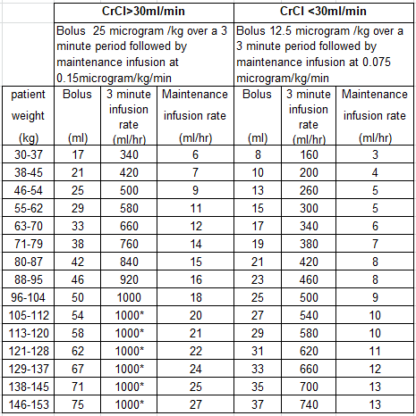
 | *if the maximum pump rate is 1000 ml/hour, for patients above 105kg the duration of the bolus dose will exceed 3 minutes
SIDE-EFFECTS | Bleeding, thrombocytopenia, headache, nausea, fever
CONTRAINDICATIONS | History of stroke within 30 days or any history of haemorrhagic stroke, history of intracranial disease (e.g. neoplasm, arteriovenous malformation, aneurysm),active or recent (within the previous 30 days of treatment) clinically relevant bleeding (e.g. gastro-intestinal bleeding),malignant hypertension, relevant trauma or major surgical intervention within the past six weeks, thrombocytopenia (platelet count <100,000/mm), disorders of platelet function, clotting disturbances (e.g. PT>1.3 times normal or INR >1.5), severe liver failure
MONITORING | Baseline platelets, haemoglobin & haematocrit, repeated within 2 to 6 hours from start of therapy and then at least once daily if continuing treatment.
RENAL IMPAIRMENT | In severe renal failure (CrCl<30ml/min) reduce dosage by 50%
References: | For full prescribing information see www.emc.medicines.org.uk : tirofiban
Written by: | Alison Warren, Consultant Cardiac Pharmacist July 2015. Updated March 2018  Checked by Leah Colclough Specialist Clinical Pharmacist May 2018  Updated by Sarah Connop, Lead Cardiology Pharmacist August 2023  Checked by Patrick Connolly, Cardiology Practice Educator August 2023  Approved by Medicines Governance Committee September 2023, Review Sept 2025

