**Background**

Anaemia is a state in which the quality or quantity of circulating red blood cells is below normal and haemoglobin (Hb) is used as the measure.

Erythropoietin, produced by the kidneys in response to low oxygen levels, stimulates the bone marrow to produce red blood cells. Anaemia in Chronic Kidney Disease (CKD) is due to a reduction in erythropoietin production due to kidney damage.

CKD should be considered as a possible cause of anaemia when eGFR is <60 ml/min/1.73m2. It is more likely to be the cause if the GFR is <30ml/min/1.73m2 (<45/min/1.73m2 in patients with diabetes) and no other cause, e.g. blood loss, folic acid or vitamin B12 deficiency, is identified.

Adverse effects of anaemia include reduced oxygen use, increased cardiac output, left ventricular hypertrophy, reduced cognition and concentration, reduced exercise capacity and libido, and reduced immune responsiveness and negative impact on quality of life.

The purpose of this guideline is to provide standardised evidence-based approach for managing anaemia in adults (aged 18 or over) with a clinical diagnosis of anaemia associated with CKD.

**Abbreviations**

AKC – Advance Kidney Care

CKD – Chronic Kidney Disease

EPO – Erythropoietin

ESA – Erythropoietin Stimulating Agent

Hb – Haemoglobin

HIF-PH – Hypoxia-Inducible Factor Propyl Hydrohylase

NMP – Non-Medical Prescribing/Prescriber

RRT – Renal Replacement Therapy

SKU – Sussex Kidney Unit

**Responsibilities, Accountabilities and Duties**

* All medical and nursing staff working in SKU are responsible to be aware of this guideline.
* Renal consultants, senior nursing staff and lead renal pharmacists are responsible to include this guideline as part of departmental induction.
* The advanced kidney disease and haemodialysis lead nurses and the lead renal pharmacists are responsible for updating this guideline every three years or when necessary.
* All senior nursing staff are responsible to collaboratively audit this guideline with the renal audit manager.
* For ALL patients newly initiated on ESA/Roxadustat or if doses have changed – email [uhsussex.aranesp@nhs.net](mailto:uhsussex.aranesp@nhs.net).
* Hospital HD patients – email [uhsussex.aranesp@nhs.net](mailto:uhsussex.aranesp@nhs.net) to stop further home deliveries.
* HD patients have monthly review with HD consultants so non-urgent referrals should wait until then.
* Anaemia team assesses patient’s iron requirements as required and arranges ESA/Roxadustat as required.
* Aranesp prescriptions are sent to Fresenius homecare and they will manage supply to the patients’ homes. Anaemia nurses will inform the GP and will educate patients or carer on administration. (See Aranesp letter in Appendix 1)
* Roxadustat prescriptions are sent to Pharm@sea and they will manage supply to patients’ homes. Anaemia nurses will inform the GP. (See Roxadustat letter in Appendix 2).
* Anaemia nurses monitor Hb and iron levels and medical or NMP nursing staff review results monthly and arrange iron and ESA/Roxadustat dose changes.
* This guideline is only applicable to SKU services.

**Blood Tests**

1. Full blood count.
2. Absolute reticulocyte counts to assess bone marrow responsiveness (if indicated).
3. Iron studies including ferritin.
4. Plasma/Serum C-reactive protein (CRP) to assess inflammation.

Based on the initial assessment the following tests may also be useful to diagnose the cause of anaemia:

* Serum vitamin B12 and serum folate concentrations.
* Tests for haemolysis.
* Plasma/Serum and/or urine protein electrophoresis.
* Hb electrophoresis.
* Free light chains and bone marrow examination

Measure Hb levels at least annually in patients with CKD3 and at least twice a year in patients with CKD4-5 NOT on dialysis.

Measurement of erythropoietin levels should not routinely be considered for the diagnosis or management of anaemia for patients with CKD.

**Targets**

Haemoglobin (Hb): 100-120g/L.

Ferritin: 100-500μg/L

Transferritin saturation (TSat): 20-40%.

**Referral Process for NRRT, Transplant and PD Patients**



For transplant patient consider whether Mycophenolate Mofetil or Azathioprine are the cause of anaemia and whether immunosuppression could safely be changed.

**Referral Process for HD Patients**



**Diagnosis and Management**

When treating a patient with CKD and anaemia the following steps should be followed:

1. Treat clinically relevant hyperparathyroidism.
2. Optimise iron status and treat deficiency. Iron deficiency must be corrected before or at the same time as initiation of ESA/Roxadustat therapy.

|  |  |  |
| --- | --- | --- |
| Patient cohort | 1st line treatment | 2nd line treatment |
| NRRT, PD, Transplant | **Oral iron** | **IV iron\*** |
| HD | **IV iron** | **Oral iron\*\*** |

*If intolerant to oral iron or target levels are not reached within 3 months.

**If IV iron contraindicated or the patient chooses not to have IV iron therapy after discussing the relative efficacy and side effects of the two formulations

1. Offer treatment with ESAs/Roxadustat if the patient is likely to benefit in terms of quality of life and physical function and to avoid blood transfusion especially in patients considered suitable for transplantation to minimise risk of allosensitisation. ESAs/Roxadustat should NOT be started in the presence of absolute iron deficiency (ferritin<100μg/L and/or transferrin saturation<20%) without also managing the iron deficiency.

|  |  |  |  |
| --- | --- | --- | --- |
| Patient cohort | 1st line treatment | 2nd line treatment | 3rd line treatment |
| NRRT, PD, Transplant | **Darbepoetin alfa (Aranesp) SC** | **Roxadustat (Evrenzo)\*** | **Other EPO injection SC\*\*** |
| HD | **Darbepoetin alfa (Aranesp) IV** | **Other EPO injection IV** | **Roxadustat (Evrenzo)** |

*If Aranesp is contraindicated, not tolerated or if the patient meets the relevant criteria

**If both Aranesp and Roxadustat are contraindicated or not tolerated

**Treatment with Iron**

* Oral iron

Ferrous sulfate 200mg at night with vitamin C to improve absorption. If not tolerated ferrous fumarate and ferrous gluconate can be used.

* IV iron

|  |  |  |
| --- | --- | --- |
| Patient Cohort | NRRT, transplant and PD patients | HD patients |
| Drug choice | Ferric Derisomaltose | Venofer (Iron Sucrose) |
| Administration location | Stirling Unit at RSCH, SKU Satellite Units | Allocated HD Unit* |
| Considerations | Optimise treatment by offering high dose, low frequency | Avoid if presenting with active infection due to lower efficacy. |

*Home HD patients depending on the machine might not be able to administer Venofer and in this scenario Ferric Derisomaltose can be considered.

**Iron Monitoring**

Following every administration of an IV iron product, patients must be monitored for at least 30 minutes for sign of hypersensitivity reactions.

Iron status monitoring every one to three months is recommended in patients receiving IV iron to avoid toxicity. Ferritin consistently greater than 800micrograms/L with no evidence of inflammation (normal CRP) might suggest iron overload.

Recheck FBC, ferritin and TSATs 4 weeks after IV iron administration.

**Treatment with ESA**

|  |  |
| --- | --- |
| ESA – Darbepoetin alfa (Aranesp) | |
| Correction phase | |
| NRRT, Transplant and PD patients | Initially 0.45microgams/Kg once weekly, alternatively, 0.75micrograms/Kg every 2 weeks or 1.5microgram/Kg once monthly administered **subcutaneously**. |
| HD patients | Initially 0.45microstartgrams/kg once weekly by **intravenous** injection. |
| Dose adjustments (applicable to all patients) | |
| If Hb continue to remain below 105g/L | Increase ESA dose by approximately 25%. Dose increase must not be made more frequently than every four weeks. |
| If Hb remain above 115g/L or the rise is greater than 2g/dL in four weeks | Reduce the ESA dose by approximately 25%. If after a dose reduction, Hb continues to increase, the dose should be temporarily withheld until the Hb begins to decrease at which point therapy should be reinitiated at a dose approximately 25% lower than the previous dose. |

The frequency of ESA administration should be determined by the CKD treatment setting and the class of ESA – less frequent administration using long-acting ESAs may be the treatment of choice in non-HD patients.

ESA administration should continue during acute illness, surgical procedures or any other cause of hospitalisation, unless there is a clear contraindication such as uncontrolled hypertension.

Exert extreme caution while prescribing ESA therapy in CKD patients with a history of stroke, or malignancy, particularly in those with active malignancy when cure is anticipated outcome.

|  |  |
| --- | --- |
| Responsibility for ESA administration | |
| Steps for consideration | **Comments** |
| 1. Request patient self-administration. Teaching to be done by SKU staff if patient attending clinic, or request GP practice nurse to teach administration. | Device to be used: pre-filled syringes |
| 1. If patient unable to use pre-filled syringes consider switching to the SureClick device. Training to be done as per point 1. | Device to be used: SureClick |
| 1. If the above steps are not appropriate, request administration is done by the practice nurse at the patient’s GP surgery. | Switch the patient back to pre-filled syringes |
| 1. If administration cannot be done by the patient or the practice nurse, request administration of ESA by district nurse. | Device to be used: pre-filled syringes |
| 1. If the above are not possible or Aranesp is contraindicated consider switching to Roxadustat. | Oral tablets |
| 1. If patient is unable and practice/district nurse unwilling and roxadustat not tolerated, ESA to be administered via SKU. | Device to be used: pre-filled syringes |

If Aranesp is contraindicated or not tolerated other ESAs can be considered as alternatives.

*When converting from Aranesp to Eprex (Epoetin alfa) conversions are as follow:*

|  |  |
| --- | --- |
| Aranesp dose (micrograms/week) | Epoetin Alfa dose (units/week) |
| 6.25 | 1500 to 2499 |
| 12.5 | 2500 to 4999 |
| 25 | 5000 to 10999 |
| 40 | 11000 to 17999 |
| 60 | 18000 to 33999 |
| 100 | 34000 to 89999 |
| 200 | ≥ 90,000 |

*When converting from Aranesp to NeoRecormon (Epoetin Beta) use the following conversion:*

1microgram/week of Aranesp = 200units/week of NeoRecormon

**ESA monitoring**

The Hb should be measured every two weeks until it is stable. In the maintenance phase Hb can be monitored every one to three months depending on clinical circumstances.

Blood pressure should be monitored in all patients receiving ESA. Before ESA therapy initiation BP should be <160/80. For maintenance ESA, blood pressure should be <170/100.

Inadequate response (‘resistance’) to ESA therapy is defined as failure to reach the target Hb level despite SC epoetin dose > 300units/Kg/week (450units/Kg/week IV epoetin). Or darbepoetin dose > 1.5microgram/Kg/week. Hypo responsive patients who are iron replete should be screened clinically and by investigations for other common causes of anaemia.

**Treatment with Roxadustat**

Indicated for patients with CKD3-5 with no iron deficiency and not already on dialysis at the start of treatment. Conversion of dialysis patients otherwise stable on ESA treatment is only recommended when there is a valid clinical reason. Conversion on non-dialysis patients otherwise stable on ESA has not been investigated therefore currently not recommended.

Starting dose for patients not previously on ESA treatment:

|  |  |
| --- | --- |
| Patient weight | Dose |
| <100kg | 70mg three times a week |
| >100kg | 100mg three times a week |

Dose for patients converting from an ESA

The first roxadustat dose should replace the next schedule dose of ESA.

|  |  |
| --- | --- |
| Aranesp IV/SC dose (microgram/week) | Roxadustat dose (milligrams three times per week) |
| Less than 25 | 70 |
| 25 to less than 40 | 100 |
| 40 up to and including 80 | 150 |
| More than 80 | 200 |

Dose adjustment

The first dose adjustment should take place at least 4 weeks after treatment initiation unless Hb increases by more than 2g/dL, in which case the dose should be reduced by one step immediately.

|  |  |  |  |  |
| --- | --- | --- | --- | --- |
| Dose adjustments rules | | | | |
| **Change in Hb over the previous 4 weeks** | **Current Hb level (g/dL):** | | | |
| **Lower than 10.5** | **10.5 to 11.9** | **12.0 to 12.9** | **13.0 or higher** |
| **Change in value of more than +1.0g/dL** | No change | Reduce dose by one step | Reduce dose by one step | Withhold dosing, monitor Hb level and resume dosing when Hb is less than 12.0 g/dL, at a dose that is reduced by two steps |
| **Change in value between -1.0 and +1.0g/L** | Increase dose by one step | No change | Reduce dose by one step |
| **Change in value of less than -1.0g/L** | Increase dose by one step | Increase dose by one step | No change |

**DOSE STEPS: 20mg🡪40mg🡪50mg🡪70mg🡪100mg🡪150mg🡪200mg🡪250mg🡪300mg🡪400mg**

Maximum recommended dose for patients NOT on dialysis: 3mg/kg body weight or 300mg three times per week, whichever is lower.

**Roxadustat monitoring**

Hb every 2 weeks until the target levels are achieved, then every four weeks.

Blood pressure should be monitored in all patients receiving Roxadustat and, if present, should be treated by volume removal and/or antihypertensive drugs. For maintenance Roxadustat, blood pressure should be <170/100.

**Roxadustat contraindications:**

* Hypersensitivity to the active substance, peanut, soya or any of the excipients
* Third trimester of pregnancy
* Breastfeeding

*Seizures were reported as common amongst the patients in clinical studies receiving Roxadustat. Use with caution in patients with history of seizures, epilepsy or medical conditions associated with a predisposition to seizure activity such as central nervous system infections.

**Roxadustat interactions**

Sevelamer carbonate and calcium acetate (phosphate binders) reduce the absorption of Roxadustat by approximately 50% therefore should be taken at least one hour apart.

**References**

* National Institute for Health and Care Excellence (2021). Chronic kidney disease: assessment and management. [NG203].
* National Institute for Health and Care Excellence (2022). Roxadustat for treating symptomatic anaemia in chronic kidney disease. [TA807].
* UK Kidney Association (2020). Clinical Practice Guideline Anaemia of Chronic Kidney Disease.
* Pharmacosmos UK Limited (2022). Ferric Derisomaltose 100mg/ml solution for injection/infusion SmPC.
* Vifor Pharma UK Limited (2020). Venofer (iron sucrose) 20 mg iron / ml, solution for injection or concentrate for solution for infusion SmPC.
* Amgen LTD (2021). Aranesp solution for injection in pre-filled syringe SmPC.
* Astellas Pharma LTD (2022). Evrenzo (roxadustat) film coated tablets (Great Britain) SmPC.
* [aranesp_pi_hcp_english.pdf (amgen.com)](https://www.pi.amgen.com/-/media/Project/Amgen/Repository/pi-amgen-com/aranesp/ckd/aranesp_pi_hcp_english.pdf)
* [Dose equivalence between continuous erythropoietin receptor activator (CERA), Darbepoetin and Epoetin in patients with advanced chronic kidney disease - PMC (nih.gov)](https://www.ncbi.nlm.nih.gov/pmc/articles/PMC4453804/)

**Appendix 1 – Aranesp / Eprex / NeoRecormon Letters (GP and Patient)**

**Aranesp / Eprex / NeoRecormon Commencement - Letter to GP**

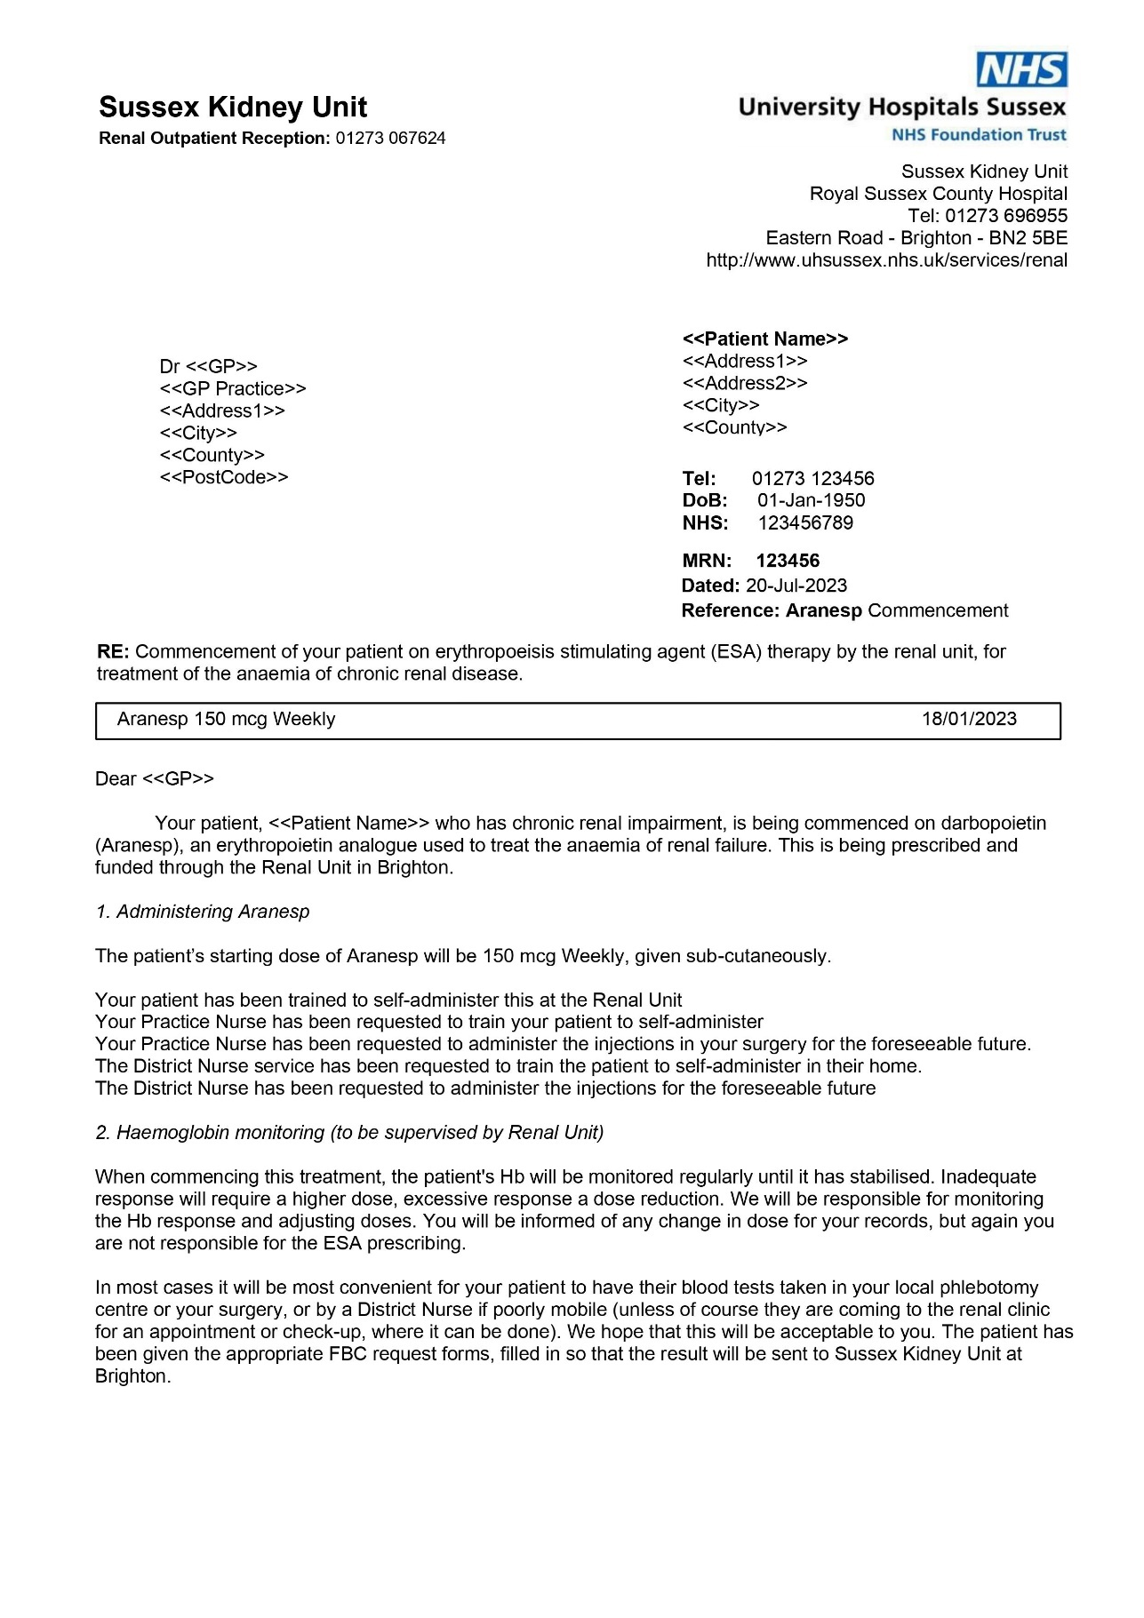

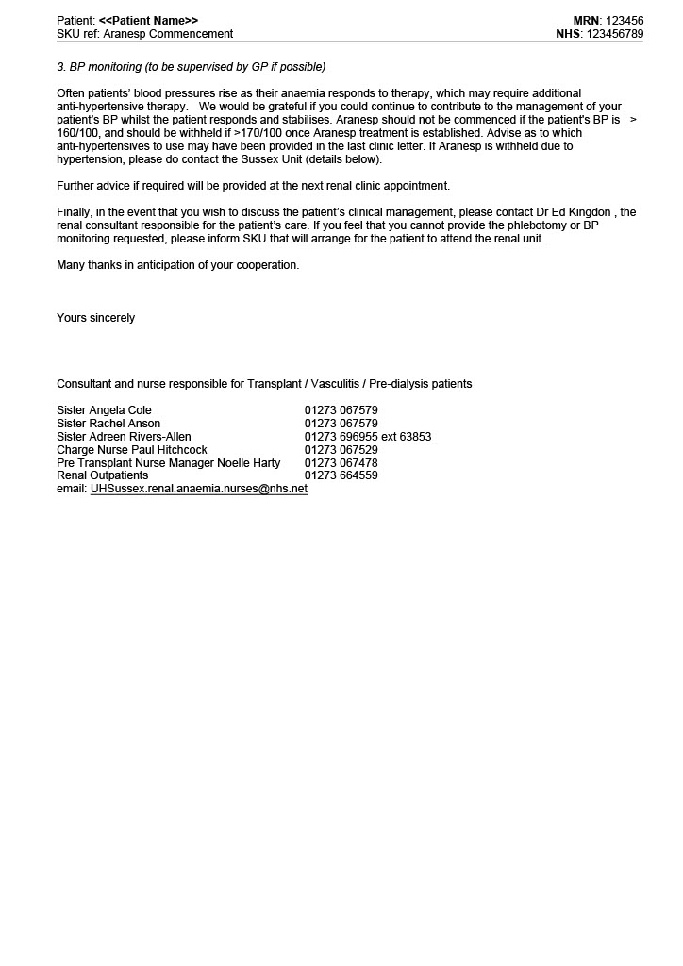

**Aranesp / Eprex / NeoRecormon Commencement - Letter to Patient**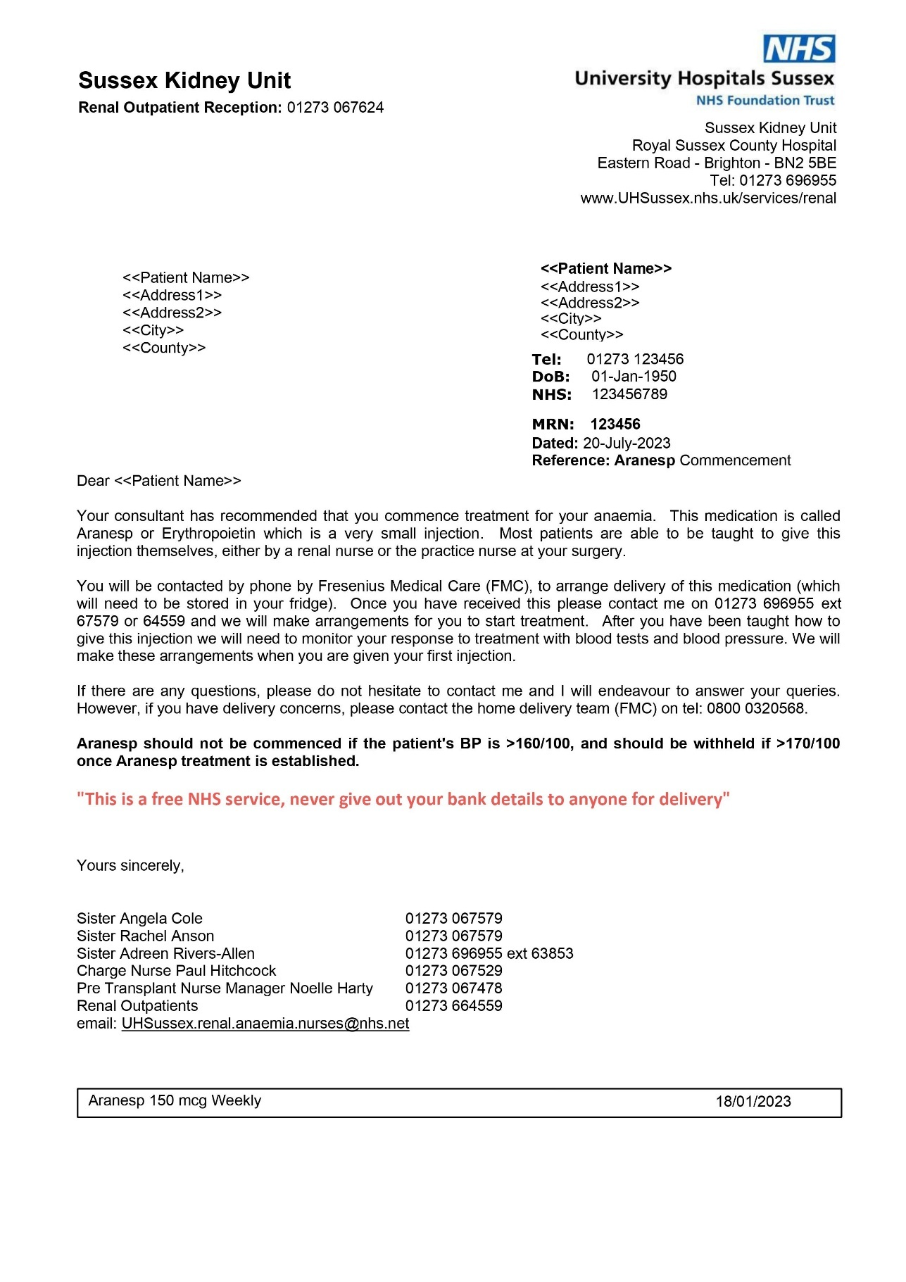

**Aranesp / Eprex / NeoRecormon Dose Change - Letter to Patient**

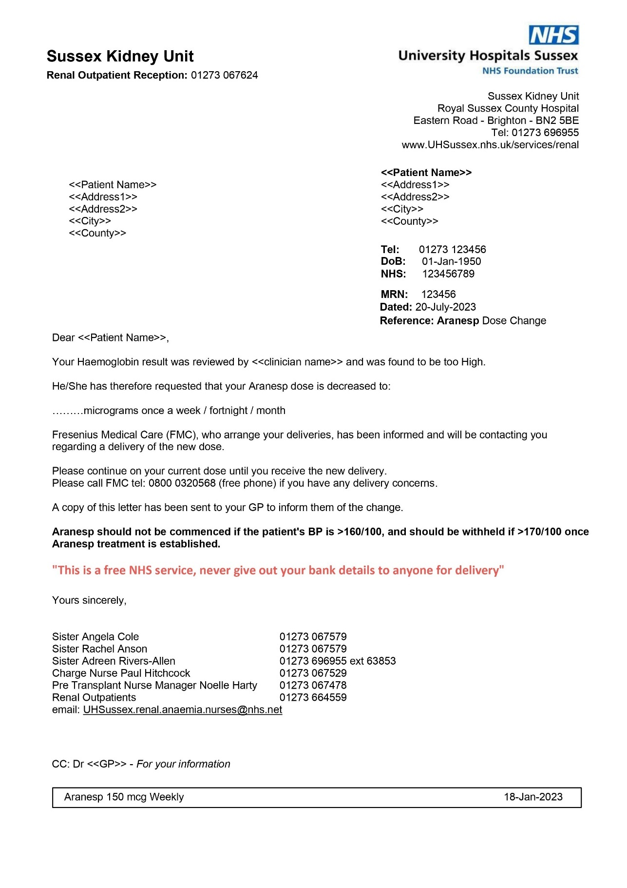



**Appendix 2 – Roxadustat Letters**

RN2973972

NHS4205118783

**Roxadustat Commencement - Letter to GP**

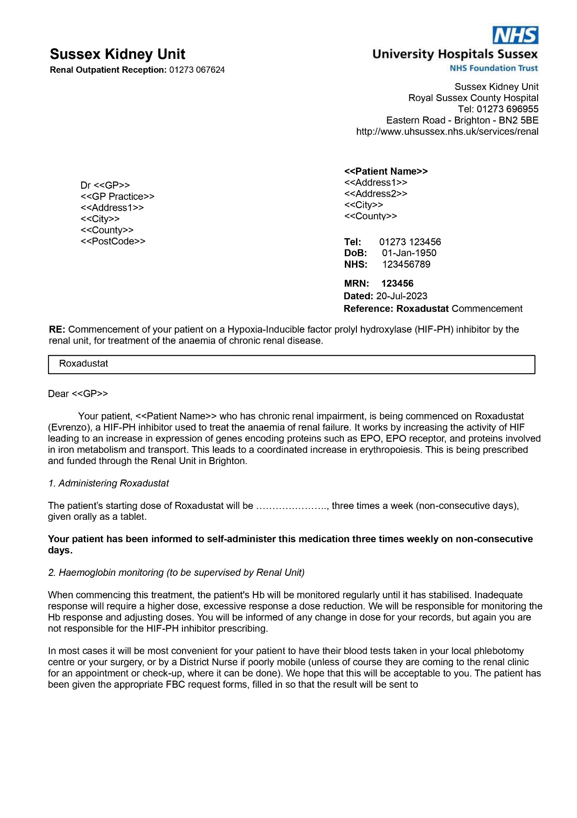

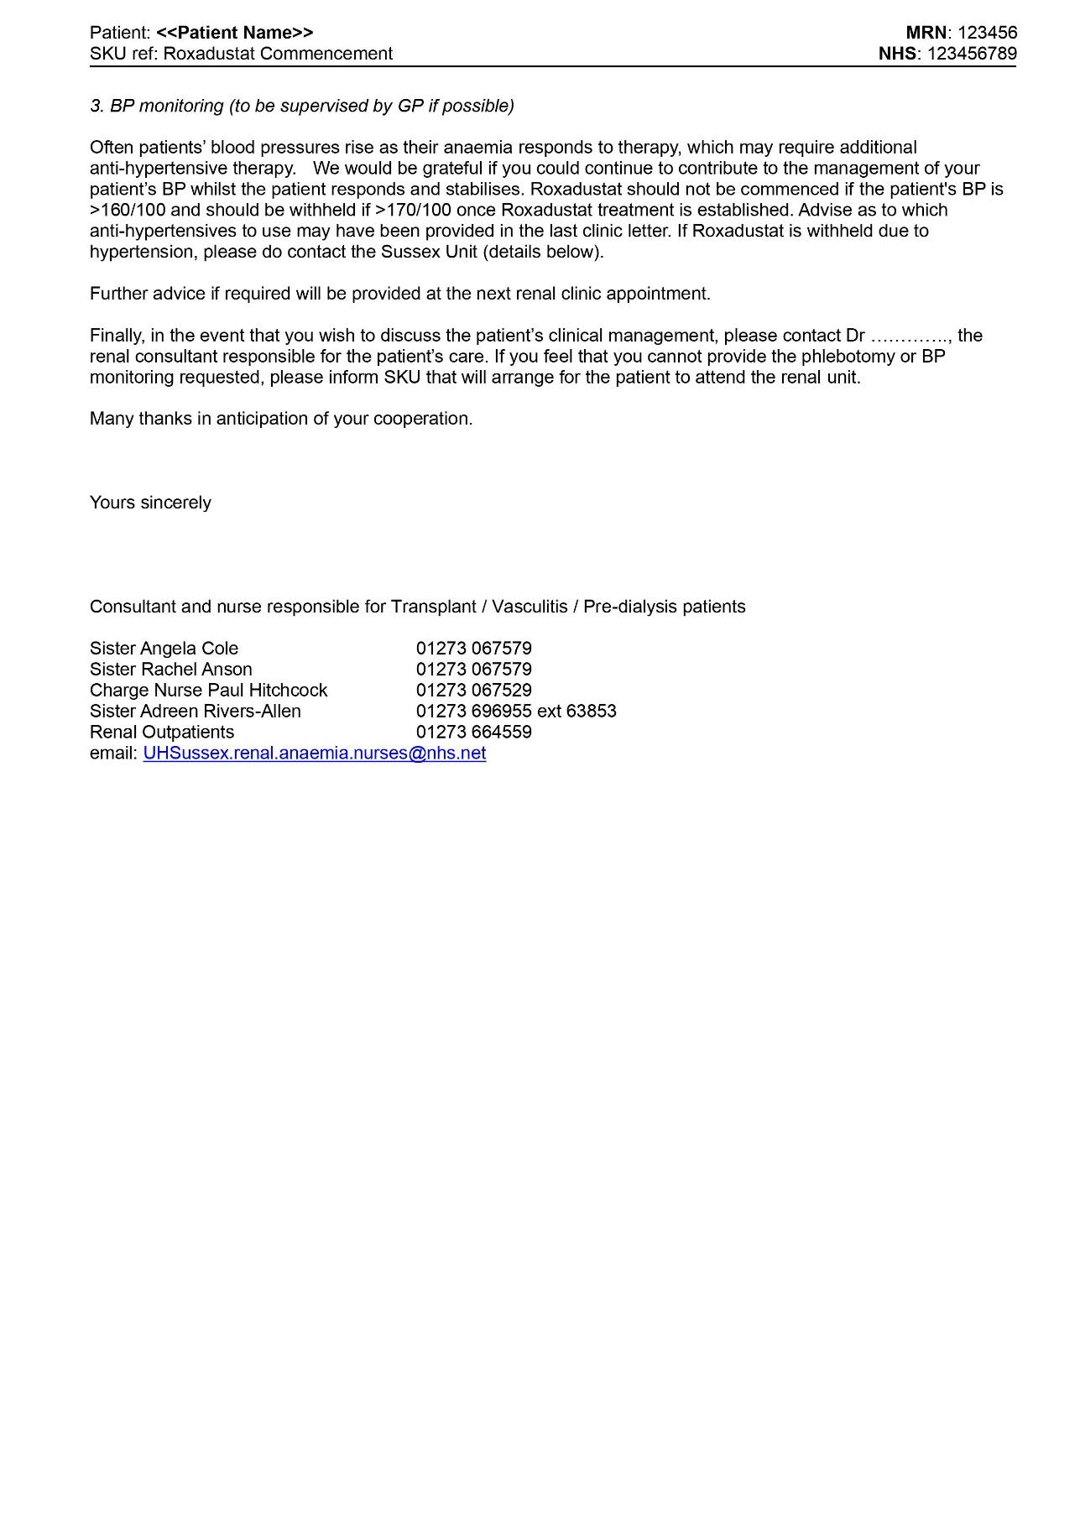

**Roxadustat Commencement - Letter to Patient**

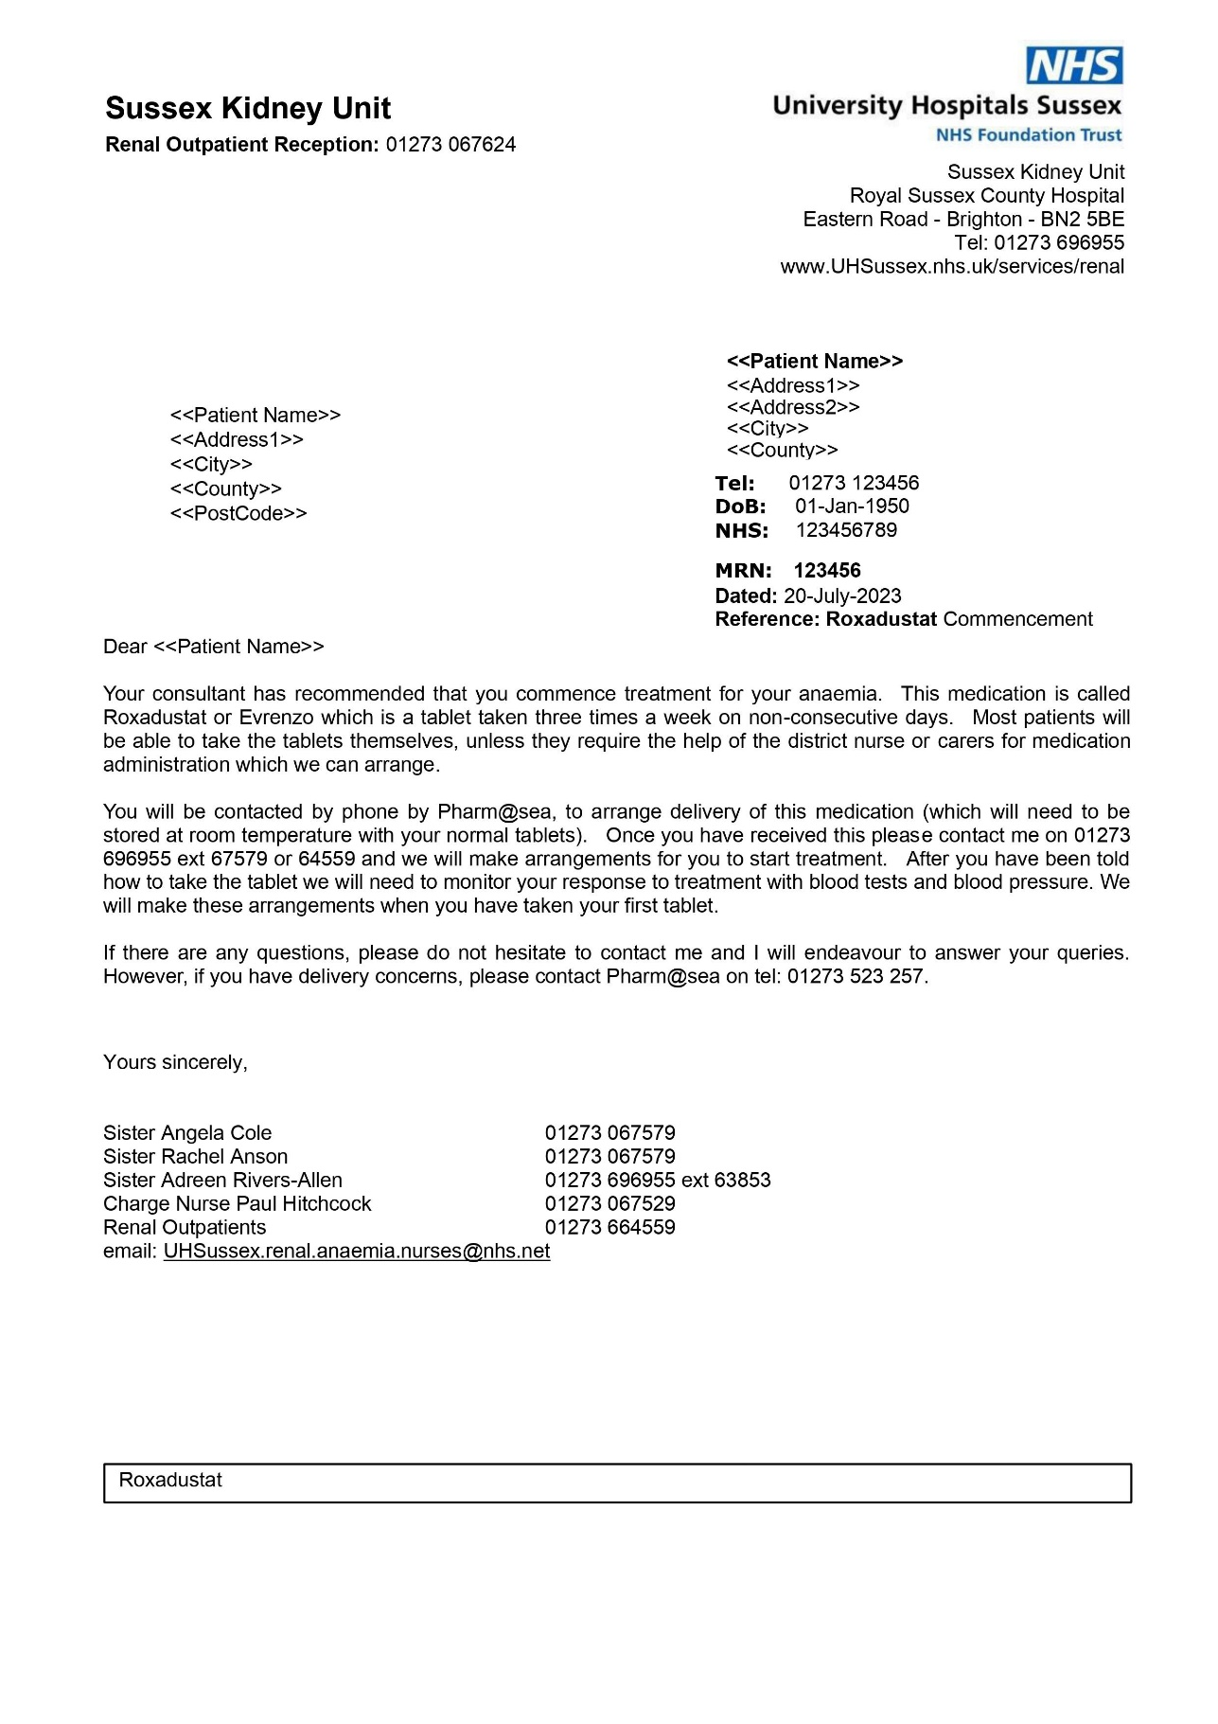

**Roxadustat Dose Change - Letter to Patient**

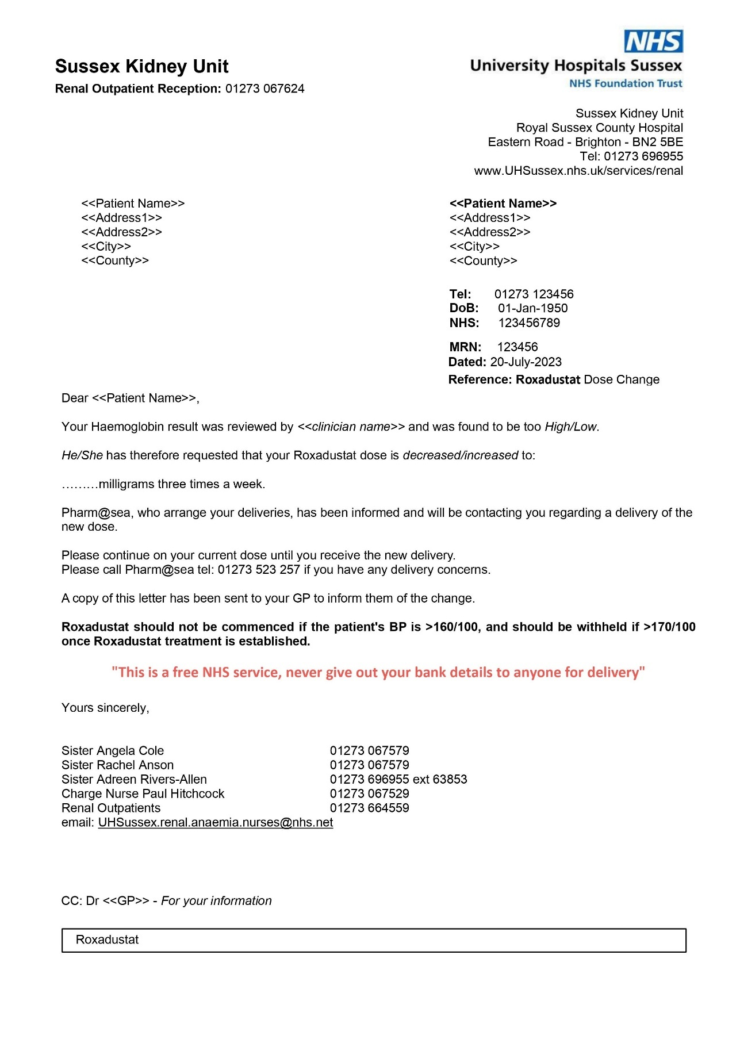



**Appendix 3** **– Roxadustat Checklist**



Completed by: __________________________________________________

Date: __________________________________________________________

Signature: ______________________________________________________

**Appendix 4 – Ferric Derisomaltose Prescription**

**Administration of Ferric Derisomaltose in Non-Renal Replacement Therapy and Home Therapy (Home Haemodialysis and Peritoneal Dialysis) patients**

Ferric Derisomaltose is reserved for use when oral iron preparations cannot be used or are ineffective or when there is a clinical need to deliver iron rapidly. The diagnosis must be based on laboratory tests.

This proforma EXCLUDES paediatric, heart failure and pregnant patients. Please refer to the separate specialty guidelines and proformas for these patient groups.

|  |  |  |  |  |  |  |  |  |  |  |  |
| --- | --- | --- | --- | --- | --- | --- | --- | --- | --- | --- | --- |
| *Affix patient label or enter details:*  Trust ID No or NHS number   |  |  |  |  |  |  |  |  |  |  | | --- | --- | --- | --- | --- | --- | --- | --- | --- | --- | |  |  |  |  |  |  |  |  |  |  | | Consultant:  Allergies:…………………………………………….Reaction:………………………………..  Weight:……………Kg Height:…………… cm BMI:……………m2  Ideal Body Weight:…………..Kg  Hb:…………… g/L Target Hb::……………g/L  Transferrin sats:……………%  Ferritin:……………ng/Ml |
| Surname (BLOCK LETTERS):  First name:  D.O.B.: |

**Contraindications:**

* Hypersensitivity to the active substance, to Ferric Derisomaltose or any of its excipients
* Known serious hypersensitivity to other parenteral iron products
* Non-iron deficiency anaemia (e.g. haemolytic anaemia)
* Iron overload or disturbances in utilisation of iron (e.g. haemochromatosis, haemosiderosis)
* Decompensated liver disease

**Special warnings and precautions for use:**

* Patients with severe asthma, eczema and atopic allergy
* Prescribe adrenaline, IV fluids (sodium chloride 0.9% or Hartmann) and high flow oxygen in case needed
* IV iron must not be used with oral iron – oral iron should be stopped before the IV infusion and can be (re)started 7 days after the infusion
* Ferric Derisomaltose should not be used in patients with ongoing bacteraemia

**Adverse reactions:**

* Cardio-pulmonary resuscitation MUST be available when administering IV Ferric Derisomaltose as allergic or anaphylactic reaction might occur.
* Observe patient for adverse effects for the duration of the infusion and for at least 30minutes following each Ferric Derisomaltose injection.
* After the infusion, extend and elevate patient’s arm and apply pressure for at least 5 minutes to avoid leakage which can lead to inflammation, necrosis or sterile abscesses and permanent discolouration of skin.

|  |  |  |
| --- | --- | --- |
| Reaction | Management | Communication |
| Allergic or anaphylactic reactions characterised by sudden onset of respiratory difficulty with or without cardiovascular collapse. | **STOP INFUSION IMMEDIATELY**  Adrenaline, IV fluids and high flow oxygen should be administered**.** | Get team support and contact a doctor immediately.   * If at RSCH/PRH 🡪 put out MET call * If in Satellite Unit 🡪 call an ambulance |
| Urticarial, rashes, itching, nausea and shivering. | **STOP INFUSION IMMEDIATELY**  Monitor the patient closely. | If symptoms deteriorate contact a member of the medical team. |

**Dosing:**

* Use the simplified table below (from SPC) to calculate iron need. Dose is based on patient’s body weight and haemoglobin level.
* Use Ideal Body Weight (IBW) for patients who are obese (BMI ≥ 30) to avoid overestimating iron requirements.

For IBW calculation follow this link [Microguide](https://viewer.microguide.global/guide/1000000061) and then press on CALCULATORS on the top left corner.

* Patient with anorexia nervosa, cachexia or anaemia due to bleeding require individually adjusted dosing; refer to the Ganzoni formula in the Ferric Derisomaltose SPC to determine the dose.

|  |  |  |  |
| --- | --- | --- | --- |
| Hb (g/L) | Patients with body weight <50kg | Patients with body weight between 50kg and 70kg (if obese, use IBW) | Patients with body weight ≥70kg (if obese use IBW) |
| ≥100 | 500mg | 1000mg | 1500mg |
| <100 | 500mg | 1500mg | 2000mg |

**Maximum total weekly dose single dose is 20mg/kg**

If the total iron dose exceeds 20mg/kg the dose must be split into two administrations with an interval of at least one week between doses. Dependant on clinical judgement the second administration could await follow-up laboratory tests (i.e. 4 weeks).

**Administration as IV infusion – do not dilute to less than 1mg/mL**

|  |  |  |
| --- | --- | --- |
| Ferric Derisomaltose dose | Dilution volume of Sodium Chloride 0.9% | Administration time |
| ≤ 1000mg | 100mL | At least 15minutes |
| >1000mg | 100mL | At least 30minutes |

**Monitoring:**

* Hb should be reassessed no earlier than 4 weeks post final Ferric Derisomaltose administration to allow adequate time for erythropoiesis and iron utilisation.
* Monitor blood pressure and pulse

**Ferric Derisomaltose prescription**

|  |  |  |  |  |  |  |  |  |  |
| --- | --- | --- | --- | --- | --- | --- | --- | --- | --- |
| **Date** | **Drug** | **Dose (see table 1)** | **Route** | **Administration time (see table 2)** | **Prescriber name, signature and contact number** | **Time administered** | **Administered by** | **Checked by** | **Pharmacy** |
|  | **Ferric Derisomaltose**  **Maximum 20mg/kg per dose** | Week 1:  …………. | **IV** |  |  |  |  |  |  |
|  | Week 2 (at least 1 week apart from first dose)  …………. | **IV** |  |  |  |  |  |  |
|  | **Sodium Chloride 0.9%** | 100mL | **For dilution** |  |  |  |  |  |  |

**AS REQUIRED medication for management of allergic/anaphylactic reactions**

|  |  |  |  |  |  |  |  |
| --- | --- | --- | --- | --- | --- | --- | --- |
| **Date** | **Drug** | **Dose** | **Route** | **Prescriber Signature** | **Time Administered** | **Administered By** | **Checked by** |
|  | **Adrenaline 1:1000**  **1mg in 1ml)** | 500 micrograms | IM Injection (repeated at 5 minute intervals according to response). **Maximum 2 doses** |  |  |  |  |
|  | **IV fluids**  **Sodium chloride 0.9% or Hartmann’s** | 500-1000mL | **IV** |  |  |  |  |
|  | **High flow Oxygen** |  |  |  |  |  |  |

**Appenix 5 – Venofer Prescription**

**Protocol for intravenous administration of Iron Sucrose (Venofer) 100mg/5mL for iron maintenance therapy in haemodialysis patients**

**Unit:**

**Last Name:**

**First Name(s):**

**DOB:**

**Hospital number:**

**DIRECTIONS FOR PROTOCOL**

1. Ferritin level < 200micrograms/L 🡪 **PROTOCOL 1**
2. Ferritin level 200micrograms/L – 500micrograms/L 🡪 **PROTOCOL 2**
3. Ferritin level 500micrograms/L – 800micrograms/L 🡪 check functional iron (TSAT)
4. Ferritin level 500micrograms/L – 800 micrograms/L + TSAT < 20% 🡪 **PROTOCOL 3**
5. Ferritin level 500micrograms/L – 800 micrograms/L + TSAT ≥ 20% 🡪 **NO IV IRON**, recheck ferritin in 10weeks, follow **PROTOCOL 4**
6. Ferritin level > 800micrograms/L 🡪 **NO IV IRON**, recheck iron store at 10 weeks, follow **PROTOCOL 4**
7. If CRP > 30, discuss iron protocol with consultant
8. Hb 120-130 , continue with iron as per protocol
9. Hb ≥ 130, withhold IV iron and recheck with monthly bloods

|  |  |  |  |  |  |
| --- | --- | --- | --- | --- | --- |
| Date: | Hb: | Ferritin: | TSAT: | CRP: | Signature: |

**INSTRUCTIONS**

1. Iron maintenance therapy must not be administered without a valid ferritin level i.e. taken within the preceding 1 month.
2. This is NOT a prescription as prescription and documentation of administration must be completed on CV5, including what regime and week it is.
3. If it is protocol 4, please still document on medication administration – Protocol 4 week 1 and what date to recheck bloods for IV iron.

|  |  |  |  |  |  |  |  |
| --- | --- | --- | --- | --- | --- | --- | --- |
| Week | Date | Drug | Dose | Time | Route | Administered + documented on CV5 | Comments/lot No |
| **PROTOCOL 1, 1 dose per week for 4 doses. Repeat ferritin 2 weeks after last dose.** | | | | | | | |
| Week 1 |  | Iron Sucrose | 200mg | 10minutes | IV |  |  |
| Week 2 |  | Iron Sucrose | 200mg | 10minutes | IV |  |  |
| Week 3 |  | Iron Sucrose | 200mg | 10minutes | IV |  |  |
| Week 4 |  | Iron Sucrose | 200mg | 10minutes | IV |  |  |
| Week 6 |  | Ferritin level |  |  |  |  |  |
| **PROTOCOL 2, 1 dose every 2 weeks for 5 doses. Repeat ferritin 2 weeks after last dose.** | | | | | | | |
| Week 1 |  | Iron Sucrose | 200mg | 10minutes | IV |  |  |
| Week 3 |  | Iron Sucrose | 200mg | 10minutes | IV |  |  |
| Week 5 |  | Iron Sucrose | 200mg | 10minutes | IV |  |  |
| Week 7 |  | Iron Sucrose | 200mg | 10minutes | IV |  |  |
| Week 9 |  | Iron Sucrose | 200mg | 10minutes | IV |  |  |
| Week 11 |  | Ferritin level |  |  |  |  |  |
| **PROTOCOL 3, 1 dose every 4 weeks for 3 doses. Repeat ferritin 2 weeks after last dose.** | | | | | | | |
| Week 1 |  | Iron Sucrose | 200mg | 10minutes | IV |  |  |
| Week 5 |  | Iron Sucrose | 200mg | 10minutes | IV |  |  |
| Week 9 |  | Iron Sucrose | 200mg | 10minutes | IV |  |  |
| Week 11 |  | Ferritin level |  |  |  |  |  |
| **PROTOCOL 4, IV iron NOT required. Repeat ferritin in 10 weeks (week11)** | | | | | | | |
| Week 1 |  | Ferritin level |  |  |  |  |  |
| Week 11 |  | Ferritin level |  |  |  |  |  |