Standard Operating Procedure for: ‘Newhaven Community Ward’ –

SECTION | TITLE | PAGE
1. | Introduction | 1
2. | Purpose and Objectives | 2
3. | Scope | 2
4. | Management of the Newhaven | 2
5. | Roles and responsibilities | 3
6. | Referral to the Newhaven Ward | 4
7. | Transferring to Newhaven | 5
8. | Arrival to the Newhaven (Process) | 5
9. | Patient Criteria | 5
10. | Untoward Incidents/ Medical emergencies | 6
11. | Pharmacy Arrangements | 7
12. | Quality Assurance & Monitoring | 7
13. | Touch-point | 8
14. | Newhaven referral flow chart | 9
15. | Newhaven Admission Criteria | 10
16.
17.

  - 1. Introduction
University Hospital Sussex (UHSx) has a stand alone unit in Newhaven, patients are referred from RSCH and PRH hospitals to transfer there once they become medically optimised but need further care and support before discharge.
Patients can transfer to Newhaven for inpatient rehabilitation or an interim bed whist waiting for on-going discharge support. The Unit provides a vital role in the timely and safe discharge/ transfer of care of patients from inpatient wards once they are medically optimised. They aim to provide a pleasant and relaxing environment for patients to continue their recovery, supporting ongoing discharge plans.
Newhaven is supported by
- Medical team
- Nurses
- Physio
- OT
- Adult Social Care from Brighton and Hove and East Sussex
- Dieticians
- SALT
- TVN’s
- Stoma Nurses
  - 2. Purpose and Objectives
This Standard Operating Procedure (SOP) describes the daily operation of ‘Newhaven’. The SOP defines both the roles and responsibilities of staff working within the areas which aim to support the safe and effective discharge/ transfer of care of adult patients.
By adhering to this SOP the following should be achieved:

- Suitable patients identified for admission to Newhaven, with visibility to all to help with discharge planning and out of hours admissions.
- Safe transfer of care for patients from inpatient areas to Newhaven.
- Timely availability of beds on inpatient wards, improving patient flow across the trust.
- Improved placement of patients on wards appropriate to their condition.
- Smooth patient transition from hospital to Newhaven.
- Patients will have a positive and comfortable experience of transfer.
- Improved utilisation of Newhaven.
  - 3. Scope
This SOP applies to the care of patients and the necessary escalation process for patients transferred to Newhaven. This is a working document and will be subject to amendment and modification as the function and operation evolve. The SOP applies to all Trust staff involved in any way with the transfer of patients.
  - 4. Management of ‘Newhaven’
Newhaven is the responsibility of the Medical Division at Royal Sussex County Hospital and Princess Royal Hospital.
The Newhaven management structure is
HON – Medicine Division
DLN - Medicine
Newhaven Matron
Ward Manager
The Matron and Ward Manager are based at Newhaven, who oversee and support the day to day operational management of the facilities and staff.
On every shift there is an allocated Nurse In Charge who is responsible for the shift management at Newhaven.
  - 5. Roles and Responsibilities
All Ward clinical staff are responsible for ensuring the patient meets the criteria (please see appendix for criteria) for transfer to Newhaven and :
- Patient has a community referral completed on Bamboo and sent.
- Patient consents to transfer or NOK if patient does not have capacity.
- Referral is completed via Bamboo Panda for Newhaven.
- Informing Patient about transfer – once confirmed by Newhaven bed is available
- Notes and POD medications to be sent with patient on transfer
- TTOs clinical narrative to be completed by current medical team.
- Patient should be transferred on Care Flow to Newhaven Ward NOT DISCHARGED

  - 5.1 The Role of the Newhaven Senior Nurse
- To review Panda referral forms, reviewing community referral form to ensure patient appropriate for transfer.
- Update Status of the form, with comments as appropriate – e.g. patients suitable for side rooms, bay beds required etc.
- Attend and chair MDT Touch point at 10.30 with the IDT senior, the Speciality Medicine Patient Pathway Co-ordinator to ensure suitable patients are identified and are on the list.
- Ensure actions from Touch-point are completed in a timely manner
  - 5.2 The Role of the Newhaven Senior Nurse
- Responsible for the shift running in Newhaven
- Act in role of Newhaven Senior Nurse as required
- Be a point of escalation for the Flow-Co

  - 5.3 The Role of the Flow co-ordinator Newhaven.
- Review patients in ‘Accepted filter and preliminary investigations’, updating comments/filter as required, e.g. patient NMRFD, discharged etc.
- Attend MDT Touch-point at 10.30 and take any actions from this meeting.
- Communicate with ward for patients to be admitted, ensuring patient is planned in a timely manner.
- Complete required discharge tasks for patients to ensure timely discharge.
- Communicate changes to discharge plan/admission to Nurse In Charge
- Be point of contact for Acute hospital, answering queries – escalating to seniors as required.
- Update Medical bed manager via phone with an update email sent to others prior to leaving with admission/discharges planned in coming days.
  - 6. Referral to the Newhaven Ward
- All patients should have a community unified referral form completed and sent via normal route
- Newhaven referral should be completed via bamboo
- Newhaven team will review the referral and then contact the ward to inform of outcome.
- A daily record will be kept of all patients arrivals/discharges to and from the lounge in addition to data added to the trusts electronic system.
  - 6.1 Panda Management
Once a referral has been made, the Nurse at Newhaven will assess the referral including reviewing the community referral to gain more information about the patient. If further information is required the Nurse will contact the ward. The expectation is that the referrals will be reviewed at all times. The ward will be contacted with the outcome of the assessment. The 10.30am Touch-point call will help to identify suitable patients for the ‘live list’ from the Hospital MRD list
Filters will be used for the management of referrals for Newhaven:
- Pending Review = Awaiting assessment by Newhaven
- Pending Preliminary Investigations = Patient who has been accepted but if now not ready for transfer
- Rejected = Patients who have been declined – the reason for decline MUST be documented
- Accepted = this will be the live list of patients awaiting transfer to Newhaven
- Completed = once the patient is transferred to Newhaven the form will be moved here.
The comments section will be used to identify:
- What bed the patient requires – Side Room, Bay Bed etc.
- Date the patient is to be admitted, once this decision has been made.
- If the patient becomes not medically ready for transfer, the reason will be documented here.
- Any changes in the patient management/care

7.Transferring to Newhaven
Newhaven will aim to map patients into beds as soon as a discharge is confirmed, ideally with at least 24hrs notice. Once a patient has been mapped, the ward will be informed and these patients should not be changed unless the patient condition changes. The Newhaven Flow coordinator will contact the appropriate ward to ensure discharge is planned, and the patient transferred to Newhaven via the Discharge Lounge. The patient must arrive in Newhaven by 20.00.
The Patient MUST NOT BE DISCHARGED on CareFlow – they should be transferred to Newhaven.
On transfer the patient will require:
- A verbal handover Nurse to Nurse using the SAFER Framework found in the Safety booklet.
- Medical Notes
- Nursing Notes
- TTOs clinical narrative to be completed by current medical team
- POD medications to be sent – Newhaven do not require 2 weeks of medication for transfer, please ensure any specialist medications to be sent with patient
- Property list to be completed by transferring ward
- Any specialist dressings
- Stoma supplies

  - 8. Arrival to Newhaven (Process)
Upon admission Newhaven Team to update the referral form to the ‘completed filter’.
  - 9. Patient Criteria
  - 9.1 Inclusion Criteria
- Patients MUST be clinically stable and medically ready for discharge.
- Patient/NOK must have consented.
- Patients NEWS is identified as less than 3 unless it is discussed and escalated with the nurse in charge.

Must be a Brighton and Hove or East Sussex registered GP patient to be able to transfer to Newhaven for:

Interim beds
- Awaiting POC, nursing or residential placement: must have a clear discharge plan agreed and documented by the MDT.
- Patients requiring on-going care which can be provided outside of the acute setting: e.g. complex wound management, Hospital At Home, OPAT.

Inpatient Rehabilitation
- Decision will have been made by the therapists, that the patient needs on-going rehab to gain strength and improve mobility to enable discharge home.

Slow Stream rehabilitation:
- will be a therapy and IDT led decision cross site.
Stoma education:
- Agreed with the stoma nurses.

  - 9.2 Exclusion Criteria
- COVID positive/exposed patients – until after isolation
- Tracheostomy and laryngectomy patients
- Patients requiring Non Invasive BIPAP ventilation (CPAP patients can be accepted but MUST be independent and have their own equipment)
- Patients requiring continuous oxygen
- Patients who have acute delirium or requiring one to one specialling
- Newly sited PEGs or RIGs
- Any patient with an unstable spinal injury and requiring brace and collars
- Acute mental health, newly diagnosed patients or symptoms of acute mental illness requiring input form Psychiatric Liaison or the OPMHT Mental Health Team
- Patients defined as homeless without an agreed discharge plan in place
- Patients who are intravenous drug users
- Bariatric Patients
- End of Life care patients in their terminal phase
- Complex dementia patients to be approved by dementia nurse
- History of aggression or violence

  - 10. Untoward Incidents/ Medical emergencies
- All normal Trust policies will apply.
- Patients transfer to the care of the Newhaven Consultant team who will provide care for them whilst an inpatient of Newhaven.
- Please note that Newhaven have limited access to security support.
- In the event of a relapse or medical emergency:
In hours (08.00 – 17.00 Monday to Sunday)
Reviewed by onsite Doctor – if required the patient will transfer to Emergency Department for further assessment and or admission back into acute bed base.
Out Of Hours (17.00-08.00)
Nursing team will speak with On-Call Medical Registrar to discuss patient deterioration and call 999 for transfer to Emergency Department as appropriate.

  - 11. Pharmacy Arrangements
Newhaven Ward is support by the Trust Pharmacy, with a small amount of stock medications, medications are ordered via RSCH for patients at Newhaven, please ensure any POD medications are sent with patient on transfer.
  - 12. Quality Assurance & Monitoring
The quality of care will be monitored through:
a) Datix Incident reporting
b) Quality Risk and Safety/ Governance audits via Tendable
c) Patient feedback given on our Friends and Family questionnaire via the Trust Envoy system.
d) Feedback from colleagues and multi professional team
f) External visits i.e. Care quality commission, Clinical commissioning groups
g) Matron spot checks

14. Complaints Procedure Grievances and complaints regarding the operation of the standard operating procedure may be progressed through the Trust’s normal complaints/grievance procedures.

  - 12.1 Monitoring Compliance
What will be measured to monitor compliance | How will compliance be monitored | Monitoring lead | Frequency | Reporting Arrangements
Number of patients referred | Through Data – Panda | Matron | Quarterly | Discussed at clinical governance
Number of referrals declined | Panda ref data | Matron | Quarterly | Discussed at clinical governance
Number of inappropriate admission | DATIX | Matron | Quarterly | Discussed at clinical governance
No. of DATIX incidents reported | DATIX | Matron | Quarterly | Discussed at clinical governance
Patient experience indicators | Questionnaires | Matron | Quarterly | Discussed at clinical governance

  - 13. Touch point
Will be held via teams every day at 10.30, with an aim to ensure all parties are updated with current information.
This will be chaired by the Senior at Newhaven downs, the aim of this Touch-point is to communicate admission plans for same day, share information from 09.15 community touch point, review live list and plan admissions for upcoming beds.
Attendees
Required
Newhaven Senior – Chair
IDT senior – 09.15 attendee
Speciality Medicine Patient Pathway Co-ordinator
Newhaven Flow Co-ordinator
Optional
Matron – if required
Site team – if required
Agenda
Admission | Check patient planned for admission today is going ahead as planned.  Newhaven Flow Co to ensure inpatient ward has been contacted before touch point to ensure transfer is happening as planned.
Information | Opportunity for the IDT senior to update NHD following community touch point if required.
Live list | Review ‘accepted filter’ and ‘pending filter’ and update comments as applicable
Admissions | Plan admissions for upcoming beds and document.
Any other business

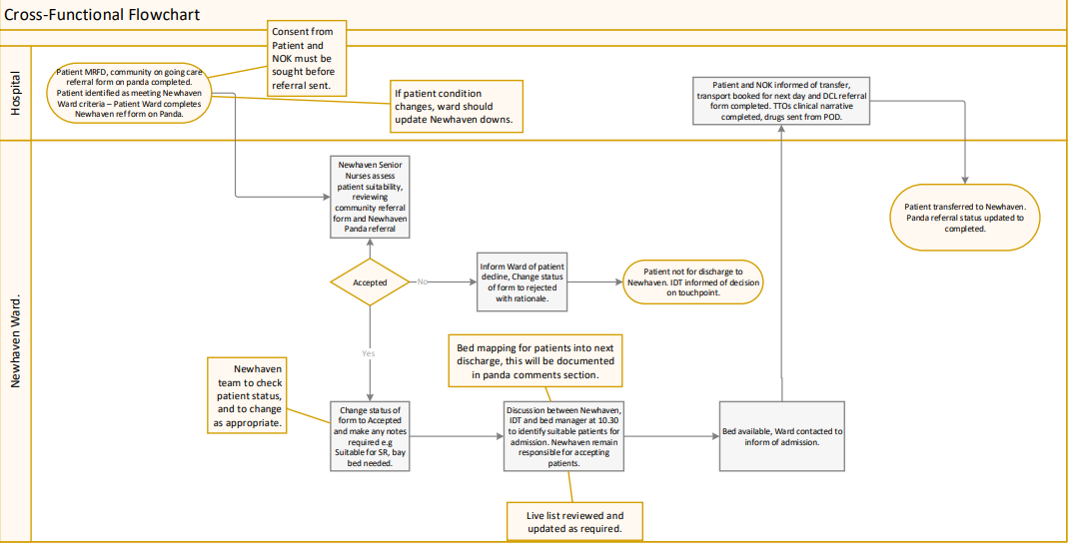
Newhaven Referral flow chart

Newhaven Community Ward
Admission Criteria
for Interim and Rehabilitation beds

Brighton and Hove or East Sussex registered GP patients can transfer to Newhaven for:

Interim beds
- Awaiting POC, nursing or residential placement: must have a clear discharge plan agreed and documented by the MDT.
- Patients requiring on-going care which can be provided outside of the acute setting: e.g. complex wound management, Hospital At Home, OPAT.

Inpatient Rehabilitation
This is therapy led: a decision will have been made that the patient needs on-going rehab to gain strength and improve mobility to enable discharge home.

Slow Stream rehabilitation: will be a therapy and IDT led decision cross site.
Stoma education: agreed with the stoma nurses.

Criteria

- Patients MUST be clinically stable and medically ready for discharge.

- Patient/NOK must have consented.

- Patients NEWS is identified as less than 3 unless it is discussed and escalated with the nurse in charge.

Exclusion criteria:

- COVID positive/exposed patients – until after isolation.

- Tracheostomy and laryngectomy patients.

- Patients requiring Non Invasive BIPAP ventilation.

- Patients requiring continuous oxygen.

- Patients who have acute delirium or requiring one to one specialling.

- Newly sited PEGs or RIGs.

- Any patient with an unstable spinal injury.

- Acute mental health, newly diagnosed patients or symptoms of acute mental illness requiring input form Psychiatric Liaison or the OPMHT Mental Health Team

- Patients defined as homeless without an agreed discharge plan in place.

- Patients who are intravenous drug users.

- Bariatric Patients

- End of Life care patients in their terminal phase.

Services available at Newhaven:
Speech and language therapist (SALT); dietician; stoma nurse; TVN; adult social care; diabetic nurse.

