PARENTERAL NUTRITION PRESCRIPTION CHART 30 kg actual bodyweight if BMI ≤ 25, and 30 kg ideal body weight if BMI > 25

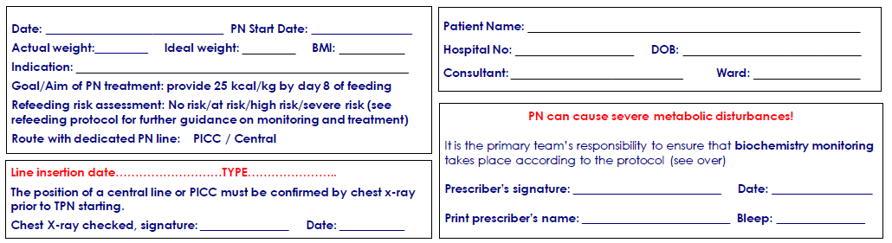

Bags should be administered sequentially e.g. Day 1, 2, 3, 4, 5. A bag should not be missed out, regardless of date.
Date and time commenced | Day of feeding | PN bag | Total volume of bag* (ml) | Volume to be given | Rate of infusion  (ml/hr) | Number of hours  infusion to run | Rest period | Na+ (mmol /24 hr) | K+ (mmol /24 hr) | Additional instructions
 | 1 | Triomel 14g | 2000 | 168 | 7 | 24 | Nil | 6 | 5 | Please note:
 | 2 | Triomel 14g | 2000 | 336 | 14 | 24 | Nil | 12 | 10 | Volume given may be less than total bag volume.
 | 3 | Triomel 14g | 2000 | 456 | 19 | 24 | Nil | 16 | 14
 | 4 | Triomel 14g | 2000 | 456 | 19 | 24 | Nil | 16 | 14 | Bags should only be hung for 24 hr. Discard any remaining PN in the the bag after 24 hr.
 | 5 | Triomel 14g | 2000 | 456 | 19 | 24 | Nil | 16 | 14
 | 6 | Triomel 14g | 2000 | 456 | 19 | 24 | Nil | 16 | 14 | PN giving sets can be clamped but AVOID disconnection. If PN is disconnected, bag must be discarded and notify Pharmacy
 | 7 | Triomel14g | 2000 | 456 | 19 | 24 | Nil | 16 | 14
 | 8 onwards | Triomel 14g | 2000 | 648 | 27 | 24 | Nil | 23 | 19
Please contact the Dietitian (Vicky 8384) if:
1) On feeding, serum phosphate drops significantly. Refeeding hypophosphatemia is defined as PO4 < 0.65 mmol/L or a drop of > 0.16 mmol/L (ensure Pabrinex is prescribed). 2) Propofol is running > 10 ml/hour.
3) Your patient no longer requires TPN.

DAY OF REGIMEN  Date | Day.…….  Date ……... | Day ….…  Date ……... | Day …….… Date …….. | Day .……  Date …... | Day …….… Date ….….. | Day.…….… Date ….….. | Day ….…… Date ….…..
DOCTOR TO PLEASE SIGN
Bloods checked and signed | Dr to sign here | Dr to sign here | Dr to sign here | Dr to sign here | Dr to sign here | Dr to sign here | Dr to sign here
Fluid balance checked (IVI stopped/decreased according to rate of PN) | Dr to sign here | Dr to sign here | Dr to sign here | Dr to sign here | Dr to sign here | Dr to sign here | Dr to sign here
NURSE TO PLEASE SIGN
PICC bundle completed and dressing in date
Blood sugars checked. (Every 6hrs including 1 hour into rest period until stable on PN, then daily. Or as per patient’s diabetic regimen)
Bag name (e.g.Triomel 14g) checked on actual PN bag and cover, and matches prescription overleaf
Batch No. and expiry date of bag
Batch No. and expiry date on label
Attach PN to dedicated purple port on PICC line
Is opaque cover on PN bag?
Nurse signature connecting PN
Nurse signature checking PN
Start Time
Finish time

For Biochemistry monitoring please request ‘TPN bloods’ on blood form: these consist of FBC (EDTA, purple topped tube), U&E + Mg + PO4 + Ca (clotted yellow topped tube).
Baseline Test | TPN profile, LFTs and C-Reactive Protein (CRP)
1St Week | Daily TPN bloods and TG + CRP twice or three times a week if appropriate
2nd Week onwards | If the patient is well and stable – TPN profile twice a week; otherwise daily bloods as clinical

