Guidelines for use of Antivirals and Neutralising Monoclonal Antibodies for treatment of non-hospitalised patients with COVID-19 within Covid19 Medines Delivery Unit (CMDU)

Version: | 1.5
Approved by: | Professor Mike Okorie
Clinical Sponsor: | Dr Stephen Pike
Date approved: | 27/06/2023
Name of author(s): | Vikesh Gudka
Name of responsible committee: | Medicnes Governance Committee UHSx and NHS Sussex Programme Board for Covid19 Treatments in Non-hospitalsied Patients
Date issued: | 27/06/2023
Review date: | At next NHSE Policy or NICE TA update
Target audience: | Covid19 Medicines Delivery Unit (CMDU) Clinical Assessors

Commissioning position

Antivirals or neutralising Monoclonal Antibodies (nMABs) are recommended to be available as a treatment option through routine commissioning for non-hospitalised adults with COVID-19 treated in accordance with the criteria set out in this document.

This policy applies to non-hospitalised patients with COVID-19 who are symptomatic and showing no evidence of clinical recovery and covers the following treatment options:

- First-line: Nirmatrelvir plus ritonavir (Paxlovid®, oral antiviral) – As per NICE TA 878¹
- Second Line: Sortorvimab* (neutralising Monoclonal Antibody – nMAB) – As per NICE TA 878¹
- Third Line: Molnupiravir# (oral antiviral) – As per Interim Clinical Commissioning Policy PR00453²

*Sotrovimab is only recommended if Nirmatrelvir plus ritonavir is contraindicated or clinically unsuitable.
#Molnupiravir is only recommended if Nirmatrelvir plus ritonavir or Sotrovimab are contraindicated or clinically unsuitable.

There will be internal and external factors regarding service demands that may require us to reorganise the treatment options temporarily. This will be assessed at the time and a decision will be made considering risks to patients and service. This will then be communicated to all stakeholders.

Combination treatment with an nMAB and an antiviral is NOT routinely recommended. Patients who have previously received treatment with an antiviral or nMAB, and who meet the eligibility criteria within this guideline, may receive treatment for a subsequent infective episode, if clinically appropriate.

Where patients are ineligible for treatment under this policy, recruitment to the PANORAMIC trial, which is building the evidence for novel oral antivirals in a broader cohort of at risk patients, should be supported.

Remdesivir is currently not considered within the scope of this guidelines or within Sussex CMDU due to logistical challenges. These challenges have been escalated to NHSE Regional teams and this decision aligns with all regional CMDUs.

Importance of medication history taking

It is of utmost importance that a patient’s current medication is considered before prescribing Nirmatrelvir plus ritonavir as many patients will be ineligible for treatment.

Ineligibility could be due to a contraindication or where strong advice to not use concomitantly
exists. In these circumstances Nirmatrelvir plus ritonavir must NOT be prescribed
together with the patient’s medication. However, if the factors impacting decisions about risk
assessment are met and the prescriber is confident of appropriate follow up, management options
can be considered e.g. temporary stopping of concomitant medication eg statins.

Further management options are available via the University of Liverpool COVID-19 Drug
Interaction checker- https://www.covid19-druginteractions.org/

Eligibility criteria

Patients must meet all of the eligibility criteria and none of the exclusion criteria. Non-hospitalised patients are eligible for treatment if:

• SARS-CoV-2 infection is confirmed by either:
o Lateral flow test (registered via gov.uk or NHS 119) OR
o Polymerase chain reaction (PCR) testing
within the last 5 days
AND
- Symptomatic³ with COVID-19 and showing no signs of clinical recovery
AND
- Onset of symptoms of COVID-19 within the last 7 days†
AND
- A member of a ‘highest’ risk group (as defined in the updated Department of Health and Social Care commissioned Independent Advisory Group Report)⁴

Children aged 12-17 years may only be considered for treatment with Sotrovimab. For paediatric/adolescent patients (aged 12-17 years inclusive), paediatric multi-disciplinary team (MDT) assessment can be used to determine clinical capacity to benefit from the treatment.

† Treatment commencement may be extended up to a maximum of 7 days from symptom onset if clinically indicated (treatment commencement beyond 5 days from symptom onset is off-label.

Exclusion criteria

- Requirement for hospitalisation for COVID-19
- Requirement for supplemental Oxygen for Covid-19
- The pattern of clinical presentation indicates that there is recovery rather than risk of deterioration from infection
- Known hypersensitivity reaction to the active substances or to any of the excipients of the medications below as listed in their respective Summary of Product Characteristics

Additional Exclusion Criteria per Treatment

Nirmatrelvir plus ritonavir
- Swallowing difficulties and difficulty with compliance to a complex dosage 5 day course of tablets
- The patient has a history of advanced decompensated liver cirrhosis or stage 4-5 chronic kidney disease
- Preganancy or possibility of being pregnant
- Less than 18 years of age
- The patient is taking any of the medications listed in Appendix 2

Sotrovimab
- Children aged under 12 years
- Adolescents (aged 12-17) weighing 40kg and under

Molnupiravir
- Less than 18 years of age
- Pregnancy or possibility of being pregnant
- Swallowing difficulties. Capsules are 22mm x 7mm, cannot be opened and four capsules need to be taken twice a day for five days

Pregnancy and women of childbearing potential

Nirmatrelvir plus ritonavir
Nirmaltrelvir plus ritonavit is not recommended during pregnancy. There are no human data on the use of Nirmatrelvir plus ritonavir during pregnancy to inform the drug-associated risk of adverse developmental outcomes, women of childbearing potential should avoid becoming pregnant during treatment with Nirmatrelvir plus ritonavir. Nirmatrelvir plus ritonavir is not recommended in women of childbearing potential not using effective contraception.

Use of ritonavir may reduce the efficacy of combined hormonal contraceptives. Patients using combined hormonal contraceptives should be advised to use an effective alternative contraceptive method or an additional barrier method of contraception during treatment and until after one complete menstrual cycle after stopping Nirmaltrelvir plus ritonavir.

Molnupiravir
There are no data from the use of molnupiravir in pregnant women. Studies in animals have shown reproductive toxicity. Molnupiravir is not recommended during pregnancy. Individuals of childbearing potential should use effective contraception for the duration of treatment and for 4 days after the last dose of molnupiravir.

Sotrovimab
There are no data from the use of sotrovimab in pregnant women. The SmPC for sotrovimab states that sotrovimab may be used during pregnancy where the expected benefit to the mother justifies the risk to the foetus.

Breastfeeding

Nirmatrelvir plus ritonavir
There are no human data on the use of Nirmatrelvir and ritonavir in breastfeeding. It is unknown whether Nirmatrelvir is excreted in human or animal milk, and the effects of it on the breast fed newborn/infant, or the effects on milk production.
Limited published data reports that ritonavir is present in human milk. There is no information on the effects of ritonavir on the breast-fed newborn/infant or the effects of the medicinal product on milk production. A risk to the newborn/infant cannot be excluded. Breast feeding should be discontinued during treatment with Paxlovid and for 7 days after the last dose of Paxlovid.

Molnupiravir
It is unknown whether Molnupiravir or any of the metabolites of Molnupiravir are present in human milk, affect human milk production, or have effect on the breastfed infant. Based on the potential for adverse reactions on the infant from Molnupiravir, breast-feeding is not recommended during treatment and for 4 days after the last dose of Molnupiravir.

Sotrovimab
There are no data on the excretion of Sotrovimab in human milk. The potential treatment benefit or risk to the newborn or infants via breastfeeding is not known.
Decisions on whether to breastfeed during treatment or to abstain from sotrovimab therapy should take into account the benefit of breast-feeding for the child and the benefit of therapy for the woman.

Dose and administration

Nirmatrelvir plus ritonavir
The recommended dose of Nirmatrelvir plus ritonavir is 300mg (two 150mg tablets) Nirmatrelvir with 100mg (one 100mg tablet) ritonavir taken together orally twice daily for 5 days.

This is illustrated pictorially as:

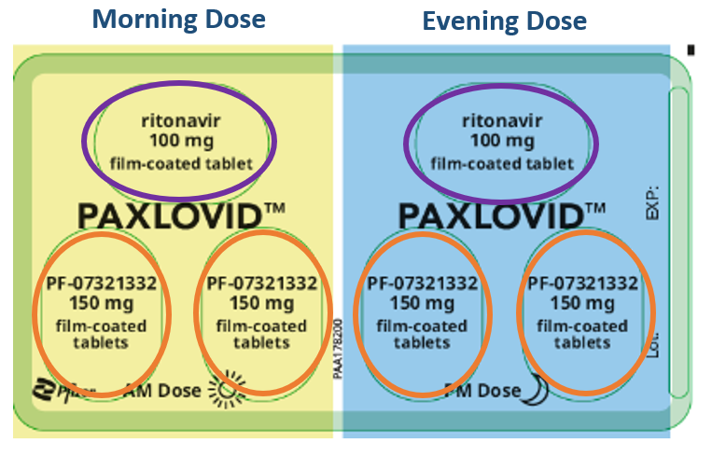

Nirmatrelvir plus ritonavir Renal Dose (eGFR/CrCl: 30-60ml/min or CKD Stage 3)
The recommended dose of Nirmatrelvir plus ritonavir is 150mg (one 150mg tablet) Nirmatrelvir with 100mg (one 100mg tablet) ritonavir taken together orally twice daily for 5 days.

This is illustrated pictorially as:

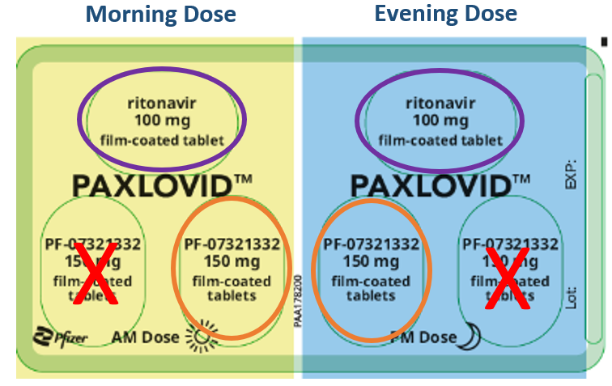

Nirmatrelvir plus ritonavir should be given as soon as possible after positive results of direct SARS-CoV-2 viral testing and within 7 days of onset of symptoms. Clinicians should assure themselves that patients are able to swallow the oral tablets.

A missed dose should be taken as soon as possible and within 8 hours of the scheduled time, and the normal dosing schedule should be resumed. If more than 8 hours has elapsed, the missed dose should not be taken and the treatment should resume according to the normal dosing schedule.

If a patient requires hospitalisation due to severe or critical COVID-19 after starting treatment with Nirmatrelvir plus ritonavir, the patient should complete the full 5-day treatment course at the discretion of his/her healthcare provider.

Sotrovimab
The recommended dose of Sotrovimab is 500mg to be administered as a single intravenous infusion. 8mls of Sotrovimab (62.5mg/ml) should be added to a 100ml pre-filled infusion bag containing 0.9% sodium chloride and administered over 30 minutes.

Preparation and administration of Sotrovimab should be initiated and monitored by a qualified healthcare provider using aseptic technique. Administration should be under conditions where management of severe hypersensitivity reactions, such as anaphylaxis, is possible. Individuals should be monitored post intravenous infusion for 1 hour.
Sotrovimab should not be infused concomitantly in the same intravenous line with other medication.

Monitoring during administration of Sotrovimab:

Serious hypersensitivity reactions including anaphylaxis have been reported with infusion of Sotrovimab. The patient should be monitored closely during infusion and for upto 15 min after the infusion for signs and symptoms of hypersensitivity, including anaphylaxis. If signs or symptoms of a clinically significant hypersensitivity reaction or anaphylaxis occur, immediately discontinue administration and initiate appropriate medications and/or supportive care.

If an IRR (Infusion-related reaction) occurs, consider interrupting, slowing or stopping the infusion (if severe) and administer appropriate medications and/or supportive care. IRRs observed with IV administration of casirivimab and imdevimab include nausea, chills, dizziness (or syncope), rash, urticaria and flushing. IRRs observed in clinical studies were mostly mild to moderate in severity and were typically observed during or within 24 hours of infusion.

Molnupiravir
The recommended dose of Molnupiravir is 800mg (four 200mg capsules) taken orally every 12 hours for 5 days. Treatment must not be extended beyond 5 days. Molnupiravir should be commenced as soon as possible after a diagnosis of COVID-19 has been made and within 7 days of symptom onset. Clinicians should assure themselves that patients are able to swallow the oral capsules.

If a patient missed a dose within 10 hours of the time it is usually taken, they should take as soon as possible and resume the normal dosing schedule. If a patient misses a dose by more than 10 hours, the patient should not take the missed dose and instead take the next dose at the regularly scheduled time. The patient should not double the dose to make up for a missed dose.

To reduce the possibility of emerging resistance, patients should be advised to complete the whole course of treatment even if their symptoms improve and/or they feel better. If a patient requires hospitalisation due to severe or critical COVID-19 after starting treatment with Molnupiravir, the patient should complete the full 5-day treatment course at the discretion of his/her healthcare provider.

Cautions
Please refer to the Summary of Product Characteristics (SmPC) for nirmatrelvir/ritonavir, sotrovimab and molnupiravir for special warnings and precautions for use.

Safety reporting
It is vital that any suspected adverse reactions (including congenital malformations and/or neurodevelopmental problems following treatment during pregnancy) are reported directly to the MHRA via the new dedicated COVID-19 Yellow Card reporting site at: https://coronavirus-yellowcard.mhra.gov.uk/ .

Reference

- Casirivimab plus imdevimab, nirmatrelvir plus ritonavir, sotrovimab and tocilizumab for treating COVID-19. NICE TA 878 - Overview | Casirivimab plus imdevimab, nirmatrelvir plus ritonavir, sotrovimab and tocilizumab for treating COVID-19 | Guidance | NICE
- Interim clinical commissioning policy: Remdesivir and molnupiravir for non-hospitalised patients with COVID-19. NHS England » Interim clinical commissioning policy: Remdesivir and molnupiravir for non-hospitalised patients with COVID-19
- COVID-19 rapid guideline: managing COVID-19. NICE Guideline [NG 191] Overview | COVID-19 rapid guideline: managing COVID-19 | Guidance | NICE
- Independent report: Higher-risk patients eligible for COVID-19 treatments: independent advisory group report. https://www.gov.uk/government/publications/higher-risk-patients-eligible-for-covid-19-treatments-independent-advisory-group-report

