Baxter blood administration set
Please note that we are currently experiencing a shortage of this product.
FSB1244 is the NHS supply chain number and the manufacturers product code is MMC9609L
Product details for FSB1244 - NHS Supply Chain Online Catalogue

If you need to transfuse without an infusion device please refer to the guidance on the pages below - ensure cannula is not placed over areas of flexion and monitor transfusion carefully.

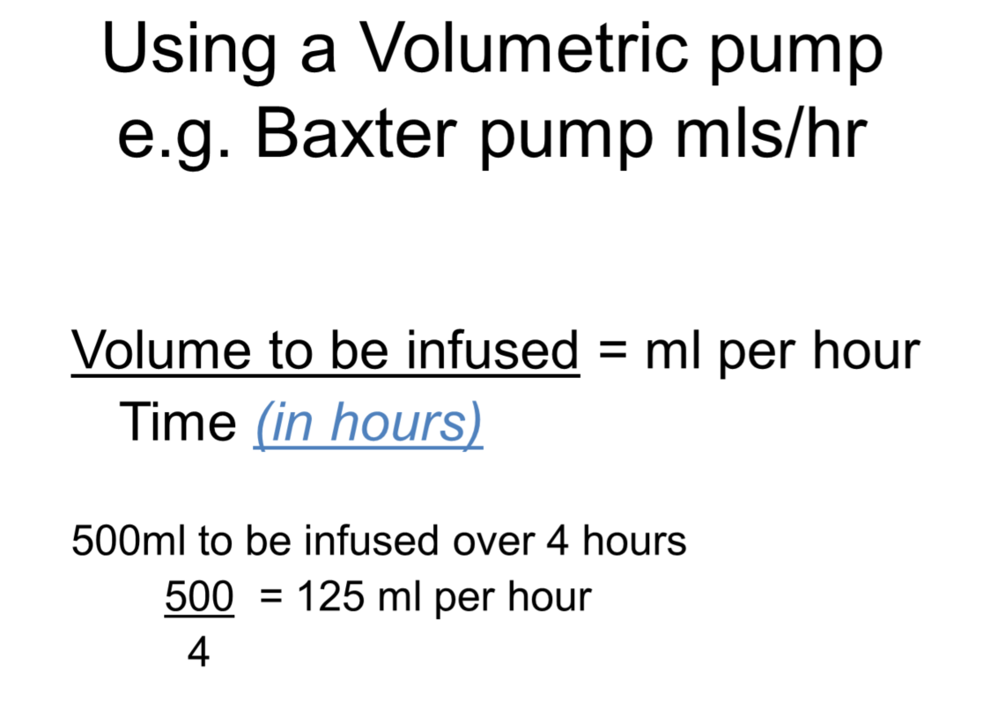
(Continued on following page…)
