EBSCO User Guide

Contents
A: Accessing EBSCO Databases and Creating a Personal Account 1
B: Searching for Terms 3
C: Searching for Subject Headings 5
D: Combining Search Terms and Subject Headings 7
E: Filtering and Saving Results 9

A: Accessing EBSCO Databases and Creating a Personal Account

1. Accessing EBSCO Databases

- Go to the Library Website: https://www.northerncarealliance.nhs.uk/research-education/library
- Select ‘Evidence Toolkit’ – Scroll down to the ‘Databases’ drop-down – Select ‘EBSCO Databases’
- At this point you will be prompted to sign in using your Athens account. You will then be taken to the EBSCO “select resources” page, select “EBSCOhost Research Databases…”

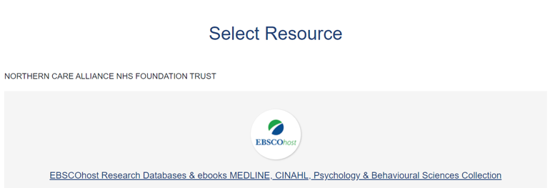

- To enable full functionality (save searches and results) and allow access to your Folder (previous searches etc.), click the Sign In link on the top bar

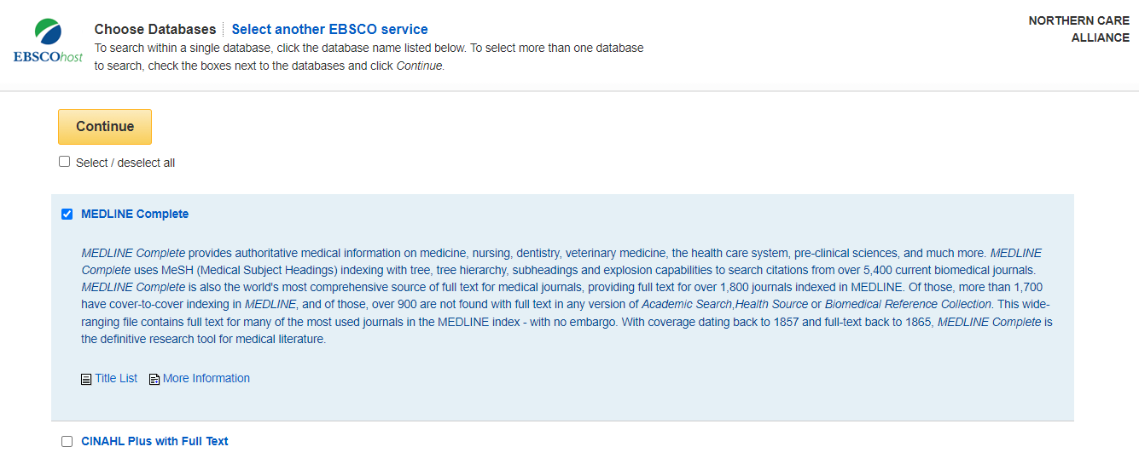
- Select the database you want to search, for instance Medline. Then click ‘continue’. We recommend searching one database at a time:

4. If you would like to change your database, from the menu above the search bar you will see the database you are currently searching, and here you can change the database by clicking on ‘Choose Databases’:

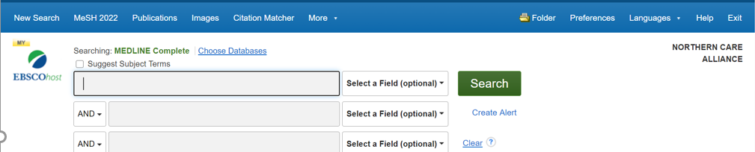

5. Once you have selected a database, you can begin searching. If the screen displayed is not shown, click the New Search button in the top left

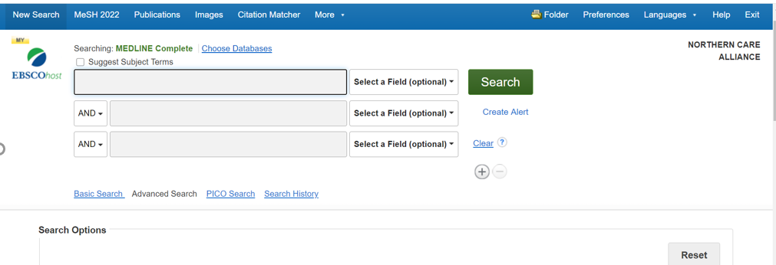

B: Searching for Terms

6. To start a search, ensure ‘Advanced Search’ is selected:

You can now start entering your search terms in the fields.

7. To select which fields you would like to search, use the drop-down menus. You can choose to search all text in an item’s record, or narrow your search down to specific fields
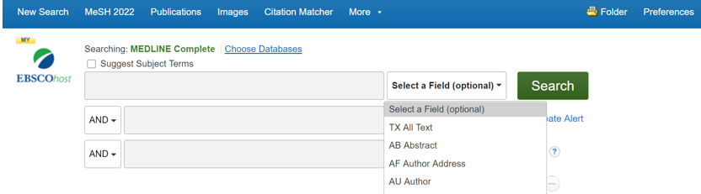

8. If you want to search more than one specific field, for example, Title and Abstract, you need to search for these on separate rows using ‘OR’. Once you’ve entered your search term, select ‘Search’:

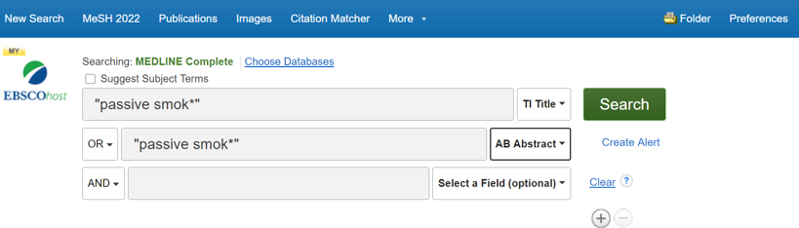

Note that EBSCO will suggest similar concepts which may be useful as you type. These can be selected by clicking on them:

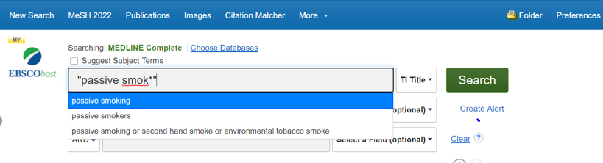

9. This will generate a results line for your search concept:

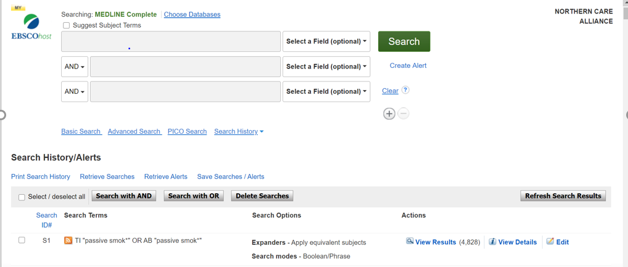

Repeat steps 7 & 8 for all keywords concepts.

C: Searching for Subject Terms (MeSH Headings)

10. To search for Subject Headings, tick ‘Suggest Subject Terms’:

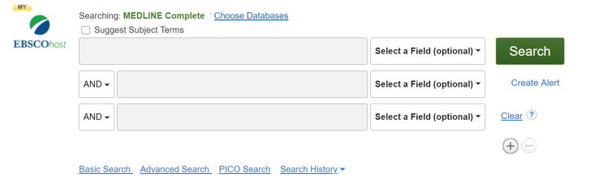

11. Type in what subject headings you want to search for and click ‘Search’:

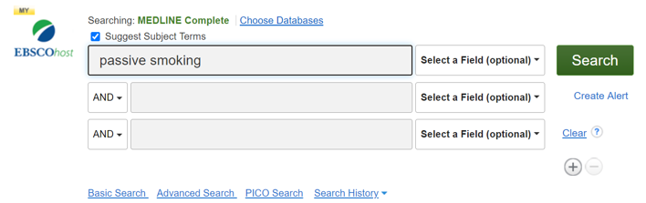

12. The Thesaurus may have exactly what you’re looking for, or offer suggestions to other subjects – have a go at searching for alternative terms too. Click on the relevant heading if there is one:

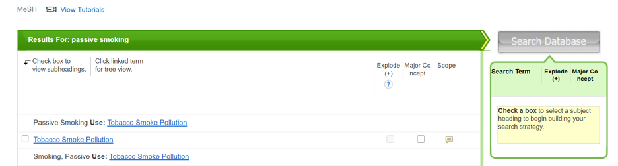

13. Tick the term(s) you want to use, and it will appear on the righthand side.

The database will also give you options to apply Explode or Major concept to the term selected, or to apply subheadings to the term; these options can widen or narrow the search.

To find out more about each term, click on the Scope icon:

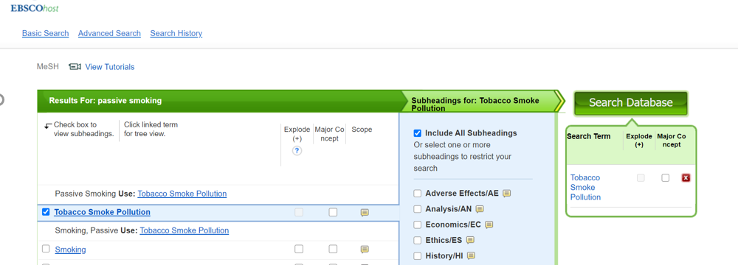

14. Click ‘Search Database’ to search for the subject heading:

Repeat steps 10-14 for all subject headings.

D: Combining Search Terms and Subject Headings

15. Combine your search terms and subject headings by selecting the line numbers you want to combine Then click ‘Search with OR’:

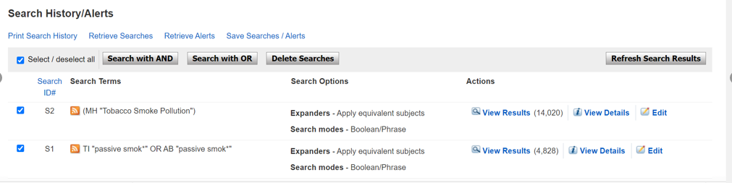

Repeat steps 6 - 15 to search for the rest of your concepts.

16. In the below example, line S3 combines the results for one concept (passive smoking) and line S6 for the second concept (cancer). Once you have searched all your concepts, combine them using “Search with AND”:

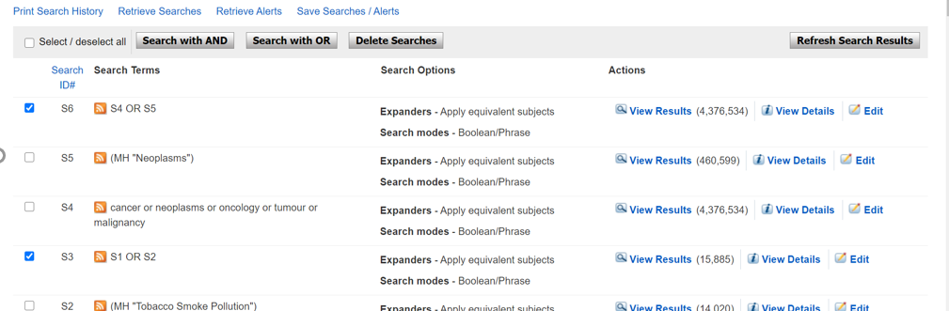

E: Filtering and Saving Results

17. To filter or limit your results you will need to click view results:

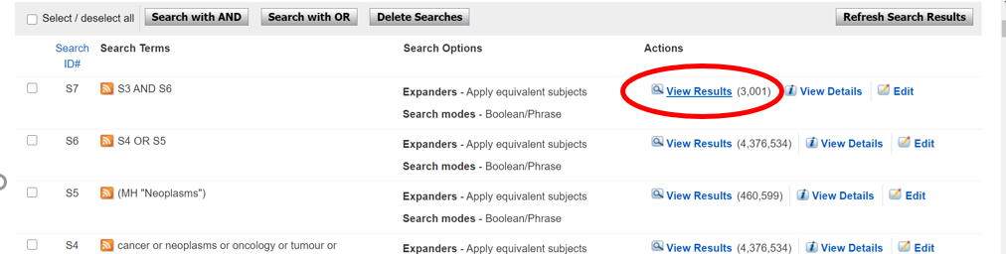

18. On the results page, you can filter down or limit your results by publication date, language, gender etc. on the left-hand side options bar:

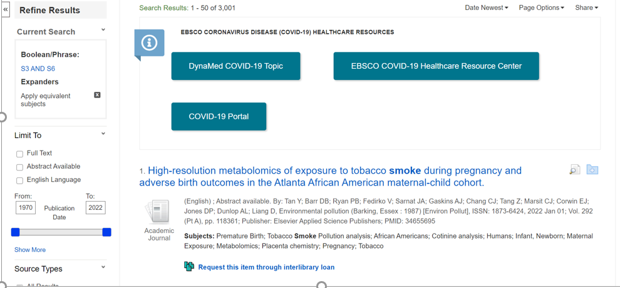

19. You can save individual results by clicking the folder icon. The database will display folders to which you can save the result; My Folder is the default option. Click this link and the item(s) selected will be saved:

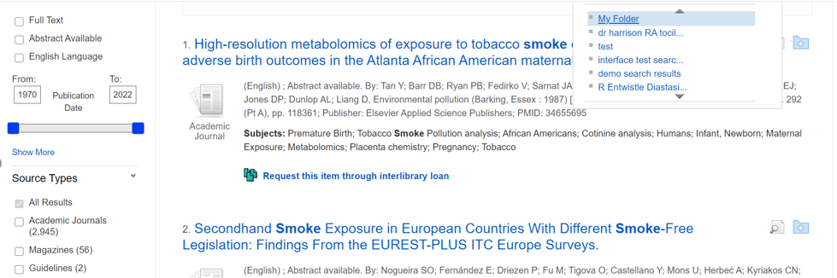

Should you wish to keep the results long term or do multiple search queries we would suggest that you set up individual folders.

20. To export results, click on Folder:

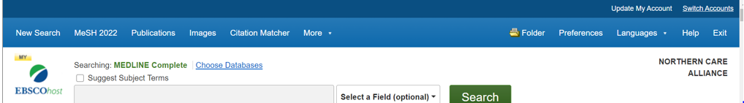

21. Select the results you would like to export and click on the output format / action

From here you can print or save your results as a file, send them via email, export to reference management software:

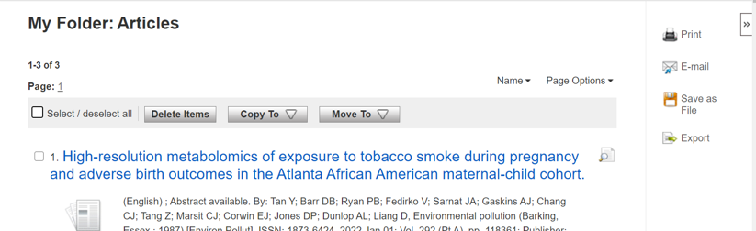

22. As well as saving the results, we highly recommend saving your search. To view your search, head back to your Recent Search by clicking the ‘Back’ option:

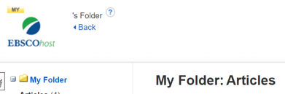

23. Select the search lines and click ‘Save Searches / Alerts’:

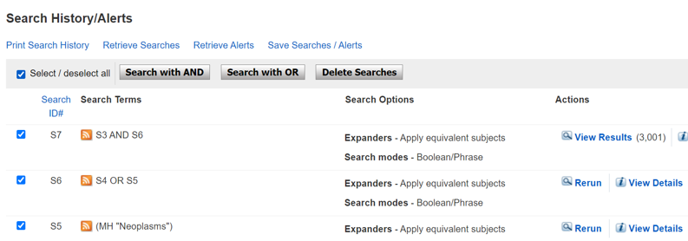

24. Give your search strategy a name and add a description if you wish.
Click ‘Save’:

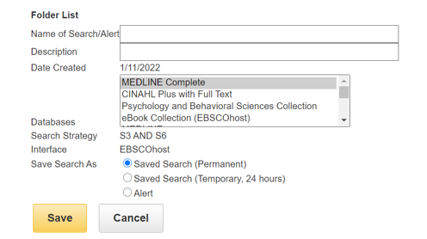

25. You can access your saved searches and saved results from your Folder:

Select your articles of saved searches from the bar on the left:

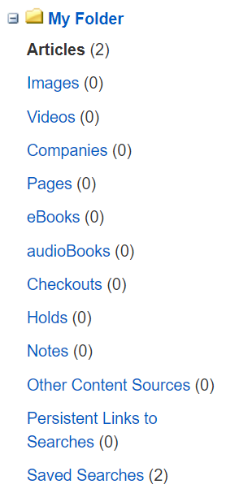

More questions? Book onto a training session with one of our experts:

https://www.northerncarealliance.nhs.uk/research-education/library

evidence@nca.nhs.uk

