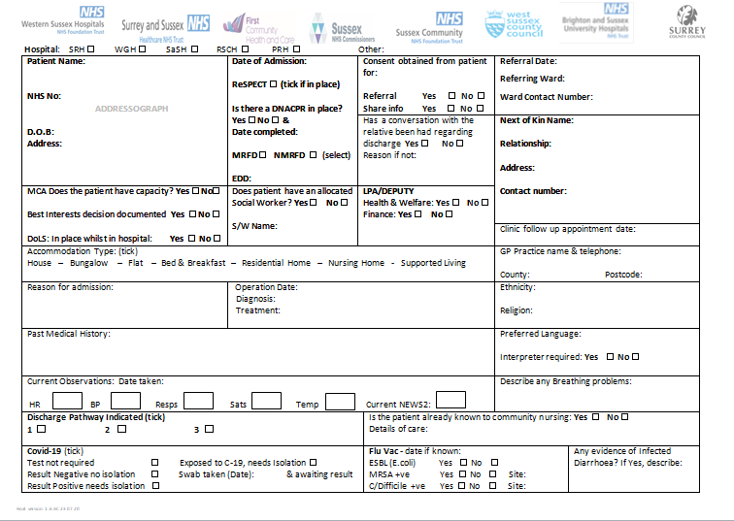

* Tick the hospital you are based at.
* Add patients details
* Ensure you fill in your ward details.
* Fill in NoK details
* Tick the accommodation type
* GP details
* Reason for admission, with treatments whilst in hospital.
* Latest observations taken prior to sending referral.
* Infection details; please ensure all areas are filled in.

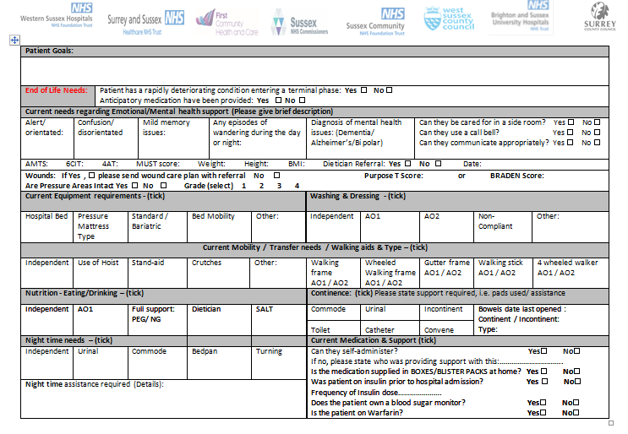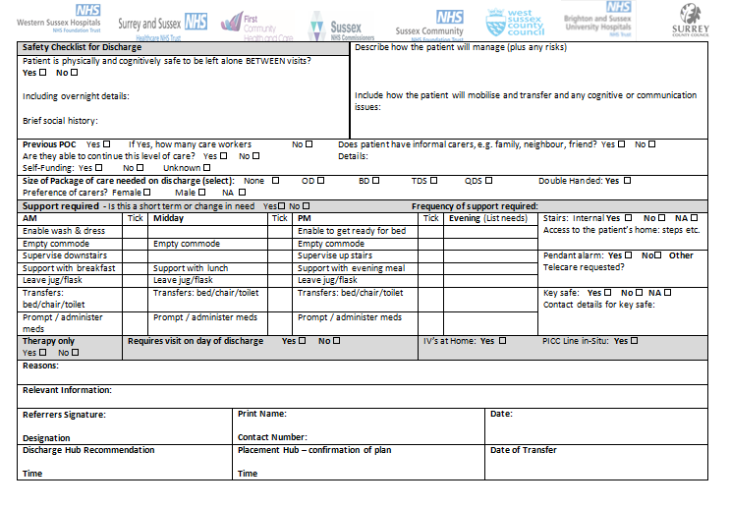

* Ensure that the physio or OT goals are written here, or sent with the referral.
* Tick appropriate box, is the patient suitable for a side room?
* If there are wound please ensure wound care plan is sent.
* Waterlow score
* What is the patient currently requiring?
* How is the patient mobilising and transferring?
* Do they require any nutritional support?
* Continence – does the patient need pads, or toilet assistance?
* Does the patient require support at night?
* If possible please send TTO with referral.
* Safety net for if the patient is going home (P1)
* Any other support at home?
* What package of care are you requesting? Does it require two people?
* Tick change in need if the patient had a previous POC.

* What will be required at each call?
* If there is a key safe – give details of who can give number.
* Tick here if referral is for physio at home only
* Any information you feel is important and not covered elsewhere on form.
* Referrers Signature
* For IDT use.