|  |  |  |  |  |  |  |  |  |  |  |  |
| --- | --- | --- | --- | --- | --- | --- | --- | --- | --- | --- | --- |
| [Admission Date________](http://nww.bsuh.nhs.uk/)  **Maternity Patients only** | *Affix patient label or enter details:*  Trust ID No or NHS number   |  |  |  |  |  |  |  |  |  |  | | --- | --- | --- | --- | --- | --- | --- | --- | --- | --- | |  |  |  |  |  |  |  |  |  |  | |
| Surname (BLOCK LETTERS):  First name:  D.O.B.: |

**Administration of Ferrous Carboxymaltose (Ferinject®) IV Infusion to Pregnant Patients**

CPR equipment must available when administering as allergic or anaphylactic reactions and hypotensive episodes may occur (prescribe adrenaline, hydrocortisone and chlopheniramine in case needed – see below).

After infusion extend and elevate patient’s arm and apply pressure for at least 5 minutes to avoid leakage which can lead to inflammation, necrosis or sterile abscesses and discolouration of skin.

Hb g/dl Ferritin ug/l Booking weight (kg)

**Determination of the iron need**

|  |  |  |  |  |
| --- | --- | --- | --- | --- |
| **Hb** | | **Patient body weight** | | |
| **g/dL** | **mmol/L** | **below 35 kg** | **35 kg to <70 kg** | **70 kg and above** |
| <10 | <6.2 | 500 mg | **1,500 mg**  (Split into two doses of 1000mg and 500mg administered one week apart) | **2,000 mg**  (Split into two doses of 1000mg and 1000mg administered one week apart) |
| 10 to <14 | 6.2 to <8.7 | 500 mg | 1,000 mg | **1,500 mg**  (Split into two doses of 1000mg and 500mg administered one week apart) |
| ≥14 | ≥8.7 | 500 mg | 500 mg | 500 mg |

**The maximum recommended cumulative dose of Ferinject ® is 1,000 mg of iron per week**

|  |  |  |  |  |  |  |  |  |  |  |  |  |  |  |
| --- | --- | --- | --- | --- | --- | --- | --- | --- | --- | --- | --- | --- | --- | --- |
| Drug | Dose | Date of admin | | Admin | Prescriber Signature | | Prescriber Name | | Time/ date  Given | | Given By | Pharmacy clinical screen | | Supply made pharmacy |
| **Week 1**  Ferric  Carboxymaltose | dose *  ……. |  | | over 15 minutes |  | |  | |  | |  |  | |  |
| **Week 2 (if needed)**  Ferric  Carboxymaltose | dose *  ……. |  | |  | |  | |  | |  |  | |  |
| **\*Add to 250ml of sodium chloride 0.9% w/v and administer over 15mins via a volumetric pump.** | | | | | | | | | | | | | | |
|  | | | | | | | | | | | | | | |
| **As required medication for management of allergic/anaphylactic reactions.** | | | | | | | | | | | | | | |
| Drug | Dose | | Administration | | | Prescriber signature | | Prescriber Name | | Time Given | | | Given By | |
| Adrenaline  1 in 1000 (1mg in 1ml) | 500 micrograms | | IM injection  (max 2 doses 5 minutes apart) | | |  | |  | |  | | |  | |
| Hydrocortisone IV | 100mg | | IV injection | | |  | |  | |  | | |  | |
| Chlorphenamine IV | 10mg | | IV injection | | |  | |  | |  | | |  | |

FULL PRESCRIBING DETAILS CAN BE FOUND AT [www.medicines.org.uk/emc](http://www.medicines.org.uk/emc) **PTO**

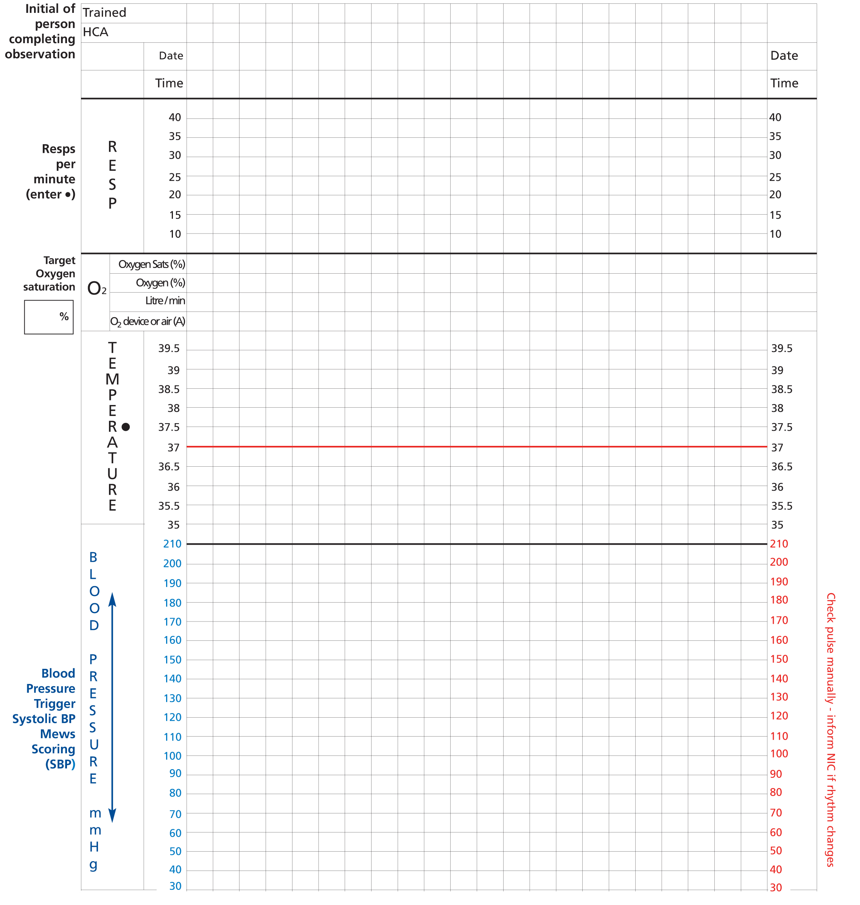

Record observations prior and post infusion, more if clinically indicated

**DISCHARGE CHECK LIST**

|  |  |  |  |
| --- | --- | --- | --- |
|  | **YES** | **NO** | **N/A** |
| Cannula removed |  |  |  |
| Stable for 30 minutes following infusion |  |  |  |
| Blood form given to the patient for FBC, ferritin and iron studies to be checked at 3 months |  |  |  |

SIGN_______________________