If operation is in the morning
- Do not eat any food after 2am or as advised.
- Drink water up to 6 am then nil orally or as advised.

If operation is in the afternoon
- Eat breakfast before 7.30 am and take no food after this time or as advised.
- Drink water up to 11.30 am or as advised.
- Monitor blood glucose levels on admission and peri-operatively.
- Check that there is HbA1c value within the last two months.
Appropriate use of IV insulin infusion (VRIII) (to achieve and maintain normoglycaemia):
- Patient anticipated to have a long starvation period (more than 1 missed meal).
- Decompensated diabetes (HbA1c>69mmols/mol).
- Patients on lifestyle alone or on Metformin, should ONLY start a VRIII if the CBG are >12mmols/L on 2 consecutive occasions.

Implement the WHO surgical safety checklist bundle.

For advice on peri-operative management of oral diabetes medication, non-insulin injectables and insulin: See tables below.
For patients treated with VRIII:
- Subcutaneous Long/Intermediate acting insulin should be continued and reduced by 20% while on VRIII.
- CBG monitoring at least hourly:
Target range 6-10 mmols/L (6-12 mmol/l acceptable).
- Refer to insulin prescription chart for hypo management.
- Continue VRIII until patient eating and drinking reliably.

Usual diabetes therapy can be restarted once the patient is eating and drinking normally.
Restarting oral diabetes medication:
- Withhold sulfonylureas (Gliclazide, Glibenclamide, Glipizide) if food intake is reduced or the patient is experiencing nausea or vomiting.
Restarting subcutaneous insulin (patients already established on insulin):
- The transition from IV insulin to SC insulin should take place when the next mealtime insulin dose is due (discontinue VRIII 30 minutes after meal-time SC insulin is given).
- If the basal insulin was stopped in error, give basal insulin as soon as possible and continue the infusion for a further 4 hours.

POST OPERATIVE CARE
THEATRE AND RECOVERY
ON ADMISSION
PRIOR TO ADMISSION
DIABETES ELECTIVE SURGERY PLAN: ADULTS
Adapted from the Joint British Diabetes Society (JBDS) 2016 Guidelines

Key Points:
- Patient should be transferred from ward to operating theatre and recovery on VRIII alongside IV fluids and must NOT be discontinued until patient is returned to ward. Please note both the Alaris and volumetric pump must be attached to a bed mounted IV pole during transfer.
- Ensure blood glucose levels are checked 15minutes prior to transfer.
- Suggested Fluid: 0.18%NaCl/0.4% Glucose with 20mmol/L KCl OR 40mmol/L KCl if potassium is less than 3.5mmol/L.

Post-operative hyperglycaemia T1 & T2 Diabetes (>12mmols/L):
- Check for urine ketones if blood glucose levels >14mmols/L on 2 consecutive occasions.
- Ensure PRN insulin is prescribed (for short term use). May need review of usual diabetes treatments.

DISCHARGE PLAN
Advice for patients with diabetes who are discharged following a surgical procedure:
- Monitor more frequently following surgery until blood glucose levels are within a normal range.
- If blood glucose levels remain >12mmols/L advise the patient to seek advice from the Health Care Professional who helps to manage the patients’ diabetes e.g. GP, Practice Nurse, Specialist Diabetes Team.

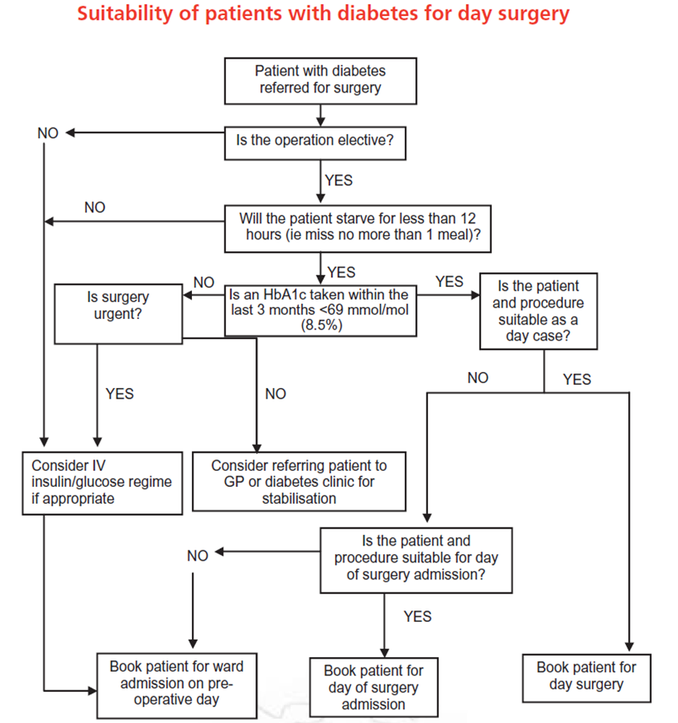

GUIDELINES FOR ADJUSTMENT OF NON-INSULIN MEDICATION FOR SURGERY
Medications | Day before going into hospital | Day of Surgery / Whilst on VRIII
 |  | If the surgery is in the morning | If the surgery is in the afternoon | If a VRIII is being used
Metformin (Glucophage MR)  With or without contrast media. If you are due to have contrast media the metformin should be stopped 48 hrs prior to the procedure and not taken for at least 48 hrs after procedure (your doctor should inform you in advance). | Take as normal | Omit morning dose. Restart when eating and drinking normally | Omit morning and lunchtime dose. Restart when eating and drinking normally | Stop once VRIII commenced, do not recommence until eating and drinking normally
Sulphonylureas  Glibenclamide, glipizide, gliclazide/ gliclazide MR, glimepiride, gliquidone) | Take as normal | Omit and recommence once eating and drinking | Omit and recommence once eating and drinking | Stop once VRIII commenced, do not recommence until eating and drinking normally
DPP-IV inhibitors Sitagliptin Saxagliptin Vildagliptin Linagliptin  Alogliptin | Take as normal | Take as normal | Take as normal | Stop once VRIII commenced, do not recommence until eating and drinking normally
SGLT-2 Inhibitors  Dapagliflozin  Canagliflozin  Empagliflozin | Take as normal | Omit and recommence once eating and drinking | Omit and recommence once eating and drinking | Omit on day of surgery
Injectable GLP analogue  Exenatide, Liraglutide, Lixisenatide, Dulaglutide | Take as normal | Take as normal | Take as normal | Omit and recommence once eating and drinking
Thiazolidinedione  (Pioglitazone) | Take as normal | Take as normal | Take as normal | Stop once VRIII commenced, do not recommence until eating and drinking normally
Acarbose  And  Meglitinide  (repaglinide or nateglinide) | Take as normal | Omit morning dose if patient told to fast from midnight | Take the morning dose if eating breakfast. Do not take the lunchtime dose | Stop once VRIII commenced, do not recommence until eating and drinking normally
Patient to restart normal tablets the morning after surgery. However, explain the blood glucose readings may be higher than usual for a day or so.

GUIDELINES FOR ADJUSTMENT OF INSULIN TREATMENTS FOR SURGERY
Insulins | Day before going into hospital | Day of Surgery / Whilst on VRIII
 |  | If the surgery is in the morning |  | If the surgery is in the afternoon | If a VRIII is being used
(LONG/IINTERMEDIATE ACTING)  Once daily (evening)  Lantus  Toujeo  Abasaglar  Levemir  Tresiba  Insulatard  Humulin I | Reduce dose by 20% | No dose adjustment necessary |  | No dose adjustment necessary | Reduce dose by 20%
 |  |  | Resume normal insulin post-surgery (providing VRIII has been discontinued).
(LONG/INTERMEDIATE ACTING)  Once daily (morning)  Lantus  Toujeo  Abasaglar  Levemir  Tresiba  Insulatard  Humulin I  Insuman basal | Reduce dose by 20% | Reduce dose by 20%  Check blood glucose level on admission |  | Reduce dose by 20%  Check blood glucose level on admission | Reduce dose by 20%
(PRE-MIXED INSULIN)  TWICE DAILY  Novomix 30  Humulin M3  Humalog Mix 25  Humulog Mix 50  Insuman Comb 50  Insuman Comb 25 | No dose change | Halve the usual am dose.  Check blood glucose on admission. Resume normal insulin with evening meal. |  | Halve the usual am dose.  Check blood glucose on admission. Resume normal insulin with evening meal. | Stop until eating and drinking normally
(RAPID/SHORT ACTING)  With meals  Novorapid  Fiasp  Humalog  Apidra  Actrapid | No dose change | Do not take morning dose of insulin if no breakfast is eaten.  Check blood glucose level on admission.  Resume normal insulin with evening meal. |  | Take usual morning insulin dose with breakfast.  Do not take lunchtime dose. Blood glucose readings should be taken on admission. Resume normal insulin with evening meal. | Stop until eating and drinking normally
STOPPING INTRAVENOUS INSULIN
- Must be eating and drinking
- Resume usual diabetic regimen at usual time and stop intravenous insulin 30 minutes later
RECORD time intravenous insulin stopped on Insulin Pump Infusion Chart
- See more detailed information on diabetes intranet site

