**South East Region:**

Guide to Covid-19 Testing

Edition 4

28 July 2020

Updates since previous edition all shown in blue text.

**Contents**

**Introduction – Regional strategy** 4

**Introduction – National strategy** 5

**NHS Testing Strategy** 7

**Different Covid-19 tests** 8

**Testing pathway – for PCR antigen testing - Do I have Covid-19?** 9

**Patient PCR testing (pillar 1)** 10

**Staff PCR testing (pillar 1) – asymptomatic staff** 12

**General Population PCR Testing – Self Referral (pillar 2)** 13

**Eligible Population PCR Testing – Employer Referral (pillar 2)** 14

**Care Home PCR Testing – (pillar 1 and 2)** 15

**Care Home PCR Testing – Residents testing on discharge from hospital (pillar 1)** 16

**Care Home PCR Testing – Staff & Residents: Covid-19 suspected or diagnosed (pillar 1 & 2)** 17

**Care Home PCR Testing – Pathway: Covid-19 suspected or diagnosed (pillar 1)** 18

**Care Home PCR Testing – Staff and Residents: When requested (pillar 2)** 19

**Care Home PCR Testing – Staff & Residents: Regular Testing** 21

**Mobile Testing - Pillar 2** 25

**GP PCR Testing – Home Testing kit pilot (pillar 2)** 26

**PCR Testing complaint process (pillar 2)** 28

**Antibody Testing (pillar 3) – Have I had Covid-19?** 29

**Patient Antibody testing (pillar 3 – NHS labs)** 30

**NHS Staff Antibody testing (pillar 3 – NHS labs)** 31

**Care Home Antibody Testing (pillar 3)** 32

37

**Capital regime to support increased testing capacity** 38

**Reporting** 40

**Outstanding Queries** 41

**APPENDIX 1: Pathology Networks** 43

**APPENDIX 2: Points of contact: Email addresses** 44

**APPENDIX 3: SE meetings to support testing** 45

**APPENDIX 4: Glossary and Definitions** 46

**APPENDIX 5: Coronavirus Testing Call Centre** 50

# **Introduction – Regional strategy**

1. The government has made public commitments as to who is eligible for testing. Our regional responsibility is to use the resources we control to support that access, to communicate and give clarity on the operating model and in particular how eligible individuals access testing, to monitor and collect information about unmet demand for testing and finally to analyse the results of the testing including coverage achieved and testing results so that local patterns can be deduced and areas for further investigation be identified.
2. This document aims to give clarity on the current approach to Covid-19 Testing in the region. It covers who is being tested, arrangements, responsibilities, purpose and resulting actions.
3. It also references areas on which we are seeking clarity or where we could consider a SE approach. Areas for clarification are noted in the queries section, at the end of the main document.
4. Feedback is welcomed where there are omissions or insufficient clarity. Please send them to [england.sepathologycovidresponse@nhs.net](mailto:england.sepathologycovidresponse@nhs.net).
5. This document will be updated as and when new decisions are made or new testing arrangements put in place.
6. The future direction of testing nationally and regionally is outlined along with areas we will be taking forward as part of the next edition of the strategy.
7. The draft communications/meetings schedule in the SE is included at the end of the pack to give clarity on how and where to feed in issues, suggestions and questions

# **Introduction – National strategy**

**National Testing Strategy**.

1. The national strategy states:
   1. ‘*Testing is a key pillar of our strategy to protect the NHS and save lives. We are focused on two types of tests: 'swab tests' for people with symptoms to see if they have coronavirus; and 'antibody tests', which test for the presence of antibodies that will demonstrate whether you have had the disease.*
   2. *The Government is committed to mass testing: our overall ambition is to provide enough swab tests for everyone that needs one. In the 'contain' stage, our focus was on testing to support contact tracing and investigating outbreaks. At present, whilst we seek to 'delay' the spread of the virus through social distancing, this means:*
      1. *continuing to provide tests for patients who need them; and*
      2. *providing tests for NHS, social care and then wider critical key workers and their families who are in self or household isolation, to support them to return to work as soon as possible, if they are well enough to do so*.’
2. There are 5 pillars to the National Testing strategy (see next diagram below).
   1. The main method of testing available to the NHS at this time is detection of viral genetic material (RNA) by a method called RT-PCR (‘PCR tests’) (for fuller explanation see appendix). The Prime Minister stated on 06 May 2020 a target of 200,000 by the end of May 2020 and the strategy states ‘And we will continue to scale up our ambition beyond this to 250,000 tests a day from all five pillars.’
   2. The exact allocation from each pillar is unclear however the NHS has committed to delivering 25,000 through the Pillar 1 NHS labs. Antibody testing will be a significant element of the 250,000 test target.
   3. As at 24 July 2020, we currently have South East Pathology Network platform capacity, through NHS labs (pillar 1) of 17,000 PCR tests per day, and through DHSC led sites (Pillar 2) of a further 17,000 PCR tests per day (based on capacity for swabbing in pillar 2 in SE, excluding home tests). The South East networks have been asked to provide information on how they could increase their networks to 3,000 PCR tests per day, currently only one of the five networks does not have theoretical capacity of 3,000 or more tests per day.
   4. As at 24 July 2020, all networks are now providing antibody testing, with a total technical SE platform capacity of circa 27,000 serology tests per day, however work is ongoing to review and increase the actual capacity, as other constraints such as phlebotomist capacity remain.

# **NHS Testing Strategy**

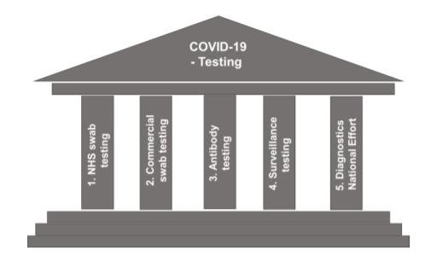

National Testing Strategy; Coronavirus (Covid-19) Scaling up our testing programmes dated 04 April 2020; <https://assets.publishing.service.gov.uk/government/uploads/system/uploads/attachment_data/file/878121/coronavirus-covid-19-testing-strategy.pdf>

# **Different Covid-19 tests**

# 

# **Testing pathway** **– for PCR antigen testing - Do I have Covid-19?**

# 

# **Patient PCR testing (pillar 1)**

|  |  |  |
| --- | --- | --- |
| **Purpose:**  The reason for patient testing is to determine whether they currently have the Covid-19 virus. It will then allow clinicians to determine the appropriate hot or cold patient care pathway. Rapid PCR methods such as POC should be used to support this cohort especially where a quick diagnosis has a significant impact on patient care. |  | **Eligibility**:  Per the latest letter on guidance (see below for link), testing programme includes:   1. all patients at emergency admission, whether or not they have symptoms; 2. those with symptoms of COVID-19 after admission; 3. for those who test negative upon admission, a further single re-test should be conducted between 5-7 days after admission; 4. test all patients on discharge to other care settings, including to care homes or hospices (see later page on “Care Home PCR Testing – Residents testing on discharge from hospital”); 5. elective patient testing prior to admission. |
|  |  |  |
| **Pillar:** Pillar 1  **Pillar Owner**: Owner is the National NHSE&I Pathology Team. Owner of testing lab is NHS. |  | **Process for items 1, 2, 3 and 5 above:**   * Patients will be swabbed by the admitting NHS Trust. * Requests for testing will be initiated on OrderComms and samples sent to pathology reception. * Samples will be processed by the local NHS Pathology Network laboratory. * Turnaround times should not be any more than 24 hours. * Lab results are then processed through the LIMS and connected to the EPR and then to the GP. |

<https://www.england.nhs.uk/coronavirus/wp-content/uploads/sites/52/2020/06/Healthcare-associated-COVID-19-infections--further-action-24-June-2020.pdf>

**Staff PCR testing (pillar 1) – symptomatic staff**

|  |  |  |
| --- | --- | --- |
| **Purpose:** The reason for staff testing is to determine whether they currently have the Covid-19 virus and thus allow staff back to work if negative. |  | **Eligibility:** All symptomatic NHS staff and their household members within NHS England guidance: <https://www.gov.uk/guidance/coronavirus-covid-19-getting-tested#who-can-be-tested> |
|  |  |  |
| **Pillar:** Pillar 1  **Pillar Owner**: Owner is the National NHSE&I Pathology Team. Owner of testing lab is NHS. |  | **Process:**   * NHS Trusts have established staff testing facilities where samples are taken. * Requests for testing in the NHS will be initiated on OrderComms and samples sent to pathology reception. * Samples will be processed by the local NHS Pathology Network laboratory. * Turnaround times should not be any more than 24 hours. * Lab results are then processed through the LIMS and connected to the EPR. Staff will be notified of their results by the requesting physician.   To note:   * Staff testing only occurs in NHS labs where there is spare capacity. * NHS staff can alternatively, and are encouraged to, make use of the self-referral portal so that they can also take household members who live with them through the drive through swabbing chain (see General Population PCR testing – Self referral (pillar 2)). * Household members go through self-referral portal pillar 2. |

# **Staff PCR testing (pillar 1) – asymptomatic staff**

|  |  |  |
| --- | --- | --- |
| **Purpose:** The reason for staff testing is to determine whether they currently have the Covid-19 virus and thus allow staff back to work if negative. |  | **Eligibility:**  Surplus NHS testing capacity should also be used for testing non-symptomatic staff working in situations where there is an untoward incident, or outbreak, or high prevalence (these terms are all explained in APPENDIX 4: Glossary and Definitions).  See link to full guidance letter at the bottom of the page. |
|  |  |  |
| **Pillar:** Pillar 1  **Pillar Owner**: Owner is the National NHSE&I Pathology Team. Owner of testing lab is NHS. |  | **Process:**   * NHS Trusts have established staff testing facilities where samples are taken. * Requests for testing in the NHS will be initiated on OrderComms and samples sent to pathology reception. * Samples will be processed by the local NHS Pathology Network laboratory. * Turnaround times should not be any more than 24 hours. * Lab results are then processed through the LIMS and connected to the EPR. Staff will be notified of their results by the requesting physician.   To note:   * Staff testing only occurs in NHS labs where there is spare capacity. * NHS staff can alternatively, and are encouraged to, make use of the self-referral portal so that they can also take household members who live with them through the drive through swabbing chain (see General Population PCR testing – Self referral (pillar 2)). * Household members go through self-referral portal pillar 2. |

<https://www.england.nhs.uk/coronavirus/wp-content/uploads/sites/52/2020/06/Healthcare-associated-COVID-19-infections--further-action-24-June-2020.pdf>

# **General Population PCR Testing – Self Referral (pillar 2)**

|  |  |  |
| --- | --- | --- |
| **Purpose:** Testing the population who have coronavirus-like symptoms to see if they currently have the virus, and our aim is that anyone who needs such a test is able to have one. |  | **Eligibility:**  • The self-referral portal is a secure portal that allows all symptomatic people to register their details and book a coronavirus test. |
|  |  |  |
| **Pillar:** Pillar 2  **Pillar Owner**: Owner is the National DHSC Testing Lead. |  | **Process:**   * All symptomatic population can request a drive through, mobile unit or postal swab (you need an email address for the postal swab option). * This can be done through the self-referral portal (for guide see below) or by phoning ‘119’ between 7am and 11pm. For those with hearing or speech difficulties please use 18001 0300 303 2713. * The symptomatic person will be requested to attend a Regional Testing Centre, Satellite Testing Centre, Mobile Unit location or wait for the post depending on the option selected. Not all sites can test under 12s but this is highlighted during booking. * Samples are collected at the centres or home collected. Samples at the centres are then dispatched to the National ‘Lighthouse’ labs or the individual posts them. Samples are processed through the National ‘Lighthouse’ labs in Milton Keynes, Manchester and Glasgow. * Results are communicated by email or text. * Essential workers are requested to inform their employers of their results. * Results are now linked to patient records. NHS Digital has developed a Pillar 2 Testing Dashboard to provide anonymous counts of Covid-19 tests completed and positive results. |

User guide can be found here: <https://assets.publishing.service.gov.uk/government/uploads/system/uploads/attachment_data/file/882654/Self_referral_portal_user_guide_v1.6.pdf>

# **Eligible Population PCR Testing – Employer Referral (pillar 2)**

|  |  |  |
| --- | --- | --- |
| **Purpose:** Testing essential workers who have coronavirus-like symptoms to see if they currently have the virus has been a priority, and our aim is that anyone who needs such a test is able to have one. |  | **Eligibility:** The employer referral portal is a secure portal that allows employers to refer eligible essential workers. Eligible people include (full list see glossary):  • All essential workers including NHS and care workers with symptoms  • Anyone over 65 with symptoms  • Anyone with symptoms whose work cannot be done from home  • Anyone with symptoms of coronavirus who lives with those identified above  • Care workers and residents in care homes (with or without symptoms)  • NHS workers and patients without symptoms where there is a clinical need in line with NHS England guidance (as noted in previous section – guidance not yet received) |
|  |  |  |
| **Pillar:** Pillar 2  **Pillar Owner**: Owner is the National DHSC Testing Lead. |  | **Process:**   * For most employees, only symptomatic people in the household can be tested. If the employee works in social care, however, the employee can be tested whether symptomatic or asymptomatic. * It is a secure portal for employers to use to upload the full list of names and contact details of self-isolating essential workers. * If referred through this portal, essential workers will receive a text message with a unique invitation code to book a test for themselves (if symptomatic) or their symptomatic household member(s) at a regional testing site. * Results are then added to the patient’s record. * Per Government guidelines to employees, while employees do not have to share results with their employer, “we strongly recommend that you inform your employer”: <https://www.gov.uk/government/publications/coronavirus-covid-19-testing-privacy-information/testing-for-coronavirus-privacy-information> |

Employer guide can be found here: [https://www.gov.uk/guidance/coronavirus-covid-19-getting-tested#arrange-a-test](https://www.gov.uk/guidance/coronavirus-covid-19-getting-tested)

# **Care Home PCR Testing – (pillar 1 and 2)**

1. There are four times when we undertake care home testing:
   1. On discharge from Hospital
   2. When Covid-19 is suspected
   3. When care home staff and care home residents ask for testing of whole home or individuals (which can be at any time)
   4. Regular testing of staff and residents of care homes with residents over 65 or those with dementia

DHSC has also provided a helpful visual guide to adult social care testing (right). <https://assets.publishing.service.gov.uk/government/uploads/system/uploads/attachment_data/file/884284/Adult_social_care_COVID-19_testing.pdf>

# **Care Home PCR Testing – Residents testing on discharge from hospital (pillar 1)**

|  |  |  |
| --- | --- | --- |
| **Purpose:** The purpose of testing care home residents before they are discharged from hospital is to ensure Covid-19 positive are not discharged back into the care home community |  | **Eligibility:**  All care home residents on release from NHS acute provider. |
|  |  |  |
| **Pillar:** Pillar 1  **Pillar Owner**: Owner is the National NHSE&I Pathology Team. Owner of testing lab is NHS. |  | **Process:**   * Requests for tests should be made at least 24 hours prior to discharge in order to ensure Covid-19 positive residents are not released back to care homes. * Requests for testing will be initiated on OrderComms and samples sent to pathology reception. * Samples will be processed by the local NHS Pathology Network laboratory. * Turnaround times should not be any more than 24 hours. * Lab results are then processed through the LIMS and connected to the EPR. Results will be passed to the resident and their family (where appropriate) and to their respective care home manager |

# **Care Home PCR Testing – Staff & Residents: Covid-19 suspected or diagnosed (pillar 1 & 2)**

|  |  |  |
| --- | --- | --- |
| **Purpose:** The purpose of testing care home residents at the point of notification of an outbreak is to confirm whether the outbreak is caused by SARS-CoV-2. PHE HPT will arrange for testing of all care home staff and residents at point of notification of the outbreak whether symptomatic or not. |  | **Eligibility:**   * All care home staff and residents (regardless of symptoms) on notification of outbreak/ cluster to PHE HPT * Any staff members or residents testing negative need to be retested within 4-7 days. * Latest guidance letter from DHSC: |
|  |  |  |
| **Pillar:** Pillar 1  **Pillar Owner**: Owner is NHS. PHE HPT triggers the NHS to test all care home staff and residents, and any re-testing required 4-7 days later for those with negative results.  **Pillar:** Pillar 2  **Pillar owner:** Owner for retesting after 28 days from the last suspected case is DHSC. |  | **Process:**   * Pillar 1 – initial testing and re-test after 4-7 days:   + See next page * Pillar 2 – re-test after 28 days post last case:   + After 28 days from the last suspected case, care home to arrange testing through pillar 2 DHSC portal.   + Use the process outlined on the pages titled:   “Care Home PCR Testing – Staff and Residents: When requested (pillar 2)” |

# 

# **Care Home PCR Testing – Pathway: Covid-19 suspected or diagnosed (pillar 1)**

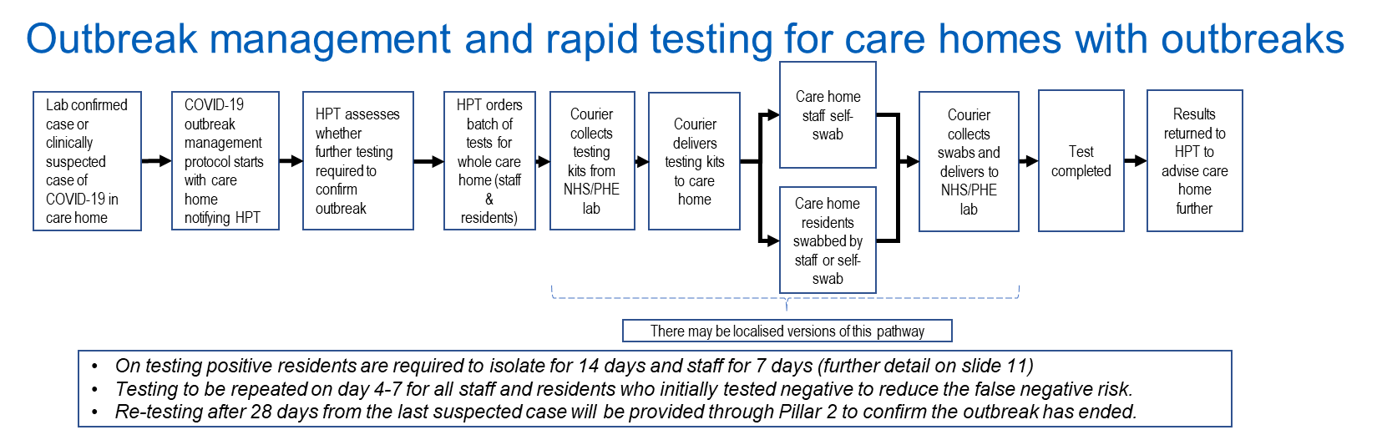

# **Care Home PCR Testing – Staff and Residents: When requested (pillar 2)**

|  |  |  |
| --- | --- | --- |
| **Purpose:**  To accompany a range of preventive measures, with a particular focus on larger care homes at greater risk of outbreaks |  | **Eligibility:**   * Whole Care Home Testing through the National Testing Programme was initially made available to care homes who primarily look after older people or people with dementia. * From 7 June 2020 the eligibility for this service has been expanded to all remaining adults care homes who will now able to access whole care home testing for all residents and asymptomatic staff through the digital portal. |
|  |  |  |
| **Pillar:** Pillar 2  **Pillar Owner**: Owner is DHSC. |  | **Process:**   * Local systems (NHS, LA DPH, DASS) to identify at risk care homes using prioritisation framework. * Care homes can be referred to the national testing service by local authorities either based on size (over 50 beds) or local knowledge. Directors of Public Health can inform which care homes to prioritise by completing a care home testing referral form:     and sending to:  [COVIDcarehometestingreferrals@dhsc.gov.uk](mailto:COVIDcarehometestingreferrals@dhsc.gov.uk)   * Care homes can request testing by registering via the DHSC:   <https://www.gov.uk/apply-coronavirus-test-care-home>   * Care homes can then book their swab returns by eCourier from the following portal:   [www.carehomecollect.co.uk](http://www.carehomecollect.co.uk)   * Where there are issues with accessing kits and test results. These should be reported to:   [COVIDCareHomeTesting@dhsc.gov.uk](mailto:COVIDCareHomeTesting@dhsc.gov.uk)  **What support is available:**   * To support care home planning to carry out whole care home testing, DHSC are hosting regular webinars on the whole home testing process. We strongly recommend them for care homes carrying out testing so that they can understand the process and what they need to do. Care Homes can register to access the webinar:   <https://event.on24.com/wcc/r/2375949/724EF6345473A192F6B9C19334699A29/1077953> |

# **Care Home PCR Testing – Staff & Residents: Regular Testing**

|  |  |  |
| --- | --- | --- |
| **Purpose:** To accompany a range of preventive measures, with a focus on care homes with residents over 65 or those with dementia.  This approach is based on advice from SAGE, the evidence from the initial round of whole home testing and the results from our Vivaldi surveillance survey. |  | **Eligibility:**   * From 6 July, in all care homes without outbreaks, DHSC are testing:   + Care home staff every 7 days (weekly)   + Care home residents every 28 days * Bank, agency and visiting professionals, such a social workers and Allied Health Professionals working in care homes should be included in the weekly staff tests (we are awaiting the formal eligibility criteria). * It has initially been rolled out to care homes with older (over 65) residents and those with dementia. |
|  |  |  |
| **Pillar:** Pillar 2  **Pillar Owner**: Owner is DHSC. |  | **Process:**   * By registering on the portal, care homes tell DHSC that they would like to carry out retesting and that they want to be sent test kits:   <https://request-care-home-testing.test-for-coronavirus.service.gov.uk/>   * Rolling out retesting to all care homes for the over 65s will take four weeks from 6th July. * Care homes for the over 65s will be divided into four even cohorts of care homes, with each cohort starting its cycle in subsequent weeks. * Each week, Pillar 2 will distribute test kits to one quarter of eligible homes. They will distribute enough kits to the care home for one month of testing (4x staff population and 1x resident population) each time an order is placed. * When a care home receives their test kits, they should carry out whole home testing (staff and residents) in that same week. * For the following three weeks, the care home should test staff weekly. * After these three weeks the cycle begins again. Cohort one begins retesting in the first week (w/c 6 July), cohort two in the second (w/c 13 July) etc. * At the end of the four-week cycle, each home will have completed whole home testing once, and staff testing a further three times (four in total). |

**Flowchart:**

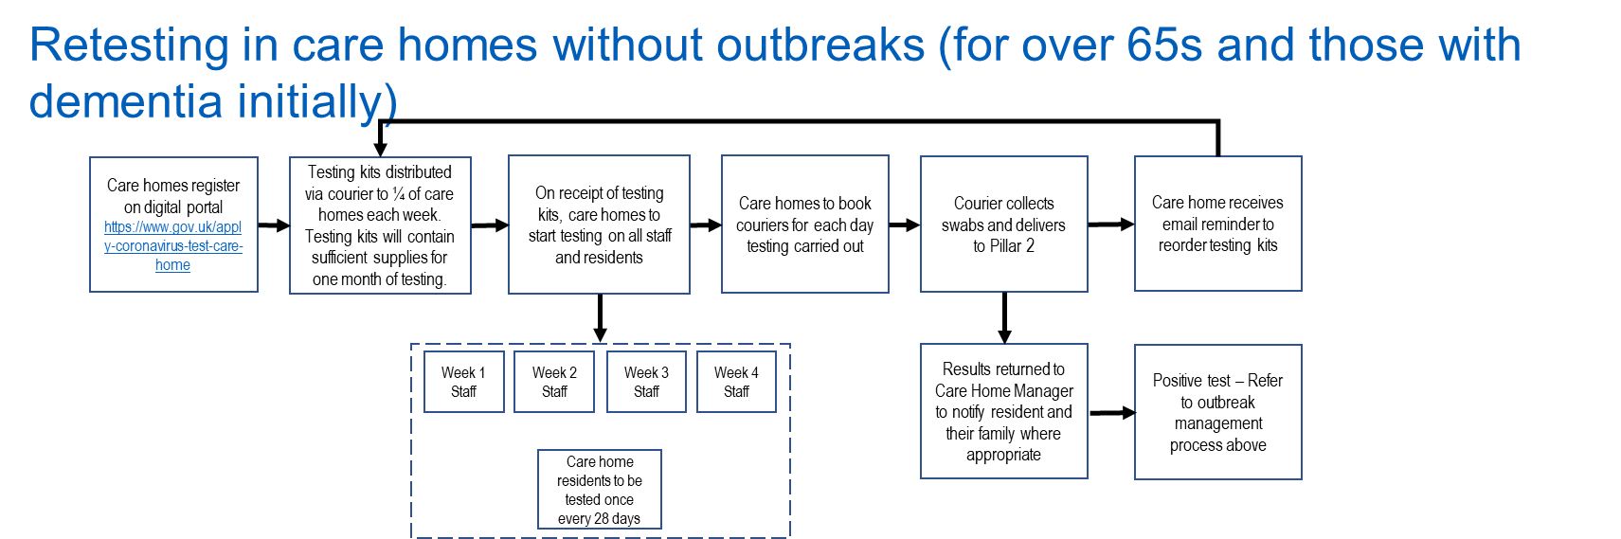

**Care Home PCR Testing – Other areas**

1. Care home portal is now live:

<https://request-care-home-testing.test-for-coronavirus.service.gov.uk/>

1. To apply for testing through the portal, the applicant will need:
   1. the care home’s CQC registration number
   2. total number of residents, including number of residents with coronavirus symptoms
   3. total number of staff, including agency staff
   4. your contact details
2. From 15 May 2020, each care home now has a dedicated GP link.
3. LA CEOs with social care responsibilities have worked with system partners to agree the following plans, which were submitted to DHSC:
   1. overview of their current activity and forward plan;
   2. confirmation of the current level of access to the support offer
   3. confirmation of the number of care homes in the area where these commitments are being delivered, including homes that the local authority does not directly commission from, as well as details of issues and support needs; and
   4. confirmation that local authorities are carrying out a daily review of the local care market (including all relevant data, especially on care homes), and taking actions immediately where necessary to support them.
4. The above request follows on from the Adult Social Care Action plan that was set out in April 2020:

<https://assets.publishing.service.gov.uk/government/uploads/system/uploads/attachment_data/file/879639/covid-19-adult-social-care-action-plan.pdf>

1. Care home issues
   1. DHSC has set up a contact email for Care Home issues, i.e. Test kits not picked up, Test kits not received, Test results delayed or not arrived. This address is:

[COVIDCareHomeTesting@dhsc.gov.uk](mailto:COVIDCareHomeTesting@dhsc.gov.uk)

# **Mobile Testing - Pillar 2**

1. Mobile testing is a DHSC-led programme delivered through Mobile Testing Units (MTUs). The MTUs are currently operated by Army personnel however commercial providers will take over the operation from the end of July. 19 MTUs are available in the SE, each with the capacity for 400 tests a day.
2. A South East MTU working group, meeting weekly and including representatives from DHSC, MoD, NHSE/I and LRFs, has been in place to discuss and agree where the MTUs should be deployed. In line with DHSC guidance, this group will transition to a Regional Coordination Group (RCG). The RCG will be accountable to the Directors of Public Health (DPHs) from the region and should ensure that oversight of MTU operations is made available to them.
3. MTUs can be broken down into three main groups:
   1. Regionally Allocated MTUs – MTUs allocated by Region for routine scheduling by RCGs under the auspices of the DPH.
   2. Regional Reserve MTUs – MTUs kept in Reserve by the RCG to meet Local Outbreaks and to provide immediate Resilience in case of MTU failure
   3. Strategic Reserve MTUs – c30 MTUs nationally, regionally dispersed but scheduled and operated centrally by the DHSC. They may be deployed in support of Local Outbreaks when requested to provide surge capacity.
4. Where a DPH has identified a need for mobile testing in response to an outbreak, a request should be submitted to the RCG via the DHSC Regional Demand Lead. Out of hours protocols for when commercial providers take over are currently being developed.

# **GP PCR Testing – Home Testing kit pilot (pillar 2)**

1. **Purpose:**

Testing the population who have coronavirus-like symptoms to see if they currently have the virus, and our aim is that anyone who needs such a test is able to have one.

1. Also, by offering swab testing through GPs we hope to reach patients who might otherwise not easily access testing and support streamlined patient care.
2. **Eligibility:**

Currently the national pilot, which started in mid-July 2020 and runs for six weeks, is represented by Surrey Heartlands Health and Care Partnership, in the South East. It includes three Primary Care Networks:

* 1. Horley
  2. Walton
  3. SASSE3

1. **Process:**



1. **Pillar Owner:**

Owner is the National DHSC Testing Lead.

1. **Frequently asked questions** in the DHSC guidance are as follows:
2. Why is this route to testing not advertised, or different to what I have heard about?
   1. This is not available across all GPs and therefore is not advertised. We are running a pilot to test how this works for GPs and for their patients.
   2. This does not replace any of the existing routes for accessing testing –instead it adds to the available routes.
3. Who is responsible for this testing?
   1. This testing is delivered by the Department of Health and Social Care with the support of NHS England and local GPs.
4. How will kits be collected?
   1. Collection of 8 or more kits a day through: ecourier.co.uk (they will provide a 2 hour window for collection)
   2. Collection of less than 8 kits per day through Royal Mail. You will find your nearest priority post box and its collection times at [www.royalmail.com/services-near-you](http://www.royalmail.com/services-near-you)
5. Where and how do I get my results?
   1. Results will normally be available within 72hours. However sometimes there is a delay. They will be emailed and texted to the details provided at registration.
6. Can my friends and family get tests this way?
   1. This is a pilot of swab testing for symptomatic patients –this pilot is limited to a number of surgeries across the country and therefore your friends and family may not be able to get a test in the same way as you have. (Direct them to other sources of testing available)

# **PCR Testing complaint process (pillar 2)**

1. A helpline has been set up for anyone tested through the national portal booking process who has not received their results (Coronavirus Testing Call Centre 0300 303 2713). Please note there is no email address to contact the helpline.
2. In the first instance key workers and stakeholders should take this route to escalate issues that they might have.
3. The next step is for the service user to escalate to the DHSC Ops Hub to investigate and resolve the service-user’s issue: [opshub@dhsc.gov.uk](mailto:opshub@dhsc.gov.uk).
4. If the Ops Hub are unable to do this the service-user will be advised that they can make a formal complaint.  They can either make their complaint directly to this dedicated complaint mailbox: [scas.Covid-19TestingComplaints@nhs.net](mailto:scas.Covid19TestingComplaints@nhs.net) or the Ops Hub can send it through on their behalf.
5. The South Central Ambulance Service (SCAS) will manage the complaints process. They will triage complaints and identify the type of investigation required. They will acknowledge the complaint and forward the issues and questions from the complainant to the appropriate part of the wider business for investigation. Once the investigation is complete and the findings returned to the SCAS team, they will prepare a response letter for sign off by the nominated manager. Where they can, SCAS will respond to complainants if the issues have been raised/investigated previously and resolutions are known to them.

# **Antibody Testing (pillar 3) – Have I had Covid-19?**

1. Detectable antibodies are likely to indicate that a person has been exposed to the virus. There is no established link between having antibodies and having immunity to Covid-19 at this stage. There is a strong desire from NHS staff to know whether they have been infected with the virus and developed antibodies. There is also a wider keenness to understand the spread of the disease.
2. Testing of NHS staff began on 29 May 2020 in all five of the South East Pathology Networks, with SE Region target of 6,000 tests per day.
3. At 21 July 2020 we have provided circa 180,000 antibody tests in the South East. Those tested include NHS staff in acute, community, mental health and ambulance trusts, and primary care. We have also begun testing staff in the wider NHS entities including: NHS Blood and Transplant, NHS Business Services Authority, Capita / PCSE (NHS), NHS Community Health Partnerships, NHS England and NHS Improvement, NHS Health Education England, NHS Home Oxygen providers, NHS Interim management and Support, NHS Property Services and NHS Resolution.
4. Plans to rollout testing to community dentists and community pharmacists are continuing to be developed, with some testing already in progress.
5. A consent form has been produced by the national team and is expected to be used for all antibody tests on staff. Patient consent must also be documented, and this can be written in patient notes or the employee consent form can be adapted locally.
6. In the SE we would like to take the opportunity to collect population health data.

# **Patient Antibody testing (pillar 3 – NHS labs)**

|  |  |  |
| --- | --- | --- |
| **Purpose:**  Per Gov.UK: While the results of an antibody test will not allow people to make any changes to their behaviour, such as easing social distancing measures, there’s clear value in knowing whether NHS and care workers and hospital patients and care home residents have had the virus, and in collecting data on the test results. |  | **Eligibility**:  Clinicians will be able to request the tests for patients in both hospital and social care settings if they think it’s appropriate. |
|  |  |  |
| **Pillar:** Pillar 3  **Pillar Owner**:  Owner is the National NHSE&I Pathology Team.  Owner of testing lab is NHS. |  | **Process:**   * Where blood is being taken by a medical professional, the clinician is able to opt for the blood to also be tested for Covid-19 antibodies. * Requests for bloods to be additionally tested for antibodies can be initiated on OrderComms and samples sent to pathology reception. * Samples will be processed by the local NHS Pathology Network laboratory. * Lab results are then processed through the LIMS and connected to the patient record. |

Guidance held here: <https://www.gov.uk/government/publications/coronavirus-covid-19-antibody-tests/coronavirus-covid-19-antibody-tests>

# **NHS Staff Antibody testing (pillar 3 – NHS labs)**

|  |  |  |
| --- | --- | --- |
| **Purpose:**  Per Gov.UK: While the results of an antibody test will not allow people to make any changes to their behaviour, such as easing social distancing measures, there’s clear value in knowing whether NHS and care workers and hospital patients and care home residents have had the virus, and in collecting data on the test results. |  | **Eligibility**:  NHS staff who would like to be tested. |
|  |  |  |
| **Pillar:** Pillar 3  **Pillar Owner**:  Owner is the National NHSE&I Pathology Team.  Owner of testing lab is NHS. |  | **Process:**   * As this is an additional blood test, phlebotomy services are required to take the sample. Work is ongoing with each of the networks to find additional capacity for this and implement booking systems to enable staff access. * Once the sample is taken, requests for bloods to be tested for antibodies can be initiated on OrderComms and samples sent to pathology reception. * Samples will be processed by the local NHS Pathology Network laboratory. * Lab results are then processed through the LIMS and connected to the patient record. |

# **Care Home Antibody Testing (pillar 3)**

1. Further national guidance on access to tests for care homes is expected shortly.

**Test and Trace – pillar 4**

1. NHS Test and Trace service launched on 28 May. The service will use 25,000 dedicated contact tracing staff working with PHE, has capacity to trace the contacts of 10,000 people who test positive for coronavirus per day and can be scaled up if needed.
2. Anyone who tests positive for coronavirus will be contacted and will need to share information about their recent interactions. Those who have been in close contact with someone who tests positive must isolate for 14 days, even if they have no symptoms, to avoid unknowingly spreading the virus.
3. If those in isolation develop symptoms, they can book a test at [nhs.uk/coronavirus](http://www.nhs.uk/coronavirus) or by calling 119. If they test positive, they must continue to stay at home for 7 days or until their symptoms have passed. If they test negative, they must complete the 14-day isolation period.
4. Close contact means:
   1. having face-to-face contact with someone (less than 1 metre away)
   2. spending more than 15 minutes within 2 metres of someone
   3. travelling in a car or other small vehicle with someone (even on a short journey) or close to them on a plane
5. There is specific guidance for healthcare and care workers who might be contacted as part of Test and Trace to consider circumstances where PPE was being worn in accordance with the current guidance on infection, prevention and control:

<https://www.gov.uk/government/publications/covid-19-management-of-exposed-healthcare-workers-and-patients-in-hospital-settings/covid-19-management-of-exposed-healthcare-workers-and-patients-in-hospital-settings>

1. The Government has announced the next phase of development in building an app that supports the end-to-end NHS Test and Trace service. This will bring together the work done so far on the NHS COVID-19 app and the new Google/Apple framework
2. Local authorities have developed local outbreak control plans focussing on identifying and containing potential outbreaks in places such as workplaces, housing complexes, care homes and schools, ensuring testing capacity is deployed effectively and helping the most vulnerable in self-isolation access essential services in their area.
3. Mobile testing units (MTUs) can be used to provide testing capacity in response to an outbreak.

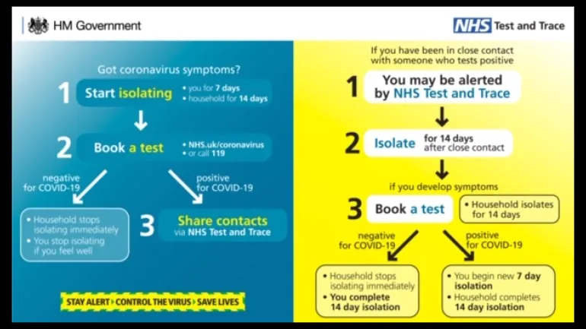

**SIREN: (Sarscov2 Immunity & REinfection EvaluatioN) – Pillar 4**

1. This is a PHE led study into “The impact of detectable anti SARS-COV2 antibody on the incidence of COVID-19 in healthcare workers”.
2. The study has received ethical approval from Berkshire Research Ethics Committee. Oversight will be by a study management group, which will include NHS trust representatives.
3. **Aim:** To determine if prior SARS-CoV-2 infection in health care workers confers future immunity to re-infection
4. Study design:
   1. Prospective longitudinal study over 24 months, which will follow-up individuals for a year.
   2. Population: Healthcare workers employed in NHS trusts.
   3. Minimum of 40 sites recruited across four nations, including at least five hospitals in each of the English regions.
   4. An initial sample size of 10k for storing blood specimens, and an addition 90k without stored blood specimens, with total sample size of up to 100k.
5. The participants in the test will have:
   1. Nose and throat swab for RT-PCR screening: 2-weekly
   2. 10ml Serology sample taken within 48 hours of RT-PCR sample: 2-weekly
   3. Frequency might change between 1-4 weekly
   4. Samples will be taken for 12 months
6. Contact for the study is: SIREN@phe.gov.uk

**Testing methods 2020 – pillar 5**

Pillar Owner: DHSC

Current Direction: Trusts are not to procure new or novel technologies. All approaches are to be directed to the on line portal below right.

Current Situation: The below graphic is the situation as at week commencing 05 May 20.

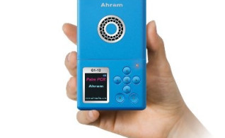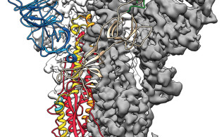

Dry Swabs for use in virus detection

30 submissi*o*ns

**2 ready to be routinely deployed**

Transport Media that inactivates the virus

34 submissions

**2 ready to be routinely deployed**

Desktop PCR equipment for Point of Care Testing

53 submissions

**1 ready to be routinely deployed**

Number of submissions = 183

Number of registered users on platform = 617



Low volume blood collection

16 submissi*o*ns

**0 ready to be routinely deployed**

RNA extraction:

New Methods

50 submissions

**11 ready to be routinely deployed**

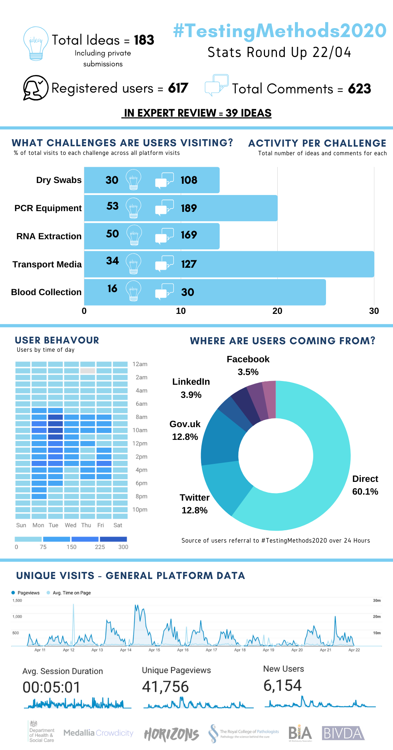

<https://testingmethods.crowdicity.com/>

# **Capital regime to support increased testing capacity**

1. **System agreement and authorisation:**

We expect that where additional testing capacity requirements are identified, that any capital investment to support these are considered as part of a co-ordinated system plan to deliver the National Testing Strategy priorities.

1. **Funding:**

There are two main options for testing in respect of capital financing for 2020/21: STP capital envelope and Covid-19 Capital Bid Reimbursement Arrangements.

1. **Funding option 1 - STP capital envelope**

Each STP/ICS has an agreed STP capital envelope. Assuming there is flexibility with the system capital plan, a system could choose to fund the capital requirement for testing from within the STP/ICS allocation.

1. Assuming the system’s capital plans were, and remain, affordable, this route does not require any further approval from NHSEI.
2. The first point of contact in this scenario would be the relevant STP/ICS Director of Finance who will have the overview of capital needs across the system and be able to indicate whether there is unallocated/available capital that could be used for investment in capital equipment for testing.
3. **Funding option 2 - Covid-19 Capital Bid Reimbursement Arrangements:**

In addition to above, the Government remains committed to covering the essential net additional cost of Covid-19 capital requirements to the NHS. It has confirmed these will be funded on top of the existing NHS capital budget.

1. The NHSEI South East Regional Team is running a capital process to support relevant items of capital expenditure that directly relate to the Covid response. All items that require Covid capital reimbursement now require prior approval in advance of expenditure being committed.
2. To start an application the relevant NHS organisation will need to complete a bid template.
3. To access this template or further advice on the process, please contact the SE Regional Capital Finance team: [england.southeastfinancecapital@nhs.net](mailto:england.southeastfinancecapital@nhs.net)
4. Before the final bid submission to NHSEI, we will require initial approval from both the ICS/STP lead and the Pathology Network of that template, to assure us that the solution best serves the population it relates to.
5. Once submitted, all bids are reviewed at a Regional Capital Panel. The Regional panel is convened on a daily basis (Monday to Friday) as and when relevant bids are submitted for consideration.
6. Once approved at Regional panel, cases are then submitted to the national team who will undertake a final review and authorise the expenditure and confirm the associated capital funding.

# **Reporting**

1. SE pathology daily SITREP
   1. On weekdays the SE pathology covid response inbox shares a situation report to the SE networks Pathology Incident Directors, SE networks pathology leads and the SE LRFs.
   2. The report includes under pillar 1 (NHS led PCR swabbing and labs):
      1. Pathology Covid-19 testing activity over the last 24 hours (capacity and tests performed by site)
      2. Cumulative tests performed in total, split by network and by staff v patient
      3. Average turnaround times of tests, including a RAG rating
      4. Key issues of each of the pathology networks across the Region
   3. The report includes under pillar 2 (DHSC led PCR swabbing and labs)
      1. Pathology Covid-19 testing activity over the last 24 hours (capacity and tests performed by site)
      2. Planned sites for MTUs (mobile testing units) for the next period (currently up to 14 days in advance)
   4. The report includes under pillar 3 (NHS led antibody serology and labs):
      1. Serology testing activity in each 24 hours since launch (capacity and tests performed by site)
      2. Total number of tests performed with number of positives
   5. The report includes data on mortuary capacity and current usage

# **Outstanding Queries**

|  |  |  |
| --- | --- | --- |
| **Area** | **Query** | **Where has it been escalated?** |
| Care home residents | Awaiting guidance on prospective residents from the community | * Query escalated to DHSC and PHE * Current admissions guidance, held here:   <https://assets.publishing.service.gov.uk/government/uploads/system/uploads/attachment_data/file/884263/admission-and-care-of-residents-during-covid-19-incident-in-a-care-home.pdf> |
| Care homes | Frequency of re-testing asymptomatic staff and residents | * Now included see main guide. 7 days for staff and 28 days for residents. |
| Care homes | What is the definition of a visiting professional, in reference to them being included in the regular weekly testing of care home staff? | * Query with NHSEI national team and DHSC. |
| Assisted living and sheltered housing | Can those in supporting living or sheltered housing access the online portal? | * Query escalated to DHSC |
| Guidance for other groups | Can we have guidance on:   * Rough sleepers in hostel accommodation * Symptomatic patients going to GP/primary care/dentist sites | * Pilots in progress on homeless (including one in Portsmouth in the SE) and GPs (further information in the main body of the Guide) |
| Prisons and schools | Is there guidance on outbreaks in other places? | * PHE has confirmed it is also responsible for investigating and managing outbreaks in community settings e.g. schools and prisons, and works with partners to arrange testing |
| Pillar 2 data | Can we get an understanding of demand for pillar 2? MPs are asking for further information on whether there are people who would like a test but cannot access one, primarily through pillar 2. | * DHSC has confirmed this data is not available. |
| Pillar 2 sites / support | * What is the longevity of RTCs? * Who will take over when the MOD exit? Are Boots staff swab takers also time limited? | * DHSC confirm work is ongoing to confirm any next steps, but there are no short-term concerns around RTCs being available or short staffed. * Commercial providers are due to take over the operation of mobile testing units from MoD from the end of July. |

# **APPENDIX 1: Pathology Networks**

# **APPENDIX 2: Points of contact: Email addresses**

|  |  |  |
| --- | --- | --- |
| **Inbox** | **Purpose** | **Times of operation** |
| [england.covid-testing@nhs.net](mailto:england.covid-testing@nhs.net) | National team inbox for all Covid-19 queries. | 7am – 7pm  Seven days a week |
| [england.pathology-](mailto:england.sepathologycovidresponse@nhs.net)[covidsupply@nhs.net](mailto:covidsupply@nhs.net) | National team inbox for all supplies and swabs escalation | 7am – 7pm Mon - Fri  9am – 5pm Sat & Sun : Out of office on inbox will give mobile number for urgent issues |
| [england.se-incident@nhs.net](mailto:england.se-incident@nhs.net) | South East (SE) Team Incident coordination inbox | 8am – 5pm Mon - Fri  9am – 4pm Sat & Sun |
| [england.sepathologycovidresponse@nhs.net](mailto:england.sepathologycovidresponse@nhs.net) | South East pathology team Covid-19 response inbox | 9am – 5pm  Mon-Fri (except public holidays) |

# **APPENDIX 3: SE meetings to support testing**

|  |  |  |  |
| --- | --- | --- | --- |
| **Meeting title** | **Purpose** | **Timing** | **Attendees\*** |
| SE Testing Coordination | To align the regional response to Covid-19 testing | Tuesday 1:30 – 2pm | SE reps: MOD, LGA, PHE. DHSC, CQC, CLG, NHSEI |
| Mobile Testing Unit (MTU) Planning | To coordinate MTU usage across SE | Thursday 3-4pm | SE reps: LRF, DHSC, MOD, NHSEI |
| Pathology Incident Director (PID) call | National meeting for PID updates | Tuesday 4:30-5:30pm  Friday 4:30-5:30pm | National reps: NHSEI, PIDs |
| SE system Pathology system call | SE meeting for PID updates | Thursday 4:30-5:30pm | SE reps: NHSEI, PIDs |
| NHSE&I and STP/ICS leads | To align the incident response across the SE. | Tuesday 10-11am  (Tues and Thurs call, but testing slot on Tues) | ICC teams from each ICS, NHSEI, CQC, LGA |

*If you wish to add or amend attendees to any meetings – please contact: [england.sepathologycovidresponse@nhs.net](mailto:england.sepathologycovidresponse@nhs.net)

# **APPENDIX 4: Glossary and Definitions**

|  |  |  |
| --- | --- | --- |
| **Word / Phrase / Abbreviation** | **Meaning** | **Definition in Relation to Covid-19** |
| Antibody Testing | Also known as serology | Covid-19 IgG antibody testing, also known as serology testing, checks for a type of antibody called immunoglobulin G (IgG). If you have been exposed to the virus that causes Covid-19, your body typically produces IgG antibodies as part of the immune response to the virus. Antibody tests may not be able to show if you have been exposed to Covid-19 because it can take at least two weeks and up to 28 days after exposure to develop antibodies.  This type of Covid-19 test is for individuals who think they may have had Covid-19 and do not currently have symptoms. This test does not tell you if you have an active infection or whether you are protected from future infection. |
| Assay |  | Per wikipedia: An assay is an investigative (analytic) procedure in laboratory medicine, pharmacology, environmental biology and molecular biology for qualitatively assessing or quantitatively measuring the presence, amount, or functional activity of a target entity (the analyte). The analyte can be a drug, biochemical substance, or cell in an organism or organic sample.  <https://en.wikipedia.org/wiki/Assay> |
| EPR | Electronic Patient Record |  |
| Essential worker |  | <https://www.gov.uk/guidance/coronavirus-covid-19-getting-tested#essential-workers> |
| High prevalence  (as relevant to COvid-19 PCR testing) |  | High prevalence: Testing will also be expected in those organisations that are identified as outliers in relation to numbers of cases of inpatients diagnosed with COVID-19 more than 7 days after admission. This definition is based on above-average number of cases aggregated over the preceding 4 weeks. |
| ICU | Intensive Care Unit |  |
| LA | Local Authority |  |
| LIMS | Laboratory Information Management System | A LIMS allows you to effectively manage the flow of samples and associated data to improve lab efficiency. A LIMS helps standardize workflows, tests and procedures, while providing accurate controls of the process. Instruments may be integrated into the LIMS to automate collection of test data, ensuring they are properly calibrated and operated by trained staff only. |
| LRF | Local Resilience Forum |  |
| NHSEI | NHS England and NHS Improvement |  |
| OrderComms | Electronic requests and pathology results | OrderComms allows the right tests are selected for the specific problem guiding staff in busy clinics as to best practice. Staff can also view pathology tests undertaken in secondary care to reduce the chance of duplication. |
| Outbreak  (as relevant to Covid-19 PCR testing) |  | The term outbreak is strictly defined in PHE guidance as two or more cases in a single setting (for example, in a single ward or having shared a location) that have become symptomatic or detected on screening on or after day eight of hospital admission. |
| PCR | Polymerase Chain Reaction | Polymerase chain reaction is a method widely used in molecular biology to rapidly make millions to billions of copies of a specific DNA sample, because Covid-19 is an RNA virus the first step (reverse transcription) is to make a DNA copy of the virus which can then me amplified by PCR. This test depends on there being small numbers of intact viral particles captured by the swabbing technique. In common with any test of this nature, because of the exquisite sensitivity of the test there is a risk of sample contamination leading to false positive tests and, because of incomplete knowledge about the shedding of the virus by infected individuals and the imperfections of swabbing technique there will also be false negative tests.  <https://www.youtube.com/watch?v=hO3mTqrEeq8>  <https://www.youtube.com/watch?v=WKiTQmbxnN4> |
| PHE | Public Health England |  |
| PID | Pathology Incident Director | On declaration of the Major Incident PIDs were established for each pathology network. |
| POC | Point of Care | These are tests which are available close to patient treatment areas which have a short turnaround of around one hour. |
| SAGE | Scientific Advisory Group for Emergencies |  |
| TATs | Turnaround Time | The time it takes between the moment a sample is checked in at pathology reception to when results are uploaded to the patient’s EPR. |
| Untoward incident  (as relevant to Covid-19 PCR testing) |  | An untoward incident in terms of probable healthcare associated COVID-19 is a single inpatient who develops COVID-19 more than 7 days after hospital admission. |

# **APPENDIX 5: Coronavirus Testing Call Centre**

**Overview**

The Coronavirus Testing Call Centre is available to assist eligible individuals through the process of booking and taking a test for Coronavirus.

The Call Centre handles all enquiries about the testing process, from how someone books an appointment, to what they do upon receipt of their result.

The Coronavirus Testing Call Centre can be contacted on 119 (in England and Wales) and 0300 303 2713 (in Scotland and Northern Ireland) between the hours of 7am – 11pm.

The service can be accessed by people with hearing or speech difficulties by calling 18001 0300 303 2713

**Q&A**

**What types of testing does the call centre advise on?**

The Call Centre advises individuals on all methods of getting a swab test:

* Regional Testing Sites
* Home testing
* Mobile test units
* Satellite centres

Our aim is that this call centre will handle all Coronavirus related testing enquiries as the testing programme expands, including antibody testing.

**Where is this Call Centre publicised?**

The Call Centre number is displayed at test sites and on home testing kits. It is also displayed within the Coronavirus test booking pages on gov.uk and nhs.uk.

**Can those with speech or hearing difficulties access the call centre?**

Yes. This service can be accessed by people with hearing or speech difficulties by calling 18001 0300 303 2713.

**Does the call centre support those for whom English is not a first language?**

Yes. The Call Centre uses the Language Line interpreter service and staff are trained to manage language barriers, including through use of this service.

**Is it UK-wide?**

Yes. The Call Centre is available for residents across the UK.

**What role does it have in assisting care homes with Coronavirus testing?**

The Call Centre is available to assist care homes in the testing process for residents and staff. This includes guidance on delivery of the tests, registration on the online portal, administering the tests and results communication.

**What volume of calls is the Call Centre receiving?**

The Call Centre currently handles around 10,000 calls a day.

**Will the Call Centre have capacity (will it hold up, what happens if it is overwhelmed etc)?**

We have rapidly built capacity in the Call Centre in order to manage call volumes. Most callers, routinely over 97%, have their call answered within 60 seconds.

**How is data being managed?**

Processes are in place for the appropriate handling of personal data. A full explanation on how your data is used and protected can be found at: <https://assets.publishing.service.gov.uk/government/uploads/system/uploads/attachment_data/file/800049/Privacy_Notice_v2_.pdf>

**Is there a way somebody can access a late test result via the Call Centre?**

Yes. Around 95% of all Coronavirus test results are sent automatically to the individual within four days. For the small proportion of results that aren’t returned promptly, the Call Centre is able to assist. If it has been more than 72hrs since the date of an individual’s test they can call the Call Centre. If troubleshooting steps do not resolve the issue, then the Call Centre will lodge an investigation which goes to the results support team for resolution.

**Is clinical advice given out by the Call Centre?**

The Testing Call Centre is to assist individuals with Coronavirus testing – it is not for medical advice or advice on the management of Coronavirus symptoms. However the Call Centre staff can explain the meaning of a test result in line with clinical guidelines.

**Is there a transfer mechanism from 111 to your service?**

Callers to NHS 111 or users of NHS 111 Online who are assessed as having coronavirus symptoms will be directed to nhs.uk or the Coronavirus Testing Call Centre to access a test.

**How and when access 111 vs Coronavirus Testing Call Centre (the difference and what to use them for)?**

The Testing Call Centre is to assist individuals with Coronavirus testing. It is not for medical advice or advice on the management of Coronavirus symptoms.

You should contact NHS 111 if you have any concerns or need advice regards your symptoms by accessing NHS 111 Online or calling 111. In an emergency, always dial 999.

**Does the Call Centre screen callers for eligibility for a test before booking?**

The Call Centre will confirm callers meet the eligibility criteria for a test by asking a few simple questions about their symptoms. This is in line with the criteria on the online booking system.

**Service providers**

DHSC has contracted Teleperformance to operate the Call Centre. Further support is provided by BJSS.