**Make patient time the most important currency in healthcare**





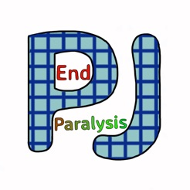



**#EndPJparalysis** has become a global movement embraced by nurses, therapists and medical colleagues. Its aim: to value patients’ time and help more people to live the richest, fullest lives possible by reducing immobility, muscle deconditioning, and dependency at the same time as protecting cognitive function, social interaction and dignity.

Useful files to learn more about this:



Finally please check out the website: <https://endpjparalysis.org/>