Patient Name: Click here to enter text.  Hosp No.: Click here to enter text.  DoB: Click here to enter a date.  Phone Number: Click here to enter text. | Date of Senate discussion:  Click here to enter a date.
Responsible Clinician:
Click here to enter text.
Surgical Speciality:  Choose an item.  Surgical urgency category:  Choose an item.  Covid Risk Category:  Choose an item.  Justify urgency category:  Click here to enter text. | Clinical Frailty Score: Choose an item.  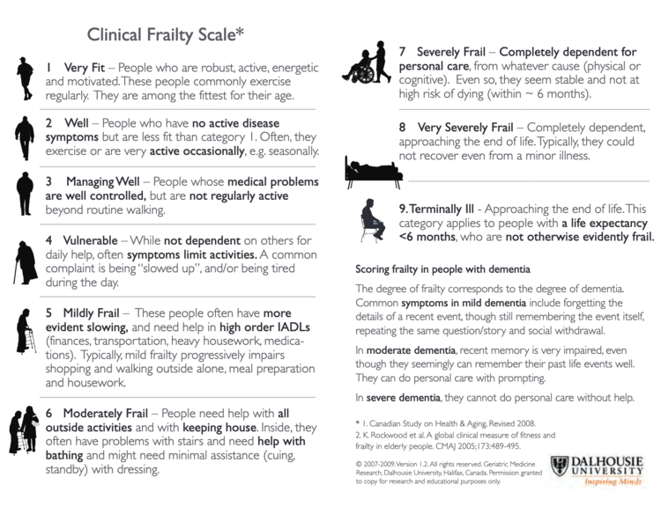
Surgery planned:
Click here to enter text.

Need for ITU/HDU?  Choose an item. | Suitable for Independent Sector if NHS?  Choose an item.
Anticipated length of surgery:  Click here to enter text. | Estimated length of stay:  Click here to enter text.
Patient ready for surgery within 1 week? Choose an item.

Surgical Senate outcome :  Choose an item.  Treat on NHS or Private list?  Choose an item. | Planned date of operation  Click here to enter a date.  Planned site of operation:  Click here to enter text.
Senate Members Present: Click here to enter text.

Name of individual to whom decision communicated: Click here to enter text.

Surgical Urgency Categorisation:
1a Emergency – surgery within 24 hours to save life

1b Urgent – surgery within 72 hours

2 Elective surgery within 4 weeks to save life/avoid progression of disease beyond operability based on:
- Urgency of symptoms
- Complications such as local compressive symptoms
- Expected growth rate of individual cancer
Local symptoms may be temporarily controlled for instance with stents or interventional radiology if surgery is deferred

3 Elective surgery can be delayed for 10-12 weeks with no predicted negative
outcome

Covid Risk Category
V1 Unlikely to have excess mortality (compared to a completely fit individual < 70 years old) in the event of Covid infection
V2 Likely to have significant excess mortality compared to a completely fit individual < 70 years old in the event of Covid infection, but would ordinarily receive invasive ventilation in that eventuality
V3 Extremely likely to succumb to Covid infection and would not ordinarily receive invasive ventilation in that eventuality

