Patient Name: Click here to enter text.  Hosp No.: Click here to enter text.  DoB: Click here to enter a date.  Phone Number Click here to enter text. | Date of MDT discussion:  Click here to enter a date.
Date of Senate discussion:
Click here to enter a date.
Tumour site: Choose an item.  Responsible Clinician:  Click here to enter text.  Surgical urgency category:  Choose an item.  Categorisation by curative intent:  Choose an item.  Covid Risk Category:  Choose an item. | Clinical Frailty Score: Choose an item.  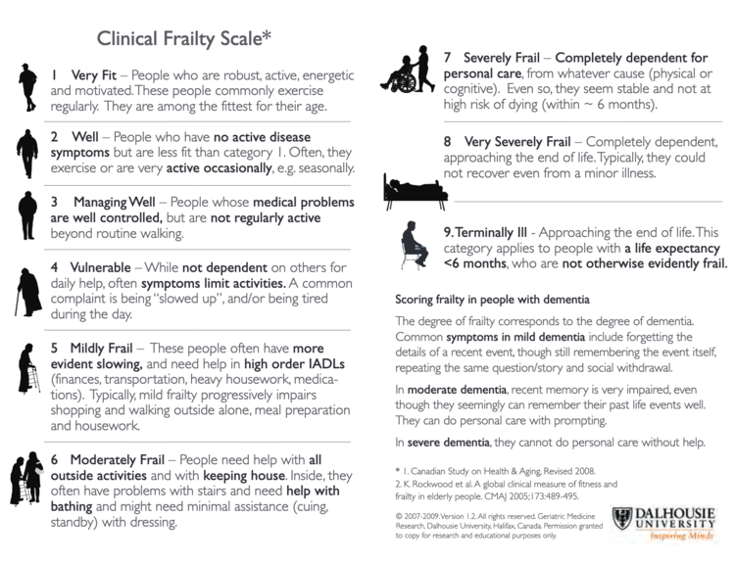
MDT outcome/surgery planned – treatment decision pre-Covid and post-Covid:
Click here to enter text.

Are non-surgical options possible, e.g. Radiotherapy or Stenting?
Click here to enter text.
Need for ITU/HDU? Choose an item. | Suitable for Independent Sector?  Choose an item.
Anticipated length of surgery:  Click here to enter text. | Estimated length of stay:  Click here to enter text.
Patient ready for surgery within 1 week? Choose an item.

Surgical Senate Decision:  Choose an item.  Treat on NHS or Private list?  Choose an item. | Planned date of operation:  Click here to enter a date.  Planned site of operation:  Click here to enter text.
Senate Members Present: Click here to enter text.

Name of individual to whom decision communicated: Click here to enter text.

Surgical Urgency Categorisation:
1a Emergency – surgery within 24 hours to save life

1b Urgent – surgery within 72 hours

2 Elective surgery within 4 weeks to save life/avoid progression of disease beyond operability based on:
- Urgency of symptoms
- Complications such as local compressive symptoms
- Expected growth rate of individual cancer
Local symptoms may be temporarily controlled for instance with stents or interventional radiology if surgery is deferred

3 Elective surgery can be delayed for 10-12 weeks with no predicted negative
outcome

Categorisation by curative intent:
(adapted from NHSE systemic anti-cancer treatment priorities)

- Curative with >50% chance of success

- Curative with a 15-50% chance of success

- Non-curative with a high (>50%) chance of >1 year life expectancy

- Curative with a low (<15%) chance of success or
Non-curative with an intermediate (15-50%) chance of > 1 year life expectancy

- Non-curative with a high (>50%) chance of palliation/temporary tumour control but < 1 year life extension

- Non-curative with an intermediate (15-50%) chance of palliation or
Temporary tumour control and <1 year life extension

Covid Risk Category
V1 Unlikely to have excess mortality (compared to a completely fit individual < 70 years old) in the event of Covid infection
V2 Likely to have significant excess mortality compared to a completely fit individual < 70 years old in the event of Covid infection, but would ordinarily receive invasive ventilation in that eventuality
V3 Extremely likely to succumb to Covid infection and would not ordinarily receive invasive ventilation in that eventuality

