Stroke Thrombectomy (Updated 2019)
- Intra-arterial thrombectomy (IAT) has been shown to be effective in reducing morbidity and mortality in patients who have an acute thrombus in the proximal (M1 & M2) middle cerebral artery (MCA) (MRCLEAN 2014).
- It is also indicated in CTA confirmed basilar artery occlusion up to 24 hours in the absence of ‘extensive’ ischaemia.
- This is currently an ad-hoc service only and available for patients presenting with stroke Monday-Friday 8-4pm.
- Referrals are accepted from Worthing hospital.
- The service is currently not available to patients from other hospitals.
- A business case has been developed and agreed by the trust in February 2019 in order to expand the service to other hospitals and out of hours gradually over 6 years.
- Formal services will not begin until sufficient staff are in post.
Thrombectomy is carried out in the neuroagio suite on level 5.
- In order to identify suitable patients they must have radiologically confirmed thrombus in the MCA by CT Angiogram of the head.
- This procedure can be performed after thrombolysis and is effective if it can be ‘reasonably’ completed within 6 hours of onset.
- This timeframe can be extended up to 24 hours including wake-up stroke with a favourable penumbra on CT perfusion.
- Anyone who presents with a stroke within 4.5 hours and meets the criteria below should have a CT angiogram (arch to vertex) straight away.
The procedure is performed under local anaesthetic therefore the patient must be compliant (although general anaesthesia can be considered).
- Age is not an exclusion but those with significant frailty (Modified Rankin Score >2) or severe cognitive problems may not be suitable.
- Decision to proceed with thrombectomy is made between Stroke Consultant on Consultant Interventional Neuroradiologist.
- Overall total numbers of patients will be 20-25 patients per year.

Inclusion Criteria (NHS England)
• Thrombectomy can be reasonably achieved within 6 hours of onset
• Thrombectomy can be reasonably achieved within 12 hours of onset AND has a favourable penumbra on CTP
• Confirmed occlusion of intracranial ICA, and/or M1 or proximal M2
• No ‘major’ ischaemic changes on CT or MRI
• NIHSS >5
• Modified Rankin Score (MRS) 1-2
Other Inclusions
• Wakeup stroke and/or last known well 6-24 hours with significant perfusion mismatch on CTP
• Confirmed basilar artery occlusion up to 24 hours without major ischaemic changes
Further information on inclusion criteria and references can be found in the thombectomy proforma
Contraindications
• MRS 4 or 5
• Matched deficit on CTP
• Co-morbidity with short life expectancy

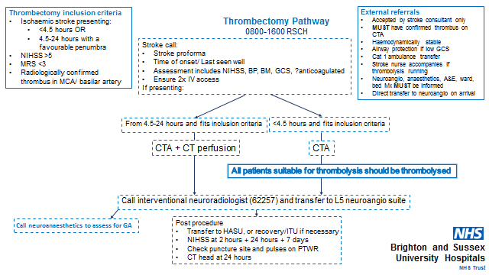

The procedure:
- This is carried out in the neuroangio suite on level 5 (past Level 5 ITU).
- The stroke consultant or registrar will be present for the entire procedure.
- Patients accepted for thrombectomy should be transferred here as soon after thrombolysis has been given and if the patient is haemodynamically stable.
- Patients will undergo continuous ECG monitoring and 15 minute observations.
- The procedure is carried out by the interventional neuroradiologist.
- It is usually carried out under local anaesthetic however some patients may require sedation or a general anaesthetic.
- For this reason the neruoanaesthetist is informed of ALL cases (in case their assistance is required).
- A guide catheter is inserted (usually via the groin) under X-ray screening and passed to the occluded vessel.
- The type of procedure is decided by the interventionist but usually involved a stent retriever device or clot aspiration.
Post procedure care:
•Patients are transferred immediately to the stroke unit if stable
•Patients requiring anaesthesia or sedation should be immediately referred to the ITU registrar to assess need for ITU/HDU care
•Some patients may be extubated and placed in neurorecovery for a short period prior to SU transfer (Neurorecovery is availbale only in hours therefore a clear plan for transfer to SU or HDU should be in place and clear escalation plan for any complications)
•A nursing care plan will be provided by the neuroangio staff (over and above standard post thrombolysis care, patients are required have groin and pedal pulses checked regularly in 1st 5 hours (15mins 1st hour, 30mins 2 hours,, 60mins 2 hours). They are required to lie flat with the leg straight in this time.

Guidance Information

Lead Author (s): Dr Ingrid Kane, Dr Philip Thompson
Approved: 2016, updated Nov 2019
Review date: Nov 2021

Comments or contributions - contact bsuh.microguide@nhs.net

