BURST THERAPY AT PRH A&E BUNDLE

Please complete for all children requiring Burst.

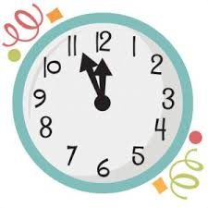
Burst therapy at PRH: Timings
Child’s Name:
Wheeze Severity according to RACH Wheeze pathway: Moderate / Severe
Please note this is not a prescription. This document is purely for timings. Please use in conjunction with RACH Wheeze pathway available on Child Health page on trust intranet.
Delete as appropriate. | Example timings | Actual timings | Signature/ Notes
First Inhalers  (10 puffs salbutamol / 4-8 puff Atrovent)  (Observations) | 1000  Sister B-R  Observations completed
Second Inhalers  (10 puffs salbutamol / 4-8 puff Atrovent) | 1020  Sister B-R
Third Inhalers  (10 puffs salbutamol / 4 -8 puff Atrovent) | 1040  Sister B-R
Steroids  (Dexamethasone 0.6mg/kg) | 1005  Sister B-R
30 minute Nurse review after burst  (Observations) | 1110  Sister B-R  Observations completed
1 hour Doctor review after burst  (10 puffs salbutamol) | 1140  Dr Jones
30 minute Nurse review  (Observations) | 1210  Sister B-R  Observations completed
2 hour Doctor review  (Observations)  Consider Ametop if unable to stretch. | 1240  Dr Jones  Observations completed
3 hour Doctor review  (Observations)  Consider need for transfer to RACH / paediatric input if unwell | 1340  Dr Jones  Observations completed
4 hours Doctor review  (Observations)  ? Home with safety netting or need for RACH transfer | 1440  Dr Jones  Home with Safety Netting advice.  Observations  completed
