If you are creating a brand new leaflet, this example will help you to get started. You don’t have to address every single point, but think of ones which are relevant to your patient. Not all leaflets are about a procedure or operation so may not fit this particular structure, but these suggestions will hopefully start you off. Don’t worry about formatting it in a Trust style: you just need to provide content.

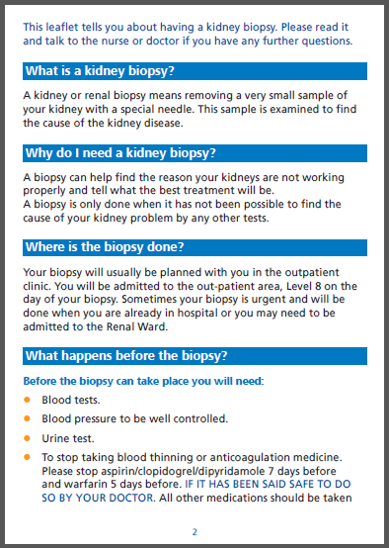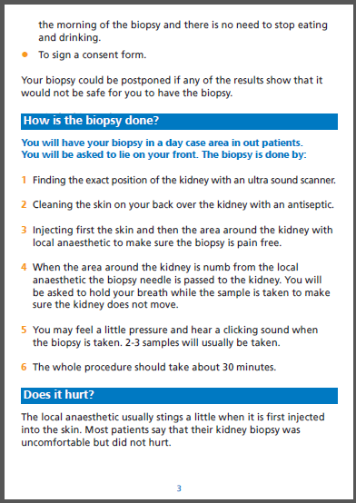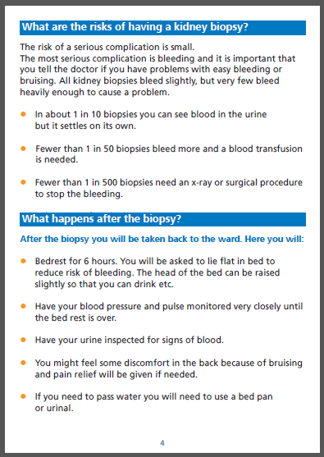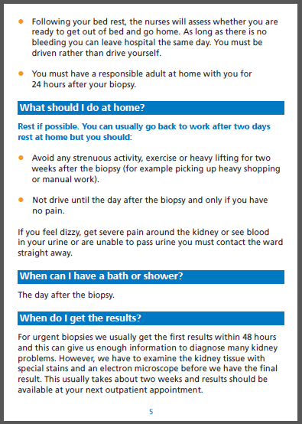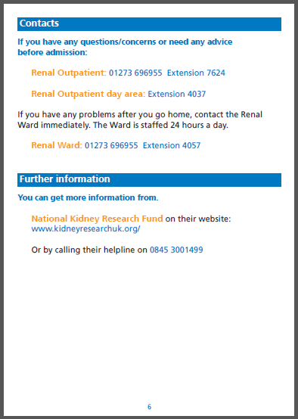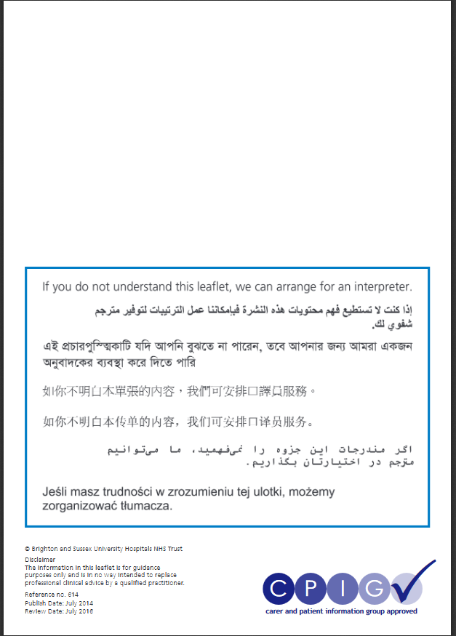

**Do** use question/answer format; short sentences; plain English

* What is this procedure/treatment/illness? **Do** explain medical terms/job titles
* **Do** state benefits, risks and alternatives If there are no alternative treatments, clearly state this

**Do** talk directly to the patient

* Where do I go? Directions and the name of the ward or department. Do I stay overnight? Is this an emergency? What should I bring with me?
* Preparation for the procedure: who will I see? What tests do I need and when/where will they be done? Will I have to undress? Where will I keep clothes and personal belongings? What medicines should I stop taking? Do I have to stop eating and drinking? Can someone come with me? What is the consent process? Can I change my mind? Will I get a chance to ask questions?

**Do** use bullet points or numbered lists rather than a lengthy paragraph

* What does this procedure involve? What position will I be in? Will I be asleep or awake? Will I get an injection? Who will be in the room with me? Will I be able to communicate during the process? Will I be asked to do anything? What will it feel like? How long will it take? Will I be hooked up to machines and what will they do? Will it hurt?
* **Do** provide a clear explanation of risks; use of simple numbers to clarify scale of risk. Any long term possible risk? Will it affect future quality of life/life choices like mobility or pregnancy?
* What happens afterwards? Where will I be taken, or can I go home straight away? Do I have to avoid certain positions/movement/actions? Will there be someone there to help me? What will they be monitoring? If I had anaesthetic, when will it wear off? Will I be in pain? Will I see a specialist like a dietician or a physiotherapist? Can I eat or drink? Can I go to the toilet? Can I have visitors? How can I get home? Will someone show me how to take care of stitches/wounds etc?
* Recovery: What should I do once I’m at home? Can I move around/do the housework/pick up children/drive/have sex/shower? How will I take care of my wound? Will someone visit me? What symptoms should I look out for and what should I do if I have them? What can I eat/drink? Will I need medicine once I get home? Do I have to buy them or will they be given to me?

**Do** use direct language and avoid ambiguity: “you must/must not” rather than “it is advisable to…”

* Results: what’s the process? How long will it take? How will I receive them (in a phone call/letter/appointment)?
* **Do** add more than one contact number and the name of the ward: what about an out of hours emergency?
* **Do** add links to further sources of information and advice

**Remember:** is your leaflet tailored for the target audience by using appropriate language; does it need to be gender neutral (e.g. transgender or same sex couple patients)?

Are images appropriate for the audience and neutral to protected characteristics (e.g. Race, sex, family unit, disabilities represented)?

Add date of publication and review date in two years’ time (eg, published 2017; review date 2019)

CPIG logo and reference number added by Clinical Media Centre