Consideration and guidance for prescribing methadone to patients with opioid dependence
Never prescribe on subjective withdrawals alone. It is appropriate to withhold medication until objective withdrawals are observed.
If opioid withdrawals persist, daily increments of 10mg can be given over the next 3 days. Twice daily prescribing, 12 hours apart is indicated for the first 2 days.
Do not exceed more than 60mg before seeking advice from Pavilions
Never give methadone to a patient who is intoxicated
Most opioid patients will be comfortably maintained on 40-60 mg daily
Observe for signs of drug use e.g track marks or opioid withdrawals e.g. anxiety / agitation / sweating / piloerection / lacrimation / dilated pupils / stomach cramps
Can a drug screen urine test be performed?
Gain clinical history of patients opioid use and ascertain if there may be dependence / prescribing needs
Refer to Pavilions Substance misuse nurses Jo / Mim / Vicky on ext 7826 who can help with managing the patient.
If we are not present and patient is resident in Brighton & Hove please call Pavilions during office hours to confirm if client is known to them and if there is any current community prescribing of methadone or buprenorphine on (01273) 731900.
Out of hours please follow this algorhythm
For out of area patients please see contact details below.

Perform a urine test to check for evidence of opioids
When opioid withdrawals are apparent an initial dose of 10-20mg of methadone 1mg/1ml should be prescribed. Never give more than 20mg as an initial dose to avoid overdose
Observe over the next 3-4 hours for signs of intoxication or ongoing withdrawals. If still withdrawing after 4-6 hours a further 10-20mg can be given.
Never give more than 40mg in the first 24 hours
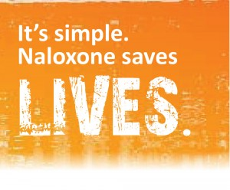

Yes
No

PLEASE ENSURE A TAKE-OUT A PRENOXAD (NALOXONE) MINIJET IS GIVEN TO ANYONE AT RISK OF OPIOID OD & PLEASE CONTACT THE LIAISON NURSES OR PAVILIONS FOR ADVICE AROUND DISCHARGE
W. & Mid Sx Drug & Alcohol services: CGL - 0300 303 8677 /E. Sx. Drug & Alcohol services: CGL - 0300 30 38 160

