Child Protection Referral To Social Care Services Children & Families Team
Referred to
B&H SW team, West Sussex, East Sussex

Child/Young Person’s name & address (or expectant mother)

Family Name |  |  |  |  | Forenames:  M / F
Address: |  |  |  |  | NHS No
 |  |  |  |  | DOB |  |  | EDD:
 |  |  |  |  | Telephone Number
Postcode |  |  |  |  | Child/Young Person’s Religion:
Current address if different from above: |  |  |  |  | Ethnicity:
 |  |  |  |  | First Language:

Child/Young Person’s principle carers
Name |  | Relationship to child |  |  |  |  | Parental Responsibility?
 |  |  |  |  |  |  | Yes/No
 |  |  |  |  |  |  | Yes/No
 |  |  |  |  |  |  | Yes/No
Other Significant Family and Household members (including siblings and any non-family)
Name | DOB |  | Relationship to Child |  |  | Address

Details of other agencies involved
 | Name |  |  |  |  | Contact details
GP
MW
HV
SW
School
Other
Is there an early help/ CAF? Yes / No |  |  |  | Who is the lead professional?
Are Parent/s aware of referral? Yes / No Have they given consent for the referral? Yes / No
If NO, give reason:

Is this confirmation of a referral previously made by telephone? Yes / No
If YES, Name of Social Worker who took referral:

Reasons for referral and risk assessment of current situation. (include any information on the child’s or unborn baby’s needs, parents ability to meet these needs and any other family/environmental factors which will affect the situation. (see assessment triangle)

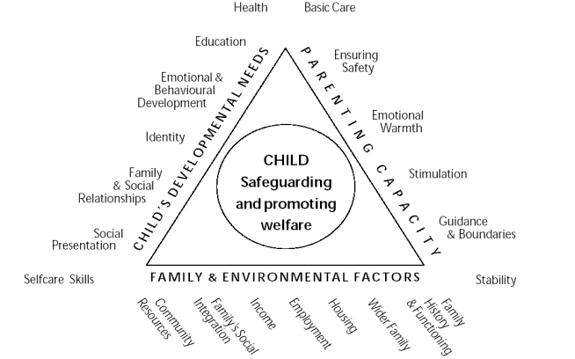

What is working well? Who is involved that helps the child (include other agencies and family, friends and community resources)

What have you done to help? & What needs to happen?

- Details of person completing this referral: please complete in full

Name: (PRINT)  Designation: | Ward/Department/ Midwifery Team:
Address: | Contact Telephone Number:
Signature: | Date:
- Copy of this referral to: |  | Tick if sent:
Patients Records (Mandatory).
Debi Fillery Nurse Consultant for Safeguarding children and young people
Level 4, RACH, extension 2363 (mobile 07876 357 456) (Mandatory).
Fiona Rose Safeguarding Midwife
Level 4, RACH, extension 2363 (mobile) 07920 503 354
Other (State Title)

