**UpToDate Anywhere – March 2018**

**Footer *(link to Liby Matters page with guidance)***

[UpToDate® Anywhere](http://bit.ly/2ELreaJ) – mobile access for BSUH NHS Trust staff.

The new remote and mobile access gives you evidence-based guidance when and where you need it. [Contact us](mailto:library.services@bsuh.nhs.uk) for more information.

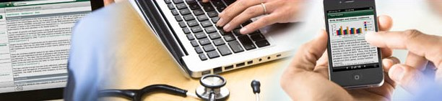

**Library Matters**

**NEW: UpToDate® Anywhere – mobile and remote access**

Now you can access all the content of UpToDate from your mobile and tablet. You can also build up free continuing education credits (CME/CE/CPD) when researching clinical questions.

To gain remote and mobile access you just need to complete a quick one-time registration process.

**Getting registered:**

1. Access UpToDate via the [BSUH Intranet link](http://w2ksvr049/intranet/uptodate/goto_uptodate.asp)

***\*****You must register from within the BSUH NHS network to gain access to the Mobile App and accrue CME credits.*

2. Click the **Register** button in the upper right corner of the screen.

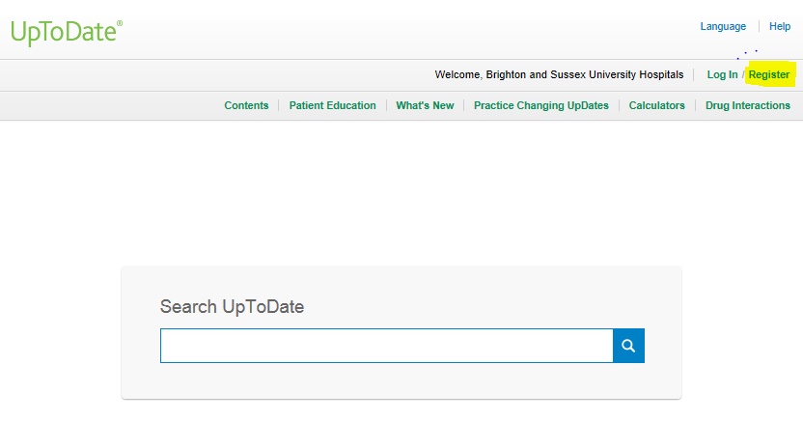

3. Complete all fields on the registration form and then click **Submit Registration.**

4. Make a note of your user name and password.

Upon completion of the registration process, you will receive a confirmation email from UpToDate with instructions on downloading the Mobile App.

You are now registered and able to download the Mobile App and earn CME credits!

**Mobile Access**

Once registered, you can install the Mobile App on up to **two devices**.

1. On your smartphone or tablet, find **“UpToDate”** in your app store and install the free app.

2. Open the UpToDate Mobile App upon completion of download.

3. Log in with your UpToDate user name and password.

*You only need to do this once — the app remembers your user name and password.*



**ACCESS UPTODATE ANYWHERE**

In addition to the Mobile App, you can access UpToDate from any computer with internet access.

Simply go to **www.uptodate.com** and click the **“Log In”** button located in the top right corner of the UpToDate home page, and enter your **user name and password**.



**MAINTAINING ACCESS**

To keep the account active, you must **re-verify** your affiliation with BSUH once **every 90 days**.

**re-verifying your affiliation**

Log into UpToDate using the [**BSUH Intranet link**](http://w2ksvr049/intranet/uptodate/goto_uptodate.asp) at least once in **every 90 days**.

In-application & email messaging will inform you of the need to verify affiliation if you have not done so by day 80. You will receive a second alert at day 90.

***If you fail to re-verify by day 90, you will lose mobile and remote access.***

To regain access, simply login to UpToDate with your user name and password using the [**BSUH Intranet link**](http://w2ksvr049/intranet/uptodate/goto_uptodate.asp) as above.

[Contact us](mailto:library.services@bsuh.nhs.uk) for more information.

**Library website**

**Roll over text:**

**UpToDate® Anywhere – mobile and remote access for BSUH NHS Trust staff.**

**UpToDate Anywhere**

