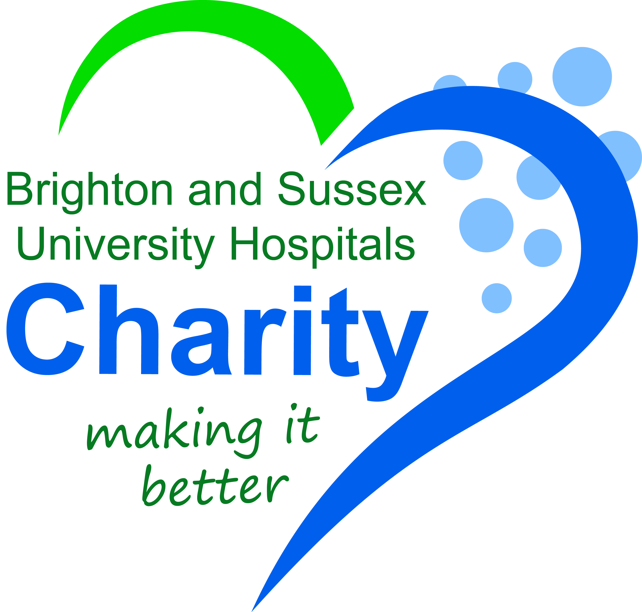
REGISTRATION FORM
Brighton Marathon Weekend, 19th April 2020
Please complete to the best of your ability. PLEASE PRINT.
Mr/Mrs/Miss/Ms...............................................................................................(first and surname)
Address: ...............................................................................................................................
................................................................................................................................................
City : .......................................................... Postcode: .................................................
Tel No: ....................................................... Email: ........................................................
Preferred method of communication:  Phone Email Post | Gender:  Male Female Prefer Not to Say
Date of Birth: ______________ | Which event are you registering for?  Marathon BM 10k BM Ride
What is your jersey/vest size?  Small Medium Large XL XXL | Do you give permission for BSUH Charity to use your name and photograph for our Newsletters, Website and social media? Yes No
Do you have a personal reason for choosing to support BSUH Charity?

How did you know that BSUH Charity had places available?

BSUH Charity is asking each participant to raise a minimum amount to receive a charity place.
Brighton Marathon = £350, BM 10k = £100, BM Ride = £200. You will be expected to have raised half of this at least 8 weeks prior to the event. If you are unable to meet this commitment, we may offer your place to someone on the waiting list. Your fundraising helps improve care for patients so we hope some people will raise a lot more!
In order to secure your place, please turn in this form and pay a £10 registration fee at your earliest convenience. Cheques should be made payable to “BSUH Charity - BMW 2020.” Online payments can be made at www.justgiving.com/bsuhnhs, please reference BMW2020 Registration.
Please note that places are limited, so the first people to turn in their registration agreement and pay their registration fee will have their places held.

You can return this registration form via email BSUH.Charity@nhs.net or post to:
BSUH Charity c/o: Post Room
Royal Sussex County Hospital, Eastern Road
Brighton, BN2 5BE
By signing below, you agree to the terms of this form:
Signed: | Date:

